Week: 7 Preparing date: October 7th 2023
Period: 25 Teaching date: October 17th 2023

Unit 4: OUR BODIES
Lesson 2 (1, 2, 3)
I. OBJECTIVES:
By the end of the lesson, Ss will be able to:
1. Knowledge:
- use Open your ………! and Touch your …........! to give instructions
- listen to and demonstrate understanding of simple communicative contexts in relation to the topic “Our bodies”.
- Vocabulary: touch, open, mouth, hair
- Skills: speaking and listening
2. Competences:
- Oral Communication: speak about names, ask and answer the questions
- Co-operation: ready to help friends in pair work/ group work.
- Sociability: Talk to each other, say good words to others.
3. Attitude/ Qualities:
- Kindness: Help partners to complete learning tasks.
- Honesty: tell the truth about feelings and emotions
- Diligence: complete learning tasks
II. TEACHING AIDS:
- Teacher: Teacher’s guide Pages 55, 56, audio Tracks 39,40, website sachmem.vn, posters, laptop, pictures, textbook, lesson plan, TV or projector.
- Students: Pupil’s book Page 30, notebooks, workbooks, school things.
III. PROCEDURES:
Stages/Time | Teacher’s activities | Students’ activities
1.Warm- up:  (3’)  2. Presentation  (16’)  3.Practice: (7’)  4.Production: (7’)  5. Homework. (2’) | Game: Review  *Aims: to create a friendly and active atmosphere in the class to beginning the lesson.  *Procedure:  - T says to Ss answer the parts of the body  +We use ... for listening (pretend to listen to music)  + We use ... for looking (pretend to wear glasses)  + We use ... for smelling (pretend to smell something good)  + We put makeup on a ... (pretend to put on makeup)  + We hold something with ... (pretend to hold heavy thing)  - Say “Open your book page 30” and look at “Unit 4, Lesson 2 (1,2,3)”.  Activity 1. Vocabulary.  *Aims: Ss will be able to know the vocabulary in front of starting the new lesson.  *Procedure:  -T elicits the new words  + touch : chạm (situation)  + open : mở / há (realia)  +mouth :miệng (realia)  + hair : tóc (realia)  - T models (3 times).  - T writes the words on the board.  - Checking: Rub out and remember  Activity 2. Listen, point and repeat:  *Aims: Ss will be able to understand and correctly repeat the sentences in two communicative contexts (pictures) focusing on giving instructions.  *Procedure:  - Have pupils look at Pictures a and b and identify the characters in the pictures.  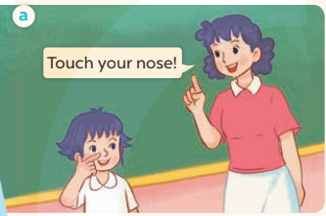  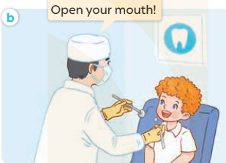  - Play the audio twice (sentence by sentence). Correct their pronunciation where necessary.  - Have Ss to practice the dialogue  - T invites a few pairs to the front of the class to practice.  - T checks pronunciation for ss.  Activity 3 Listen, point and say.  *Aims: Ss will be able to correctly say the words and use Touch your ……..! and Open your ……….! to give instructions.  *Procedure:  * Model sentences:  - T asks Ss look at picture a, b and helps Ss know the structure from the dialogue.  - T introduces new structure for Ss.  - T explains, models and gives meaning.  -Have Ss repeat the model sentences.  - Touch your nose!  - Open your mouth!  *Drill pictures  - Elicit and check comprehension the actions and the body parts.  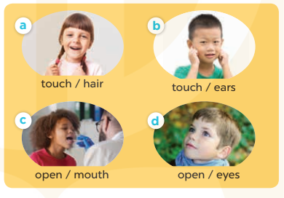  - Run through all the pictures.  - Run through model sentences.  - Have Ss to practise:  + T says the first picture  + Ss say the second picture  + Group A say the third picture  + Group B say the last picture.  - Ask Ss to work in pairs to point and say the strucure Touch your….! Open your…….!  - T controls and corrects.  - Invite a few pairs to point at the pictures and giving the instructions in front of the class.  - Encourage Ss to practise speaking English.  - T gives feedbacks.  Activity 4. Let’s talk.  *Aims: Ss will be able to enhance the correct use of Touch your …..! and Open your …..! to give instructions  *Procedure:  - Have Ss look at the picture and answer the questions:  +Who are they?  + What are they doing?  - T asks Ss look at the first speech bubble and say Touch your……!  - Get Ss to repeat and give instructions several times in pairs.  - T models: Go around the classroom, pointing to the parts of body and says Touch your…..!  - Ask Ss work in pairs to give more instructions using the words that they have learnt (ex: nose, face, ear, …..).  - Invite some pairs to perform in front of the class.  - Give feedbacks  *Consolidation  *Aims: Ss will be able consolidate and wrap up the content of the lesson.  *Procedure:  - T asks ss to answer the following questions:  + What have you learnt from the lesson today?  +What are the core values of the lesson? (if the teacher can take from the lesson).  - T review the vocabulary and model sentences.  - T praises some Ss who are hardworking / active/ good…. as well as encourage others to try more.  - Learn the vocabulary and model sentences by heart  - Prepare the new lesson: Unit 4, Lesson 2 (4,5,6). | -Ss answer  + an ear  + an eye  + a nose  + a face  + a hand  - Ss open their books  -Ss listen and answer  - - Ss listen and repeat  + Choral repetition (3 times).  + Individual repetition (3 ss)  - Ss take note  - Ss look, remember and write  -Look at the pictures and get to know the characters in the pictures.  + In picture a: Ms Hoa says: Touch your nose!  + In pucture b: The doctor says: Open your mouth!  -Ss listen and repeat in chorus (twice)  -Ss work in pairs to practice  -Ss practice the dialogue  -Ss listen  -Ss look at the picture and answer.  -Ss listen  -Ss listen and repeat  -Ss repeat to the actions and the body parts.  -Ss look at the picture and answer  + In picture a: a girl touching her hair  + In picture b: a boy touching his ears  + In picture c: a boy opening his mouth  + In picture d: a boy opening his eyes  - Ss look, listen and repeat  -Ss practice in chorus  -Ss work in pairs to practice  -Ss point and say  -Ss listen.  -Ss listen  -Ss look at the picture and listen  + A boy asks a girl to touch her hair  +A doctor asks a boy to open his mouth.  -Ss look and answer  + hair  -Ss say  - Ss answer  -Ss work in pairs  -Ss perform in front of the class.  -Ss answer the questions  - Ss listen  -Ss listen and clap their hands  -Ss listen and take note
IV. ADJUSTMENTS (if necessary):
………………………………………………………………………………………….…..……………………………………………………………………………...………………………………………….…..……………………………………………………………………………….……………………………………………………………………...

Week: 7 Preparing date: October 7th 2023
Period: 26 Teaching date: October 17th 2023

Unit 4: OUR BODIES
Lesson 2 (4, 5, 6)
I. OBJECTIVES:
By the end of the lesson, Ss will be able to:
1. Knowledge:
- listen to and demonstrate understanding of simple communicative contexts in relation to the topic “Our bodies”
- read and match the sentence halves to make complete instructions and read them aloud.
- Vocabulary: Review
- Skills: speaking, listening, reading and writing.
2. Competences:
- Critical Thinking: self-introduce
- Co-operation: ready to help friends in pair work/ group work.
- Self-control and independent learning: perform listening tasks.
3. Attitude/ Qualities:
- Kindness: Help partners to complete learning tasks.
- Honesty: tell the truth about feelings and emotions.
- Diligence: complete learning tasks.
II. TEACHING AIDS:
- Teacher: Teacher’s guide Pages 56, 57, 58; audio Tracks 41; website sachmem.vn, posters, laptop, pictures, textbook, lesson plan, TV or projector.
- Students: Pupil’s book Page 31, notebooks, workbooks, school things.
III. PROCEDURES:
Stages/Time | Teacher’s activities | Students’ activities
1.Warm- up:  (5’)  2.Practice: (27’)  3. Homework. (3’) | Game: Simon says  *Aims: to create a friendly and active atmosphere in the class to beginning the lesson.  *Procedure:  - T is the “Simon” and calls out the actions. Every student must follow and do the action, but only when they hear “Simon says ...”.  - If teacher leaves out “Simon says” before giving instruction, anyone who does the action is out.  - Then, teacher can choose one or more students as the leader to continue a game.  - Say “Open your book page 31” and look at “Unit 4, Lesson 2 (4,5,6)”.  Activity 1. Listen and number:  *Aims: Ss will be able to listen to and understand four communicative contexts in which instructions are given.  *Procedure:  - Elicit the actions of the characters in the pictures.  - Point at the pictures respectively to explain the context.    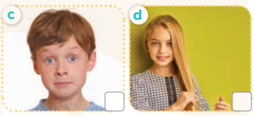  - T ask Ss to guess the answers.  + T writes Ss’guessing on the board.  - Listen to the tape:  + Play the recording  + Play the recording again and get Ss to swap books with their partners.  + Play the recording again to check answers together as a class.  + Write the answers on the board for Ss to correct their answers. Then checks Ss’ guessing.  - Play the recording, sentence by sentence, for the class to listen and repeat in chorus.  Key: 1. b 2. d 3. a 4. c  Activity 2. Look, match and read.  *Aims: Ss will be able to correctly match the sentence halves to make complete instructions and read them aloud.  *Procedure:  - Get Ss to look at the pictures and identify the actions of the characters.  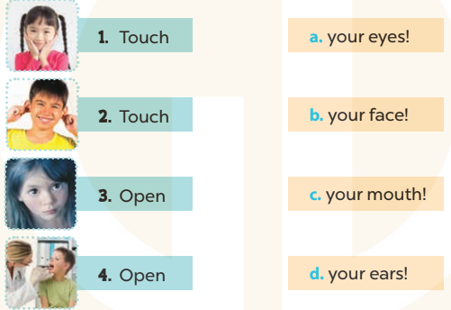  - Have Ss look at the first picture and incomplete sentence.  - T models with sentence 1  + Ask Ss to read and match. When Ss answer correctly (Touch your face!)  + Tell them to draw a line to match the two sentence halves  -Have Ss work in groups and match the sentence 2, 3 and 4.  - Ask a few Ss to stand up and read the matched instructions aloud.  -T gives feedbacks.  Key: 1. b 2. d 3. a 4. c  Activity 3. Let’s play.  *Aims: Ss will be able to practise using target sentence patterns by playing the game Touch your hair!  *Procedure:  - Elicit the language that Ss need to give instructions (Touch your ……! and Open your……..!). When Ss answer correctly, write the language on the board.  - Have Ss look at the picture. Get them to say how to play the game. Explain the rules of the game again:  + A boy / girl standing in the centre gives an instruction and other Ss have to follow it.  + If a pupil does not follow the instruction, he or she will be "out".  + Check Ss’ understanding by getting one Ss to repeat what they have to do.  - Have the whole class play the game. Ask one or two Ss to be the observer(s) of the game. Give out the instructions and monitor Ss while they play the game. Ss who cannot follow the rules of the game will be “out” and become the observers.  - Divide the class into four teams. Each team plays the game. Ss are eliminated if they do not perform the correct actions. Give stars/ points to the winner.  *Consolidation  *Aims: Ss will be able consolidate and wrap up the content of the lesson.  *Procedure:  - T asks ss to answer the following questions:  + What have you learnt from the lesson today?  +What are the core values of the lesson? (if the teacher can take from the lesson).  - T praises some Ss who are hardworking / active/ good…. as well as encourage others to try more.  - Practice about the pictures on page 31.  - Prepare the new lesson: Unit 4, Lesson 3 (1,2,3). | - Ss listen  -Ss play game  - Ss open their books  -Look at the pictures and say:  + Picture a: a boy touching his nose  + Picture b: a girl opening her mouth  + Picture c: a boy opening his eyes  + Picture d: a girl touching her hair  -Ss guess the answers  - Ss listen to the tape and write number  - Ss listen again, write and swap books with their partners.  - Ss check their answers and guessing  -Ss listen and repeat.  -Ss look at the pictures and say  -Ss listen and answer  -Ss read and match  -Ss complete the sentence  -Ss read aloud  -Ss listen  -Ss look at the picture and play the game  -Ss play the game  -Ss listen to the teacher.  -Ss answer the questions  -Ss listen and clap their hands  -Ss listen and take note
IV. ADJUSTMENTS (if necessary):
………………………………………………………………………………………….…..……………………………………………………………………………...………………………………………….…..……………………………………………………………………………….……………………………………………………………………...

Week: 7 Preparing date: October 7th 2023
Period: 27 Teaching date: October 19th 2023

Unit 4: OUR BODIES
Lesson 3 (1, 2, 3)
I. OBJECTIVES:
By the end of the lesson, Ss will be able to:
1. Knowledge:
- correctly pronounce the sounds of the letters air and ear in isolation, in the words hair and ears, and in the sentences Touch your hair! and Touch your ears!
- listen and circle the correct words.
- Vocabulary: Review
- Skills: speaking, listening, reading and writing.
2. Competences:
- Co-operation: ready to help friends in pair work/ group work.
- Sociability: Talk to each other, say good words to others.
3. Attitude/ Qualities:
- Kindness: Help partners to complete learning tasks.
- Honesty: tell the truth about feelings and emotions
II. TEACHING AIDS:
- Teacher: Teacher’s guide Pages 58, 59; audio Tracks 42, 43; website sachmem.vn, posters, laptop, pictures, textbook, lesson plan, TV or projector.
- Students: Pupil’s book Page 32, notebooks, workbooks, school things.
III. PROCEDURES:
Stages/Time | Teacher’s activities | Students’ activities
1.Warm- up:  (5’)  2. Presentation  (9’)  3.Practice: (19’)  4. Homework. (2’) | Game: I want to see ...  *Aims: to create a friendly and active atmosphere in the class to beginning the lesson.  *Procedure:  - Divide the class into 10 groups (4 Ss/ group).  - T calls out “I want to see ... 4 hands!”  - T calls out “I want to see ... 6 eyes!”  - T calls out “I want to see ... 1 mouth!”  - T calls out “I want to see ... 3 faces!”  - T calls out “I want to see ... 2 noses!”  - Say “Open your book page 32” and look at “Unit 4, Lesson 3 (1,2,3)”.  Activity 1. Listen and repeat:  *Aims: Ss will be able to correctly pronounce the sounds of the letters air and ear in isolation, in the words hair and ears, and in the sentences Touch your hair! and Touch your ears! with correct pronunciation and intonation.  *Procedure:  - T gives instruction to the letter air and ear, hair and ears, and in the sentences Touch your hair! and Touch your ears!  - Play the recording for the letter air, ear.  - Encourage Ss to point at the letter/ word/ sentence while listening.  - Play the recording again and encourage Ss to listen and repeat. - Do this several times until Ss feel confident.  - T calls some Ss to practice.  - T gives feedbacks.  Activity 2. Listen and circle.  *Aims: Ss will be able to identify the target words hair and ears while listening.  *Procedure:  - Elicit the sentences and the gap-fill options.  - T ask Ss to guess the answers.  + T writes Ss’guessing on the board.  - Listen to the tape:  + Play the recording  + Play the recording again and get Ss to swap books with their partners.  + Play the recording again to check answers together as a class.  + Write the answers on the board for Ss to correct their answers. Then checks Ss’ guessing.  - Play the recording, sentence by sentence, for the class to listen and repeat in chorus.  - Invite one or two Ss to stand up and read the completed sentences.  Key: 1.c 2.b  Activity 3. Let’s chant  *Aims: Ss will be able to say the chant with the correct rhythm and pronunciation.  *Procedure:  - Introduce the title and lyrics of the chant.  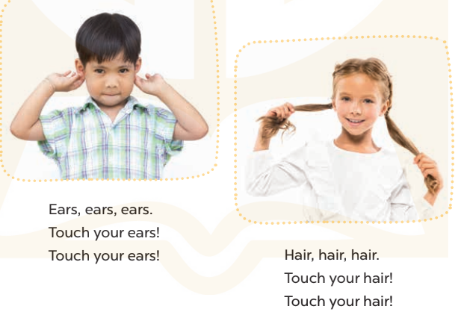  - Play the recording for Ss to listen to the whole chant.  + Have them repeat the title and lyrics line by line.  + Ask Ss to attend to the sounds of the letters air and ear and the words hair and ears.  - Play the recording all the way through for Ss to listen to pronunciation and melody.  - Play the recording line by line for Ss to listen and repeat  - Play the recording for Ss to chant and clap along.  - Ask Ss to practice chant and clap along in pairs or groups.  - Invite groups to the front of the classroom to perform the chant  -T gives feedback.  *Consolidation  *Aims: Ss will be able consolidate and wrap up the content of the lesson.  *Procedure:  - T asks ss to answer the following questions:  + What have you learnt from the lesson today?  +What are the core values of the lesson? (if the teacher can take from the lesson).  - T praises some Ss who are hardworking / active/ good…. as well as encourage others to try more.  - Practice the chant more.  - Prepare the new lesson: Unit 4, Lesson 3 (4,5,6). | - Ss listen  -Ss must show only 4 hands (other hands can be hidden behind their backs).  - Ss show only 6 eyes (other eyes can be closed).  - Ss show only 1 opened mouth (other mouths can be covered).  - Ss show only 3 faces (other mouth can be covered by hand).  - Ss show only 2 noses (other noses can be covered by hand).  - Ss open their books  - Ss recognize the differences about color of letter  - - Ss listen  - Ss listen and point  - Ss listen again and repeat  -Ss listen again and repeat  -Ss practice  -Ss listen  -Ss listen and say:  + Number 1: Touch your….!  + Number 2: Touch your…..!  -Ss guess the answers  - Ss listen to the tape and circle  - Ss listen again, circle and swap books with their partners.  - Ss check their answers and guessing  -Ss listen and repeat.  -Ss read the sentences  - Ss look and listen.  -Ss listen to the chant  - Ss listen and repeat line by line without clap their hands  -Ss note the sounds, words  -Ss listen to melody of the chant  - Ss listen and chant line by line.  - Ss chant and clap along.  - Ss work in groups (two groups) to chant  -Ss perform in front of the class.  -Ss listen  -Ss listen.  -Ss answer the questions  -Ss listen and clap their hands  -Ss listen and take note

IV. ADJUSTMENTS (if necessary):
………………………………………………………………………………………….…..……………………………………………………………………………...………………………………………….…..……………………………………………………………………………….……………………………………………………………………...

Week: 7 Preparing date: October 7th 2023
Period: 28 Teaching date: October 19th 2023

Unit 4: OUR BODIES
Lesson 3 (4, 5, 6)
I. OBJECTIVES:
By the end of the lesson, Ss will be able to:
1. Knowledge:
- read and write about parts of the body and instructions;
- make flashcards of the body parts and present them to the class.
- Vocabulary: Review
- Skills: speaking, listening, reading and writing.
2. Competences:
- Critical Thinking: self-introduce
- Co-operation: ready to help friends in pair work/ group work.
- Self-control and independent learning: perform listening tasks.
3. Attitude/ Qualities:
- Kindness: Help partners to complete learning tasks.
- Honesty: tell the truth about feelings and emotions.
- Diligence: complete learning tasks.
II. TEACHING AIDS:
- Teacher: Teacher’s guide Pages 60, 61; website sachmem.vn, posters, laptop, pictures, textbook, lesson plan, TV or projector.
- Students: Pupil’s book Page 33, notebooks, workbooks, school things.
III. PROCEDURES:
Stages/Time | Teacher’s activities | Students’ activities
1.Warm- up:  (5’)  2.Practice: (8’)  3.Production: (19’)  4. Homework. (3’) | Game: “Chant”  *Aims: to review the vocabulary and structure about greet and respond to greetings.  *Procedure:  - Ask Ss chant and do the actions in Unit 4, Lesson 3 page 32 in groups.  - Give point for the groups and encourage them.  - Say “Open your book page 33” and look at “Unit 4, Lesson 3 (4, 5, 6)”.  Activity 1. Read and match:  *Aims: Ss will be able to read the four sentences/ exchanges on the left and match them with the pictures on the right correctly.  *Procedure:  - T models with sentence 1.  + Get Ss to read Sentence 1  + Ask Ss to read the first exchange and draw a line to match.  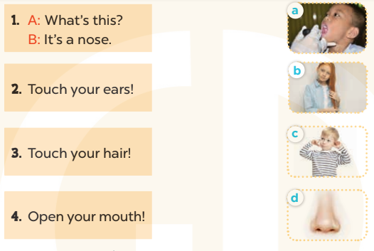  -Have Ss work in pairs and match the sentences 2, 3, 4.  - Tell Ss to swap books with a partner, then check answers together as a class.  - Write the correct answers on the board for pupils to correct their answers.  - Invite pairs of Ss to stand up and role play  -T gives feedbacks.  Key: 1. d 2. c 3. b 4. a  Activity 2. Let’s write  *Aims: Ss will be able to read, understand and complete four target sentences / exchanges with picture cues.  *Procedure:  - Have Ss read the sentences and ask some questions:  + What’s this?  + What’s that?  + What are they doing?  - Check their comprehension and remind Ss to write their personal information.  - Give Ss time to write the answers to the questions independently  - Get Ss to swap books with a partner, then check the answers together as a class.  - Ask a few Ss to stand up and role play the dialogue in front of the class.  -T gives feedbacks.  Key: 1. a hand 2. an eye  3. nose 4. Open  Activity 3. Project.  *Aims: Ss will be able to revise the target vocabulary items by making flashcards of the body parts pupils have learnt and presenting them to the class.  *Procedure:  - Ask Ss to look at the picture of an eye in the book. Demonstrate how to make a flashcard of an eye. Draw an eye on a card and write the word eye under the picture.  - Show Ss your flashcard of an eye. Tell them to pass it around so that they can see what they are going to make.  - Put Ss into groups and give each group a set of materials for making flashcards of the body parts.  - Give Ss enough time to make flashcards. Encourage them to decorate their flashcards.  - When Ss have finished making their flashcards, give them time to present the flashcards to their classmates. Go around the classroom to monitor and offer support.  Game: Who is the fastest writer?  - T asks 6 - 8 Ss to join this game.  - T says out loud a word (twice).  *Consolidation  *Aims: Ss will be able consolidate and wrap up the content of the lesson.  *Procedure:  - T asks ss to answer the following questions:  + What have you learnt from the lesson today?  +What are the core values of the lesson? (if the teacher can take from the lesson).  - T praises some Ss who are hardworking / active/ good…. as well as encourage others to try more.  - Prepare the new lesson: Unit 5, Lesson 1 (1, 2, 3). | - Ss listen and chant  - Ss open their books  - Ss look at the pictures and answer  -Ss read and match  -Ss work in pairs and match  -Ss swap books and check  -Ss check the correct their answers  -Ss role play  -Ss listen  -Ss look at the pictures and say:  + It’s a hand  + It’s an eye  + A girl touches her nose  + A boy opens his mouth.  -Ss listen to the teacher  -Ss write  -Ss swap books and check their answers  -Ss role play  -Ss listen  - Ss listen and note  -Ss listen to the teacher  -Ss make flashcards of the body parts  -Ss continute to make the flashcards  -Ss present the flashcards  -Ss listen  -Ss write as fast as they can.  -Ss answer the questions  -Ss listen and clap their hands  -Ss listen and take note
IV. ADJUSTMENTS (if necessary):
.…..……………………………………………………………………………...……
………………………………………………………………………………………….…..……………………………………………………………………………...…………

