Week 13 Preparing date: ……………….
Period 49 Teaching date: …………. …….

Unit 7: Our favourite school activities
Lesson 3 (4, 5, 6)
A. OBJECTIVES:
By the end of the lesson, Ss will be able to:
1. Knowledge:
- read a text and show understanding of the text by circling the correct options to complete the sentences provided.
- write a brief paragraph consisting of about 30 words about your favourite school activities and why their brother / sister / friend likes them with the help of guiding questions and a writing frame.
- present to the class a report of a survey on pupils’ favourite school activities.
- Vocabulary: Review
- Skills: speaking, listening, reading and writing.
2. Competences:
- Communication and collaboration: work in pairs and groups to complete the learning tasks.
- Self-control and independent learning: perform reading and writing tasks.
3. Attitude/ Qualities:
- Show their pride in their school and show their interest in their favorite school activities.
B. TEACHING AIDS:
- Teacher: Teacher’s guide Pages 113, 114; website hoclieu.vn, posters, laptop, pictures, textbook, lesson plan, TV or projector.
- Students: Student’s book Page 55, notebooks, workbooks, school things.
C. PROCEDURES:
Teacher’s activities | Students’ activities
1.Warm- up and review: (5’)  Game: Rock, paper, scissors  *Aims: to create a friendly and active atmosphere in the class to beginning the lesson.  *Procedure:  - Ask ss to play Rock, paper, scissors review the words: do projects, solve math problem, play games, read stories, useful, interesting, fun, good for group work  - Ask ss to show the sign of Rock, paper, scissors to show the answers they choose.  - Say “Open your book page 55” and look at “Unit 7, Lesson 3 (4,5,6)”.  2.Practice: (8’)  Activity 1. Read and circle:  *Aims: Ss will be able to read a text and show understanding of the text by circling the correct options to complete the sentences provided.  *Procedure:  - Explain that Ss should read the paragraph and circle the correct options to complete the sentences provided.  - Model number 1, have ss read the Sentence 1; then scan the paragraph above quickly to find the correct person (Linh).  - Set a time limit for ss to do the rest of the task independently.  - Get ss to swap books with a partner and check their answers before checking as a class.  - Invite two ss to take turns asking and answering why Linh, Minh, Lucy and Bill like these school activities, Ex: Why does Linh like singing? - Because she wants to be a singer in the future.  Key: 1. c 2. b 3. a 4. c  3.Production: (18’)  Activity 2. Let’s write  *Aims: Ss will be able to write a brief paragraph consisting of about 30 words about favourite school activities and why their brother / sister / friend likes them, with the help of guiding questions and a writing frame.  *Procedure:  - Explain that ss should read the guiding questions and complete the writing frame with their personal information  - Model the first gap. Have ss read the first sentence in the frame and remind them of the question words in the first question before completing the sentence.  - Give Ss time to do the writing task independently.  - Get Ss to swap their books with a partner and check each other’s spelling  before checking as a class.  Key: Pupil’s answer  Ex: My sister’s favourite school activities  My sister’s favourite school activity is solving maths problems. She likes it because she thinks it’s interesting, and she wants to teach maths in the future. She doesn’t like singing because she thinks she does not have a good voice.  Activity 3. Project.  *Aims: Ss will be able to present to the class a report of a survey on pupils’ favourite school activities  *Procedure:  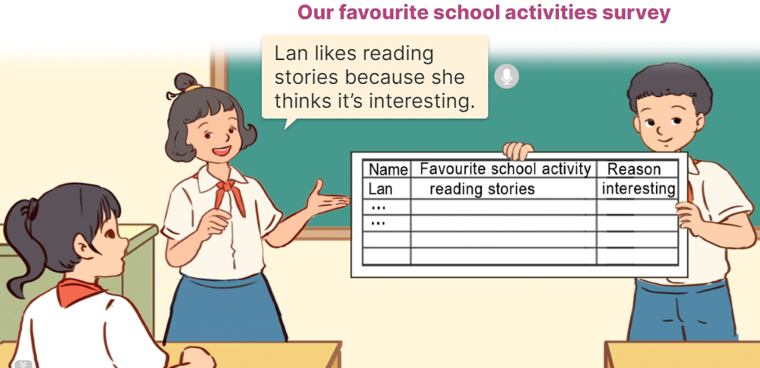  - Check ss’ survey results.  - Invite a student to report his / her survey results with your help.  - Have ss work in groups to report their own results.  - Invite a few groups to report their survey results in front of the class. Praise them when they do a good job.  4. Fun corner and wrap- up (4’)  Game: Number race  - Divide the class into three groups. Each group has ten ss.  - Give each student in one group a number so that each group has equal numbers.  - Ask the questions, Ex: What’s your sister’s favorite school activity? / Why does she like it?, and allow time for ss to think. Then call out a number, have ss with that number from each group stand up and shout out the answers, ex: My sister’s favourite activity is doing projects. Praise and give points for the groups.  - The group with more points wins the game. | - Ss listen  -Ss play game  - Ss open their books  - Ss pay attention and read the paragraph  - Ss look at the incomplete sentences and answer options.  -Ss read the text again and circle the correct answers.  - Ss swap books and check their answers before checking as a class.  - Two Ss take turns to practise asking and answering.  - Ss listen to the teacher  - Ss complete the first gap  - Ss complete the sentences  - Ss swap their and check  - Ss listen to the teacher  - Ss work in groups, report their survey to their friends in groups.  - Ss report their survey in front of the class.  -Ss listen to the teacher  -Ss play the game  -Ss congratulate the winner
D. ADJUSTMENTS (if necessary):
………………………………………………………………………………………….…..……………………………………………………………………………...……

Week 13 Preparing date: ………………
Period 50 Teaching date: ……….. ………

Unit 8: In our classroom
Lesson 1 (1, 2, 3)
A. OBJECTIVES:
By the end of the lesson, Ss will be able to:
1. Knowledge:

- understand and correctly repeat the sentences in two communicative contexts in which characters ask and answer questions about school things and their locations.

- correctly say the words and use Where are the ______? – They’re _____. to ask and answer questions about the locations of school things.

- use Where are the _____? understand and correctly repeat the sentences in two communicative contexts in which characters ask and answer questions about the locations of school things.

- Vocabulary: beside, under, above, in front of, board, bookcase

- Structures:
A: Where are the maps?
B: They’re beside the board.
- Skills: speaking and listening
2. Competences:
- Critical thinking and creativity: learn how to ask and answer questions about the locations of school things correctly and fluently.
- Communication and collaboration: work in pairs and groups to complete the learning tasks.
3. Attitude/ Qualities:
- Show their pride in school things they have and great respect for other people’s school things by using appropriate gestures and intonation when asking and answering about school things.
B. TEACHING AIDS:
- Teacher: Teacher’s guide Pages 115, 116, 117, audio Tracks 76, 77; website hoclieu.vn, posters, laptop, pictures, textbook, lesson plan, TV or projector.
- Students: Students’ book Page 56, notebooks, workbooks, school things.
C. PROCEDURES:
Teacher’s activities | Students’ activities
1.Warm- up and review: (3’)  Game: Guessing game  *Aims: to revise the vocabulary about school things and things around them.  *Procedure:  - T introduces and explains the game.  - How to play:  + T will show some pictures which is hidden about different activities.  + Ss look at the pictures in the screen.  + Ss tell what someone is doing.  - T models. (notebook)  - Ss play the game.  - T gives feedback.  - Say “Open your book page 56” and look at “Unit 8, Lesson 1 (1,2,3)”.  2. Presentation (15’)  Activity 1. Vocabulary.  *Aims: Ss will be able to know the vocabulary in the new lesson.  *Procedure:  -T elicits the new words  + beside : bên cạnh (explain)  + under : phía dưới (picture)  + above : phía trên (picture)  + in front of : phía trước (explain)  + board : bảng đen (realia)  + bookcase: kệ sách (realia)  - T models (3 times).  - T writes the words on the board.  - Checking: Matching  Activity 2. Look, listen and repeat:  *Aims: Ss will be able to understand and correctly repeat the sentences in two communicative contexts in which characters ask and answer questions about school things and their locations.  *Procedure:  - Have Ss look at Pictures a and b and identify the characters and what they can see in the pictures.  + Who is he/ she?  + Where is he/ she?  + What does Miss Hoa ask?  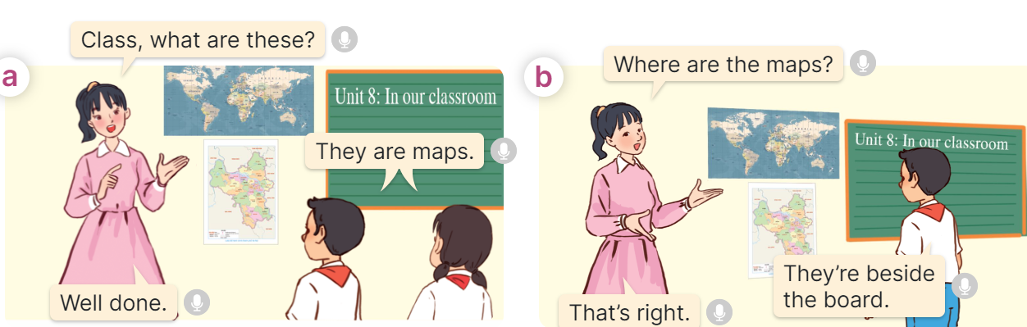  - Play the audio twice (sentence by sentence). Correct their pronunciation where necessary.  - Have Ss to practice the dialogue  - T invites a few pairs to the front of the class to practice.  - T checks pronunciation for ss.  Activity 3 Listen, point and say.  *Aims: Ss will be able to correctly say the words above, beside, in front of, under and use Where are the ______? - They’re _____. to ask and answer questions about the locations of school things.  *Procedure:  * Structures:  - T asks Ss look at picture b in activity 1 and helps Ss know the structure from the dialogue.  - T introduces new structures for Ss.  - T explains, models and gives meaning.  - Have Ss repeat the structures  A: Where are the maps?  B: They’re beside the board.  3.Practice: (7’)  *Drill pictures  - Have Ss look at the pictures and identify the locations of the school things. 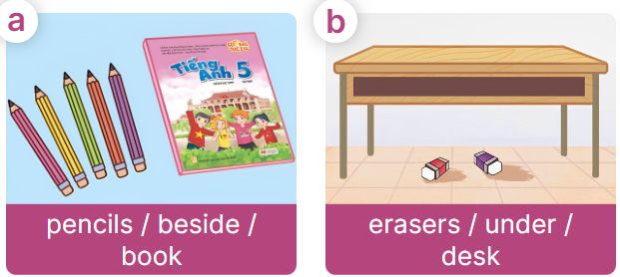  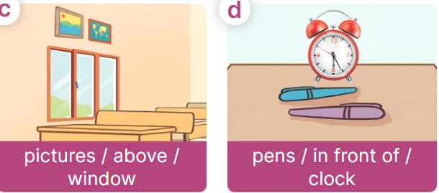  - Tell Ss in the answer, the + things  - Have Ss point at pictures, listen and run through all the pictures.  - Have Ss point at the bubbles, listen and run through model sentences.  - Have Ss to practise:  + T asks the first picture, Ss answer  + Ss asks the second picture, T answers  + Group A asks the third picture, group B  answers  + Group B asks the last picture, group A  - Ask Ss to work in pairs to practise asking and answering the Where are the ______? - They’re _____.  - T controls and corrects.  - Invite a few pairs to point at the pictures and say the questions and answers in front of the class.  4. Production: (6’)  Activity 4. Let’s talk.  *Aims: Ss will be able to use Where are the _____? – They’re _____. in a freer context  *Procedure:  - Ask Ss to look at the pictures and elicit the context  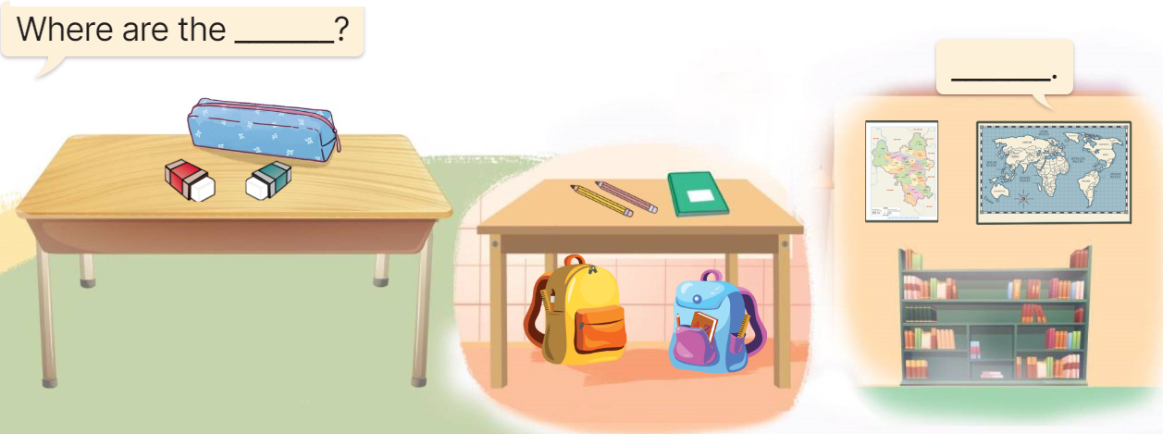  - Point at the ﬁrst picture and elicit the question in the ﬁrst speech bubble Where are the ____? and the answer in the second speech They’re __. as an example.  - Give Ss time to work in pairs and take turns pointing at each picture to ask and answer using Where are the _? They’re __  - Invite a few pairs to come to the front of the classroom and act out the exchanges.  5. Fun corner and wrap- up (4’)  Game: Musical cards  - Stick the cards on the board. Ask ss to say the words related to the cards.  - Hand out the cards to different ss around the class.  - Play the song and ask ss to pass the cards to the ss next to them while the music is playing.  - Stop the music suddenly. Invite a student to ask the question “Where are the pens?”.  Ask the student who is holding the card to answer the question, ex: It’s in front of the clock.  - Play the music again and repeat the activity. | -Ss listen and pay attention  - Ss listen to the teacher  -Ss play the game  .  - Ss listen and open their books  -Ss listen and answer  - - Ss listen and repeat  + Choral repetition (3 times).  + Individual repetition (3 ss)  - Ss take note  - Ss look and match  -Look at the pictures and say.  + In picture a:  Miss Hoa: Class, what are these?  Class: They are maps  Miss Hoa: Well done.  + In picture b:  Miss Hoa: Where are the maps?  Boy: They’re beside the board.  Miss Hoa: That’s right.  -Ss listen and repeat in chorus (twice)  -Ss work in pairs to practice  -Ss come to the front of the classroom to practice.  -Ss listen  - Ss look at the picture and answer.  -Ss listen  -Ss listen and repeat  -Ss repeat to the structures  - Ss look, listen and repeat  +Picture a: five pencils beside the book  + Picture b: two erasers under the desk  + Picture c: two pictures above the window  + Picture d: two pens in front of the clock  -Ss listen to the teacher  -Ss point at pictures, listen and repeat  -Ss point at the bubbles, listen and repeat  -Ss practice in chorus  -Ss practice in chorus  -Ss work in pairs to practise asking and answering the question  - Pairs of Ss point at the pictures and say in front of the class  -Ss look at the picture and say  - Ss look at the first picture and elicit the missing words and say the completed sentences.  - Ss role-play to practise asking and answering questions  - Ss practise asking and answering questions in front of the class.  -Ss listen to the teacher  -Ss play the game  -Ss continue to play the game
D. ADJUSTMENTS (if necessary):
………………………………………………………………………………………….…..……………………………………………………………………………...…

Week 13 Preparing date: …………………..
Period 51 Teaching date: …………………..

Unit 8: In our classroom
Lesson 1 (4, 5, 6)
A. OBJECTIVES:
By the end of the lesson, Ss will be able to:
1. Knowledge:
- listen to and understand four communicative contexts in which characters ask and answer about the locations of school things and tick or cross the pictures.
- complete four gapped exchanges with the help of the picture cues.
- sing the song Where are they? with the correct pronunciation, rhythm and melody.
- Vocabulary: Review
- Skills: speaking, listening, reading and writing.
2. Competences:
- Communication and collaboration: work in pairs and groups to complete the learning tasks.
3. Attitude/ Qualities:
- Show their pride in school things they have and great respect for other people’s school things by using appropriate gestures and intonation when asking and answering about school things.
B. TEACHING AIDS:
- Teacher: Teacher’s guide Pages 118, 119; audio Tracks 78, 79; website hoclieu.vn, posters, laptop, pictures, textbook, lesson plan, TV or projector.
- Students: Student’s book Page 57, notebooks, workbooks, school things.
C. PROCEDURES:
Teacher’s activities | Students’ activities
1.Warm- up and review: (5’)  Game: Memory Game  *Aims: to revise the learned words *Procedure:  - Show a picture on the board.  - Ss have to look at the picture and try to remember the position of things in 15 seconds.  - Put the picture away. Show a question with 03 answer options A, B and C. ss have to choose the correct answer based on what they can remember and call it out.  Ex: A. The three books are beside the bag.  - Give one score to the student with the correct answer.  - Say “Open your book page 57” and look at “Unit 8, Lesson 1 (4,5,6)”.  2.Practice: (25’)  Activity 1. Listen and tick or cross:  *Aims: Ss will be able to listen to and understand four communicative contexts in which characters ask and answer about the locations of school things, and tick or cross the pictures.  *Procedure:  - Draw Ss’ attention to the pictures and elicit the names of the school things and their locations 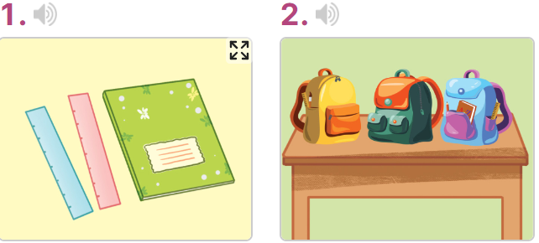  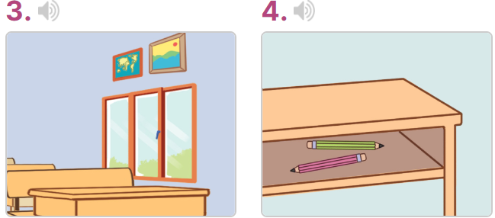  - T ask Ss to guess the answers.  + T writes Ss’guessing on the board.  - Listen to the tape:  + Play the recording  + Play the recording again for pupils to do the task.  + Play the recording a third time for pupils to check their answers.  - Get Ss to swap books with their partner, then check answers as a class.  + Write the answers on the board for Ss to correct their answers. Then checks Ss’ guessing.  - If time allows, play the recording, sentence by sentence, for Ss to listen and repeat individually and in chorus Key: 1. v 2. x 3.v 4.x  Activity 2. Read and complete  *Aims: Ss will be able to complete four gapped exchanges with the help of picture cues.  *Procedure:  - Have Ss look at the pictures and identify the locations of the school things in the pictures.  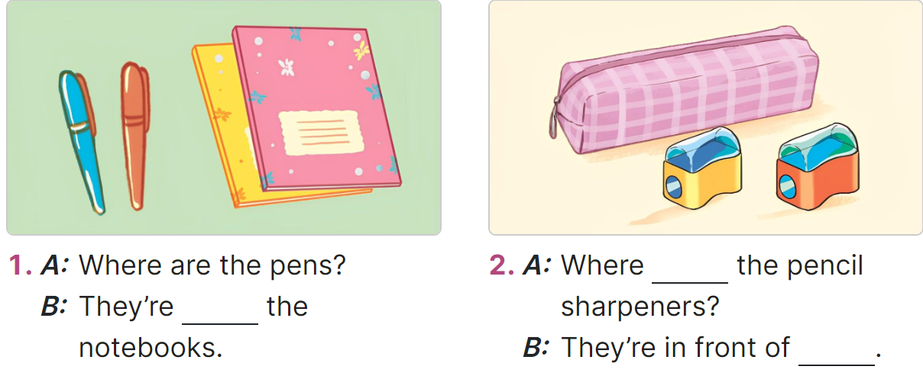  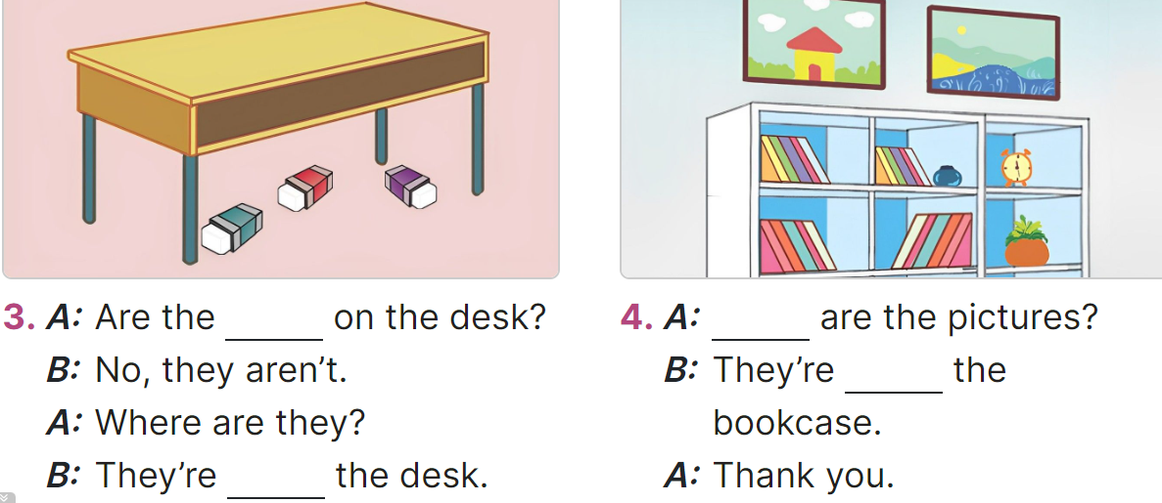  - Model the first sentence: have Ss read the question and ask what words are missing (beside)  - Give Ss a time limit to read the gapped dialogues, look at the pictures and do the task independently.  - Get Ss to swap books with a partner and check their answers before checking as a class.  + Invite one student to write the answers on the board.  - Invite two pairs of Ss to act out the completed dialogues.  Key:  1. beside, 2. are; the pencil case,  3. erasers; under, 4. Where; above  Activity 3. Let’s sing  *Aims: Ss will be able to sing the song Where are they? with the correct pronunciation, rhythm and melody. *Procedure:  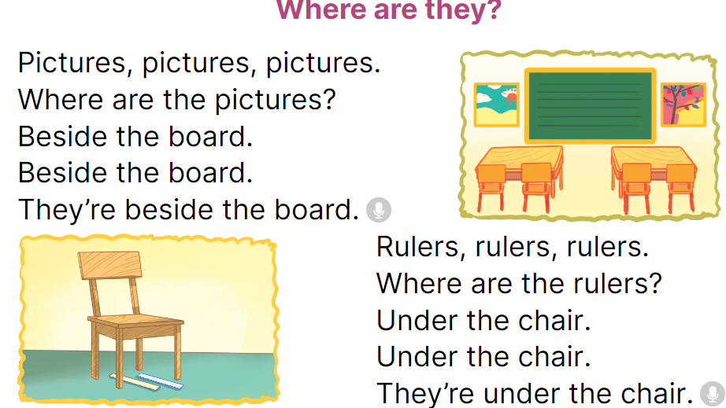  - Draw ss’ attention to the title and lyrics of the song.  - Play the recording all the way through for ss to listen to the whole song.  - Play the recording again, line by line, for ss to listen and repeat.  - Play the recording all the way through for ss to sing along.  - Play the recording again for ss to sing and clap along with the recording.  - Invite some groups to the front of the class to perform while the rest of the class sings and / or claps along.  3. Fun corner and wrap- up (5’)  Game: Angry birds  - Divide the class into 2 groups: Boys and Girls.  - Have Ss take turns choosing the numbers, then look at the picture and answer the questions.  Ex: Picture of two books on the desk. Teacher asks “Where are the books?  Ss answer “They’re on the desk.”  - Have ss look at the pictures and answer the questions.  - The group with more points wins. | -Ss listen to the teacher  -Ss play the game  -Ss read the words  - Ss open their books  -Look at the pictures and say:  + Picture 1: two rulers beside a notebook  + Picture 2: three school bags on a table  + Picture 3: two pictures above a window  + Picture 4: two pencils in a desk  -Ss guess the answers  - Ss listen to the tape  - Ss listen again and do the task.  - Ss listen and check their answers  - Ss swap books with their partner, then check answers as a class and guessing  -Ss check again  -Ss listen and repeat  -Ss look at the picture and say  -Ss follow the teacher  - Ss do the task independently.  - Ss swap books with a partner and check their answers.  - Ss write the answers on the board  - Pairs of Ss read the completed dialogues aloud  - Ss pay attention to the title and lyrics of the song.  - Ss listen to the whole song.  - Ss listen and repeat line by line  - Ss listen to the recording all the way through and sing along.  - Ss listen again to sing and clap along.  - Some groups come to the front of the class to perform  -Ss listen to the teacher  - Ss play the game.
D. ADJUSTMENTS (if necessary):
………………………………………………………………………………………….…..……………………………………………………………………………...…..…

Week 13 Preparing date: ……………………..
Period 54 Teaching date: …………… ……….

Unit 8: In our classroom
Lesson 2 (1, 2, 3)
A. OBJECTIVES:
By the end of the lesson, Ss will be able to:
1. Knowledge:

- understand and correctly repeat the sentences in two communicative contexts in which characters ask and answer questions about possession.

- correctly use Whose __ is this? - It’s ___. to ask and answer questions about possession.

- use Is this your ___? - ____. and Whose ___ is this? – It’s ___. in a freer context.

- Vocabulary: glue stick, crayon, set square, pencil sharpener
- Structures: A: Whose crayon is this?
B: It’s Linh’s.
- Skills: speaking and listening
2. Competences:
- Communication and collaboration: work in pairs and groups to complete the learning tasks.
- Self-control and independent learning: perform pronunciation and speaking tasks.
3. Attitude/ Qualities:
- Show their pride in school things they have and great respect for other people’s school things by using appropriate gestures and intonation when asking and answering about school things.
B. TEACHING AIDS:
- Teacher: Teacher’s guide Pages 120, 121, audio Tracks 80, 81; website hoclieu.vn, posters, laptop, pictures, textbook, lesson plan, TV or projector.
- Students: Students’ book Page 58, notebooks, workbooks, school things.
C. PROCEDURES:
Teacher’s activities | Students’ activities
1.Warm- up and review: (3’)  Game: Who’s faster?  *Aims: to revise the structures Where are the __? - They’re___. to ask and answer questions about the locations of school things.  *Procedure:  - Explain how the game is played  - Write a word on the board (ex: beside, under, above, in front of) and a sentence as an example: The pictures are above the bookcase.  - Divide the class into groups of five. Ask groups to look at the words and the example on the board.  - Give each group a piece of paper. Have groups make four sentences with the four words and phrases beside, under, above, in front of, then read the sentences aloud to the class. The group that makes correct sentences faster wins.  - Say “Open your book page 58” and look at “Unit 8, Lesson 2 (1,2,3)”.  2. Presentation (15’)  Activity 1. Vocabulary.  *Aims: Ss will be able to know the vocabulary in the new lesson.  *Procedure:  -T elicits the new words  + glue stick : keo dán (realia)  + crayon : bút sáp màu (realia)  + set square : thước e kê (realia)  + pencil sharpener : cục gọt bút chì  (realia)  - T models (3 times).  - T writes the words on the board.  - Checking: Rub out and remember  Activity 2. Look, listen and repeat:  *Aims: Ss will be able to understand and correctly repeat the sentences in two communicative contexts in which characters ask and answer questions about possession  *Procedure:  - Have Ss look at Pictures a and b and identify the characters and what they can see in the pictures.  + Who is he/ she?  + Where is he/ she?  + What are they talking about?  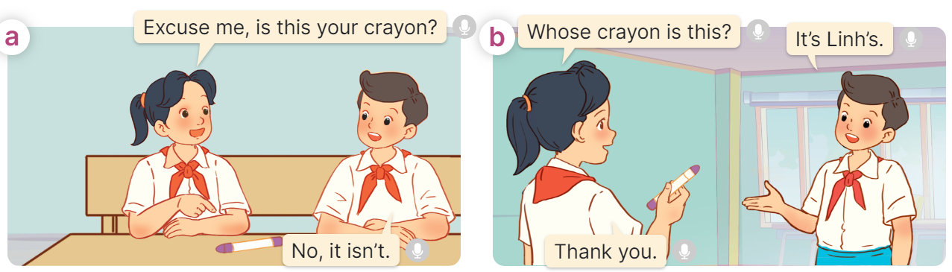  - Play the audio twice (sentence by sentence). Correct their pronunciation where necessary.  - Have Ss to practice the dialogue  - T invites a few pairs to the front of the class to practice.  - T checks pronunciation for ss.  Activity 3 Listen, point and say.  *Aims: Ss will be able to correctly use Whose ____ is this? - It’s ____. to ask and answer questions about possession.  *Procedure:  * Structures:  - T asks Ss look at picture b in activity 1 and helps Ss know the structure from the dialogue.  - T introduces new structures for Ss.  - T explains, models and gives meaning.  - Have Ss repeat the structures  A: Whose crayon is this?  B: It’s Linh’s.  3.Practice: (7’)  *Drill pictures  - Have Ss look at the pictures and elicit the names of characters and their school things. 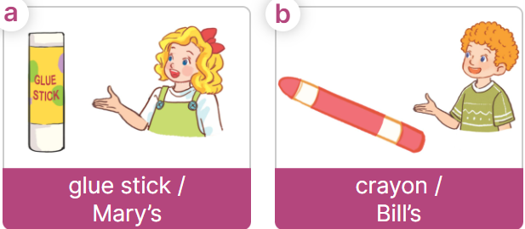  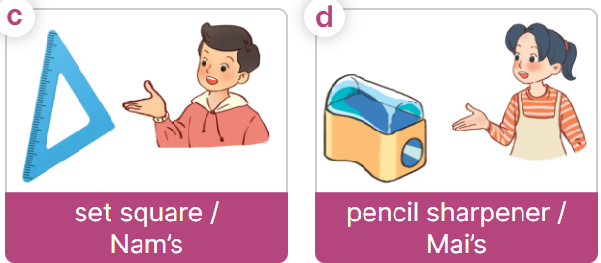  - Have Ss point at pictures, listen and run through all the pictures.  - Have Ss point at the bubbles, listen and run through model sentences.  - Have Ss to practise:  + T asks the first picture, Ss answer  + Ss asks the second picture, T answers  + Group A asks the third picture, group B  answers  + Group B asks the last picture, group A  - Ask Ss to work in pairs to practise asking and answering the Whose ____ is this? - It’s ____.  - T controls and corrects.  - Invite a few pairs to point at the pictures and say the questions and answers in front of the class.  4. Production: (6’)  Activity 4. Let’s talk.  *Aims: Ss will be able to enhance the correct use of What school activity does he/ she like? - He/ she likes……… to ask and answer questions about school activity in freer contexts.  *Procedure:  - Ask Ss to look at the pictures and elicit the context  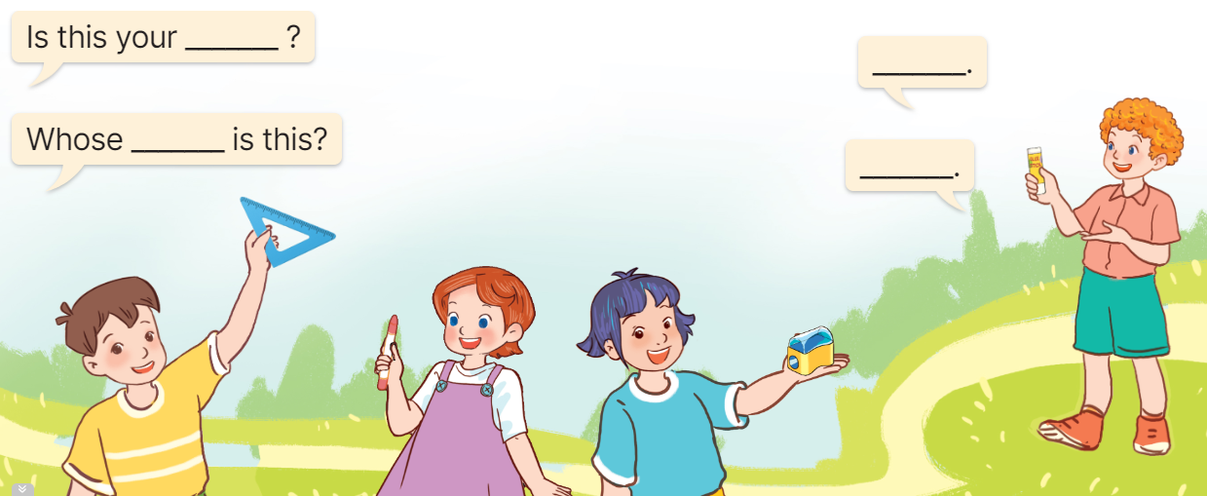  - Point at the boy/ girl and elicit the question in the ﬁrst speech bubble Is this your…..? Whose ……..is this? and the answer in the second speech ……… as an example.  - Give Ss time to work in pairs and take turns pointing at each picture to ask and answer using Is this your…..? Whose ……..is this?  - Invite a few pairs to come to the front of the classroom and act out the exchanges.  5. Fun corner and wrap- up (4’)  Game: Disappear!  - Prepare some pictures (glue stick, crayon, set square, pencil sharpener) and word cards.  - Show the pictures and word cards on the board. Have ss read all the words.  - Disappear one picture and one word card. Have a student come to the board and write the correct word. If he/ she writes it correctly, he/ she will choose the next pair. If he/ she writes it incorrectly, the teacher will show the picture and the word on the board again.  - Praise ss if they write the words correctly. | -Ss listen and pay attention  - Ss listen to the teacher  - Ss play the game  .  - Ss listen and open their books  -Ss listen and answer  - - Ss listen and repeat  + Choral repetition (3 times).  + Individual repetition (3 ss)  - Ss take note  - Ss look and write  -Look at the pictures and say.  + In picture a:  Mai: Excuse me? Is this your crayon?  Nam: No, it isn’t.  + In picture b:  Mai: Whose crayon is this?  Nam: It’s Linh’s.  Mai: Thank you.  -Ss listen and repeat in chorus (twice)  -Ss work in pairs to practice  -Ss come to the front of the classroom to practice.  -Ss listen  - Ss look at the picture and answer.  -Ss listen  -Ss listen and repeat  -Ss repeat to the structures  - Ss look, listen and repeat  +Picture a: Mary’s glue stick  + Picture b: Bill’s crayon  + Picture c: Nam’s set square  + Picture d: Mai’s pencil sharpener  -Ss point at pictures, listen and repeat  -Ss point at the bubbles, listen and repeat  -Ss practice in chorus  -Ss practice in chorus  -Ss work in pairs to practise asking and answering the question  - Pairs of Ss point at the pictures and say in front of the class  -Ss look at the picture and say  Minh holding a set square, Mary holding a crayon, Linh holding a pencil sharpener, Bill holding a glue stick.  - Ss look at the boy/ girl and elicit the missing words in speech bubbles and say the completed sentences.  - Ss role-play to practise asking and answering questions  - Ss practise asking and answering questions in front of the class.  -Ss listen to the teacher  -Ss play the game  -Ss continue to play the game
D. ADJUSTMENTS (if necessary):
………………………………………………………………………………………….…..……………………………………………………………………………...……

