Week 17 Preparing date: …………..……..
Period 65 Teaching date: ………………….

Unit 10: Our school trip
Lesson 2 (4, 5, 6)
A. OBJECTIVES:
By the end of the lesson, Ss will be able to:
1. Knowledge:
- listen to and understand two communicative contexts in which characters ask and answer questions about what they did on their school trips and tick the correct pictures.
- complete two gapped exchanges with the help of picture cues.
- revise the target vocabulary items and structures through the game What did they do there?
- Vocabulary: Review
- Skills: speaking, listening, reading and writing.
2. Competences:
- Communication and collaboration: work in pairs and groups to complete the learning tasks.
- Self-control and independent learning: perform pronunciation and speaking tasks.
3. Attitude/ Qualities:
- Show their pride in famous places of Viet Nam.
- Show their love and interest in school trips.
B. TEACHING AIDS:
- Teacher: Teacher’s guide Pages 161, 162, 163; audio Tracks 102; website hoclieu.vn, posters, laptop, pictures, textbook, lesson plan, TV or projector.
- Students: Student’s book Page 71, notebooks, workbooks, school things.
C. PROCEDURES:
Teacher’s activities | Students’ activities
1.Warm- up and review: (5’)  Game: pass the bag  *Aims: to revise the learned words *Procedure:  - Put some flashcards about places and activities in a bag.  - Have ss sit in a circle.  - Ask ss to pass the bag around the circle while music plays.  - When the music stops, ask the pupil holding the bag to take out a flashcard in the bag and ask a question about the place and invite their friend to answer the question.  - Give stickers if they ask and answer the questions correctly.  - Say “Open your book page 71” and look at “Unit 10, Lesson 2(4,5,6)”.  2.Practice: (25’)  Activity 1. Listen and tick:  *Aims: Ss will be able to listen to and understand two communicative contexts in which characters ask and answer questions about what they did on their school trips and tick the correct pictures.  *Procedure:  - Draw ss’ attention to the pictures and identify the characters. 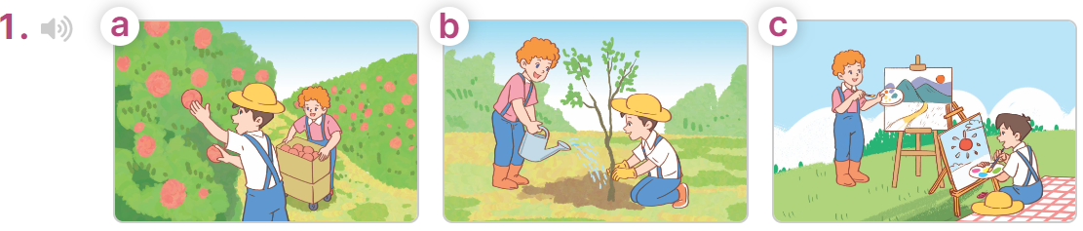  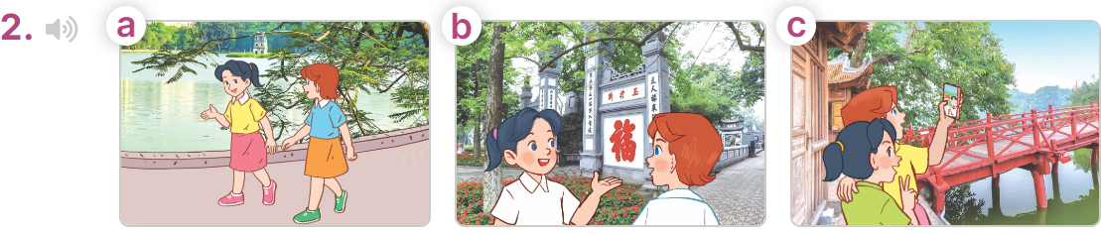  - T ask Ss to guess the answers.  + T writes Ss’guessing on the board.  - Listen to the tape:  + Play the recording  + Play the recording again for pupils to do the task.  + Play the recording a third time for pupils to check their answers.  - Get Ss to swap books with their partner, then check answers as a class.  + Write the answers on the board for Ss to correct their answers. Then checks Ss’ guessing.  - Have Ss to listen and repeat individually and in chorus  Key: 1. b 2. a  Activity 2. Read and complete  *Aims: Ss will be able to complete two gapped exchanges with the help of picture cues.  *Procedure:  - Have Ss look at the pictures and read the question and answer, and guess the missing word in the answer.  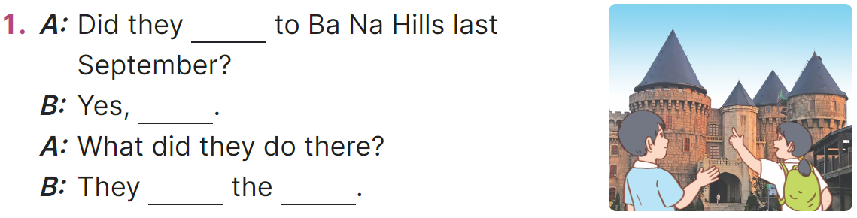  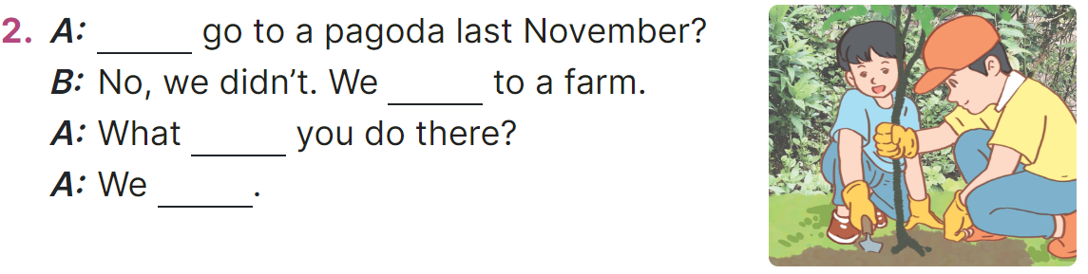  - T models: have Ss read the question and says what words are missing (go)  - Give Ss a time limit to read the gapped dialogues, look at the pictures and do the task independently.  - Get Ss to swap books with a partner and check their answers before checking as a class.  + Invite one student to write the answers on the board.  - Invite two pairs of Ss to act out the completed dialogues.  Key:  1. go; they did; visited; buildings  2. Did; went; did; planted trees  Activity 3. Let’s play  *Aims: Ss will be able to revise target vocabulary items and structures through the game What did they do there?  *Procedure:  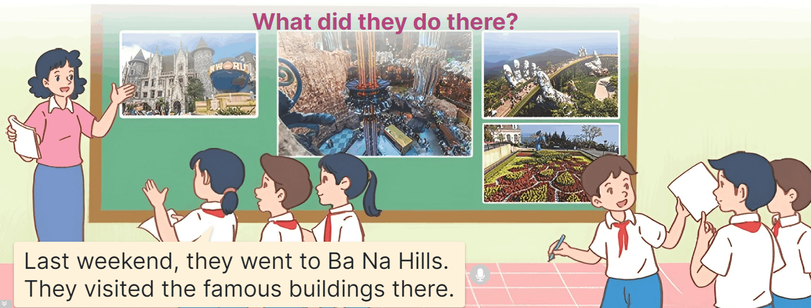  - Explain how the game is played.  - Hang four or six pictures on the board.  + Invite two groups of ss (three or four pupils each) to the front of the class.  + Give ss a time limit to look at the pictures, discuss and make notes of the place they went to and the activities they did.  - Let the group members take turns, pointing at the pictures and telling the class about the place they went to and the activities they did there.  - The group that presents more correct sentences in a short time will win the game.  3. Fun corner and wrap- up (5’)  Game: Throw the dice  - Prepare some pictures about famous places and number them from 1 to 6.  - Invite a volunteer to throw the dice and choose a picture to answer the teacher’s question about activities someone did on a school trip.  - Give stickers to ss if they have correct answers. | -Ss listen to the teacher  -Ss play the game  -Ss play the game  - Ss open their books  -Look at the pictures and say:  + Picture 1a: Bill and Minh picking apples on a farm  + Picture 1b: Bill and Minh planting trees on a farm  + Picture 1c: Bill and Minh painting pictures on a farm  + Picture 2a: Mai and Lucy walking around Hoan Kiem Lake  + Picture 2b: Mai and Lucy walking around Hoan Kiem Lake  + Picture 2c: Mai and Lucy walking around Hoan Kiem Lake  -Ss guess the answers  - Ss listen to the tape  - Ss listen again and do the task.  - Ss listen and check their answers  - Ss swap books with their partner, then check answers as a class and guessing  -Ss write the answer on the board  -Ss listen and repeat  -Ss look at the picture and say  -Ss follow the teacher  - Ss do the task independently.  - Ss swap books with a partner and check their answers.  - Ss write the answers on the board  - Pairs of Ss read the completed dialogues aloud  - Ss listen to the teacher’s explanation.  - Ss look at pictures, discuss and make notes  - The group members take turns, pointing at the pictures and telling the class  -Ss praise the winner  - Ss to the teacher  - Ss play the game  Ex:  1. Ba Na Hills 2. Suoi Tien Theme Park  3. Hoan Kiem lake 4. Thu Le Zoo  5. Opera House 6. Bai Dinh Pagoda
D. ADJUSTMENTS (if necessary):
………………………………………………………………………………………….…..……………………………………………………………………………...…..…

Week 17 Preparing date: ……………..
Period 66 Teaching date: ……….…..

Unit 10: Our school trip
Lesson 3 (1, 2, 3)
A. OBJECTIVES:
By the end of the lesson, Ss will be able to:
1. Knowledge:
- correctly repeat the second stress in the three syllable words No‘vember, De‘cember, andin the sentences We went to Sa Pa last No‘vember. and They visited Da Lat last De‘cember.
- identify the second stress in the three syllable words and check while listening.
- say the chant with the correct pronunciation, stress and rhythm.
- Vocabulary: Review
- Skills: speaking, listening, reading and writing.
2. Competences:
- Communication and collaboration: work in pairs and groups to complete the learning tasks.
- Self-control and independent learning: perform pronunciation and listening tasks.
3. Attitude/ Qualities:
- Show their pride in famous places of Viet Nam.
- Show their love and interest in school trips.
B. TEACHING AIDS:
- Teacher: Teacher’s guide Pages 164, 165, 166; audio Tracks 103, 104, 105; website hoclieu.vn, posters, laptop, pictures, textbook, lesson plan, TV or projector.
- Students: Students’ book Page 72, notebooks, workbooks, school things.
C. PROCEDURES:
Teacher’s activities | Students’ activities
1.Warm- up and review: (5’)  Chain game  *Aims: to revise the previous structures about activities someone did on a school trip.  *Procedure:  - Ask ss to stand up.  - Stick flashcards about places and the phrases about activities on the board  - Model the game. Have the first student ask a question and invite another one to answer that question. Have the student answering the question continue asking the question and so on.  - Have ss play the game until all ss can ask and answer the questions about activities someone did on a school trip.  - Say “Open your book page 72” and look at “Unit 10, Lesson 3 (1,2,3)”.  2. Presentation (9’)  Activity 1. Listen and repeat:  *Aims: Ss will be able to correctly repeat the second stress in the three syllable words No‘vember, De‘cember, and in the sentences We went to Sa Pa last No‘vember. and They visited Da Lat last De‘cember  *Procedure:  - Have Ss point at the words No‘vember, De‘cember with the stress on the second syllable, in isolation and in the sentences We went to Sa Pa last No‘vember. and They visited Da Lat last De‘cember  - Play the recording for Ss to listen and repeat in chorus and individually until they feel confident.  - Let Ss work in pairs or groups, saying the words and reading the sentences.  - T invites some Ss to practice.  3.Practice: (17’)  Activity 2. Circle, listen and check.  *Aims: Ss will be able to identify the second stress in the three syllable words and check while listening  *Procedure:  - Tell Ss circle the word having a different stress from each line. Then listen to the recording to check their answers.  - Set a time for Ss to do the task.  - Play the recording, once or twice, for Ss to listen and check their answers.  - Get Ss to swap books with a partner and check their answers before checking as a class.  - Play the recording again for Ss to double-check their answers.  - Invite a few Ss to read aloud all the words in the words.  Key: 1. Sep‘tember 2. ‘Saturday  3. ba‘nana  Activity 3. Let’s chant  *Aims: Ss will be able to say the chant with correct pronunciation, stress and rhythm.  *Procedure:  - Introduce the title and lyrics of the chant.  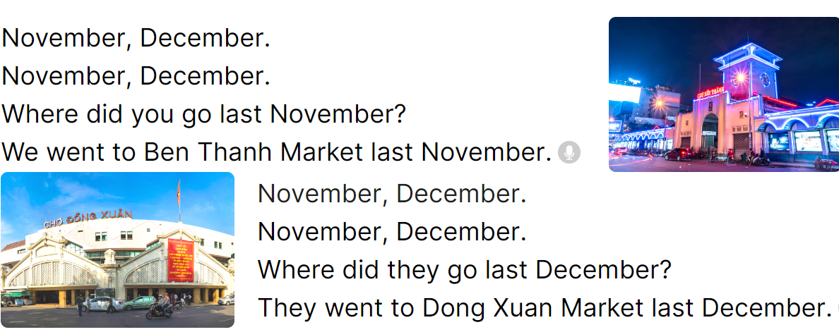  - Play the recording for Ss to listen to the whole chant.  + Have them repeat the title and lyrics line by line.  + Ask Ss to attend to three-syllable words with the stress on the second syllable in the chant, November and December.  - Play the recording all the way through for Ss to listen to pronunciation and melody.  - Play the recording line by line for Ss to listen and repeat  - Play the recording for Ss to chant and clap along.  - Ask Ss to practice chant and clap along in pairs or groups.  - Invite groups to the front of the classroom to perform the chant  3. Fun corner and wrap- up (4’)  Game: Whispering  - Divide the class into two groups.  - Have ss from each group stand in a line.  - The teacher whispers a sentence to the first ss in each row.  - Have the first ss whisper the sentence to the second ss.  - Have groups continue whispering the sentence until it reaches the last ss.  - The last student in the row has to say out the sentence.  - Give the first group to say the sentence correctly one point.  - The group that gets more points wins. Praise the winner. | - Ss follow the T’s instructions.  -Ss pay attention and play the game  Ex:  A: What did you do at Ba Na Hills?  B: I visited the old buildings. What did you do at Suoi Tien Theme park?  C: I played games. ...  D: ...  - Ss open their books  - - Ss point and pay attention  - Ss listen to the recording again and repeat.  -Ss work in pairs and practice  -Ss say the words and sentences  - Ss pay and listen to the teacher’s explanation.  - Ss do the task  - Ss listen to the recording to check their answers (individual)  - Ss swap books with a partner and check the answers  - Ss listen to the recording again and check their answers again.  - Ss stand up and read aloud the words.  - Ss look and listen.  - Ss listen to the chant  - Ss listen and repeat line by line  - Ss note the rhythm and pronunciation.  -Ss listen to melody of the chant  - Ss listen and chant line by line.  - Ss chant and clap along.  - Ss work in groups (two groups) to chant  -Ss perform in front of the class.  -Ss listen to the teacher  -Ss play the game  -Ss play the game  -Ss praise the winner
D. ADJUSTMENTS (if necessary):
………………………………………………………………………………………….…..……………………………………………………………………………...……

Week 17 Preparing date: ……..…..
Period 67 Teaching date: ………..……

Unit 10: Our school trip
Lesson 3 (4, 5, 6)
A. OBJECTIVES:
By the end of the lesson, Ss will be able to:
1. Knowledge:
- read and show understanding of the text by completing the gapped sentences with correct options.
- use the suggested questions to write a gapped text about Mai’s last school trip.
- revise the target language they have learnt by making a mind map of their school trip and presenting it to the class.
- Vocabulary: Review
- Skills: speaking, listening, reading and writing.
2. Competences:
- Communication and collaboration: work in pairs and groups to complete the learning tasks.
- Self-control and independent learning: perform reading and writing tasks.
3. Attitude/ Qualities:
- Show their pride in famous places of Viet Nam.
- Show their love and interest in school trips.
B. TEACHING AIDS:
- Teacher: Teacher’s guide Pages 166, 167; website hoclieu.vn, posters, laptop, pictures, textbook, lesson plan, TV or projector.
- Students: Student’s book Page 73, notebooks, workbooks, school things.
C. PROCEDURES:
Teacher’s activities | Students’ activities
1.Warm- up and review: (5’)  Game: Guessing Places  *Aims: to revise the new words and structures from previous lessons.  *Procedure:  - Divide the class into two groups.  - Ask one student from each group to elicit a sentence about doing an activity and have another group guess the place.  - The group guessing more places wins the game.  - Say “Open your book page 73” and look at “Unit 10, Lesson 3 (4,5,6)”.  2.Practice: (8’)  Activity 1. Read and circle:  *Aims: Ss will be able to read and show understanding of the text by completing the gapped sentences with correct options.  *Procedure:  - Explain that Ss should read the text and choose the correct option to complete the gapped sentences.  - Model the first sentnce: have ss read the sentence and identify the gap and the options given and find the appropriate information from the text to select the correct option (c. Sunday) to complete the gap.  - Set a time limit for ss to do the rest of the task independently.  - Get ss to swap their books with a partner and check their answers before checking as a class.  - Have ss retell or write some sentences about the main ideas of the text  (Ex: They visited a farm near their school last Sunday. They planted trees with the farmers. They watched a film about the farm. They played some games and danced together.)  Key: 1. c, 2. a, 3. b, 4. c  3.Production: (18’)  Activity 2. Let’s write  *Aims: Ss will be able to use the suggested questions to write a gapped text about Mai’s last school trip.  *Procedure:  - Explain that they should answer the suggested questions and use the gapped sentences as a guide to write the text.  - Ask ss to answer the first question (Where did Mai’s class go on their last school trip?) and elicit the place they went for their school trip (ex: Ba Na Hills).  + Have ss write the first sentence of the text  - Give ss time to write the text independently.  - Get ss to swap their books with a partner and check their answers before checking as a class.  - Invite one or two ss to read their completed texts in front of the class.  Key: Pupil’s answer  On Mai’s last school trip, they went to Ba Na Hills. In the morning, they visited the old buildings. In the afternoon, they walked along the Golden Bridge and took photos of the flowers. In the evening, they listened to music and watched the dances. They had a lot of fun.  Activity 3. Project.  *Aims: Ss will be able to revise the target language they have learnt by making a mind map of their school trip and presenting it to the class  *Procedure:  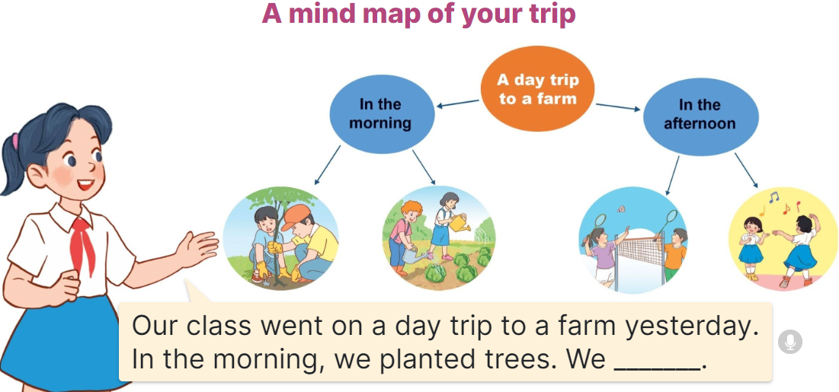  - Explain Ss have to make the mind  map of their school trip at home and present it to their groups.  - Have ss work in groups of five. Each student shows his / her mind map and tells  the group about it.  - Invite a few ss to show their mind maps and tell the class about them. Praise  good performances.  4. Fun corner and wrap- up (4’)  Game: Pass the ball  - T gives Ss a ball.  - T asks Ss to listen to music and transfer a ball around the class.  - When the music stops, Ss who keep a ball have to answer the question using: We went to………….. | - Ss listen  -Ss play game  Ex: A: I played games there. Which place is it?  B: Suoi Tien Theme Park  - Ss open their books  - ass listen to the teacher’s explanation.  - Ss read the text to find the appropriate information from the text to select the correct option to complete the gap.  - Ss do the task independently.  - Ss swap books and check the answers  - Ss retell some sentences about the main ideas of the text.  - Ss listen to the teacher’s explanation.  - Ss answer the first question and elicit the place they went for their school trip.  +Ss write the first sentence  - Ss write the text independently.  - Ss swap their books and check their answers  - Ss read their completed texts  - Ss listen to the teacher’s explanation.  - Ss work in groups and show and tell about his / her mind map of their school trip at home  - Ss show their mind maps and tell the class  Ex: Hi. Our class went on a day trip to a farm yesterday. In the morning, we planted trees. We watered the vegetables. In the afternoon, we played badminton and danced. We had a lot of fun.  -Ss listen to the teacher  -Ss play the game
D. ADJUSTMENTS (if necessary):
………………………………………………………………………………………….…..……………………………………………………………………………...……

Week 17 Preparing date: ………… …….
Period 68 Teaching date: ………………….

Review 2
Parts 1, 2
A. OBJECTIVES:
By the end of the lesson, Ss will be able to:
1. Knowledge:
- listen to and understand five communicative contexts in which characters talk about familiar topics such as our school, our favourite school activities, location of school things, where someone went, what someone did, and tick the correct pictures
- ask and answer questions using picture cues or personal information.
- Vocabulary: Review
- Skills: speaking, listening, reading and writing.
2. Competences:
- Communication and collaboration: work in pairs and teams to complete the learning tasks.
- Self-control and independent learning: perform reading and writing tasks.
3. Attitude/ Qualities:
- Study hard to review the vocabulary and sentence patterns they have learnt.
- Be honest in the learning tasks.
B. TEACHING AIDS:
- Teacher: Teacher’s guide Pages 171, 172, 173; Track 106; website hoclieu.vn, posters, laptop, pictures, textbook, lesson plan, TV or projector.
- Students: Student’s book Page 74, notebooks, workbooks, school things.
C. PROCEDURES:
Teacher’s activities | Students’ activities
1.Warm- up and review: (5’)  Game: Whispering  *Aims: to revise the sentence structures they have learnt.  *Procedure:  - Divide class into 2 groups.  - Ask 5 Ss in each group stand in a straight line.  - T says a word or phrase to the first student in this line.  - Then, the first student whispers what she/ he hear to the second person in line; the second one whispers what he/ she hears to the third one and so on until the last student in group hears the word or phrase.  - The last student says the word or phrase out loud.  - The faster group has correct word or phrase is the winner.  - Say “Open your book page 74” and look at Review 2.  2.Practice: (26’)  Activity 1. Listen and tick:  *Aims: Ss will be able to listen to and understand five communicative contexts in which characters talk about familiar topics such as our school, our favourite school activities, location of school things, where someone went, what someone did, and tick the correct pictures.  *Procedure:  - Draw Ss’ attention to the pictures and elicit the informations  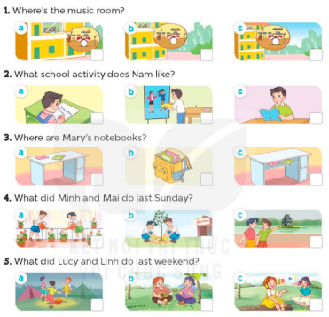  - Play the recording for Ss to do the task. (three times)  - Get Ss to swap books with a partner, then check answers as a class.  - Write the correct answers on the board.  - Play the recording for S to double-check their answers.  - Play the recording, have Ss listen and repeat in chorus.  Key: 1. a 2. a 3. c 4. b 5. a  Activity 2. Ask and answer:  *Aims: Ss will be able to ask and answer questions using picture cues personal information.  *Procedure:  - Draw ss’ attention to look at the picture, the questions and elicit the answer.  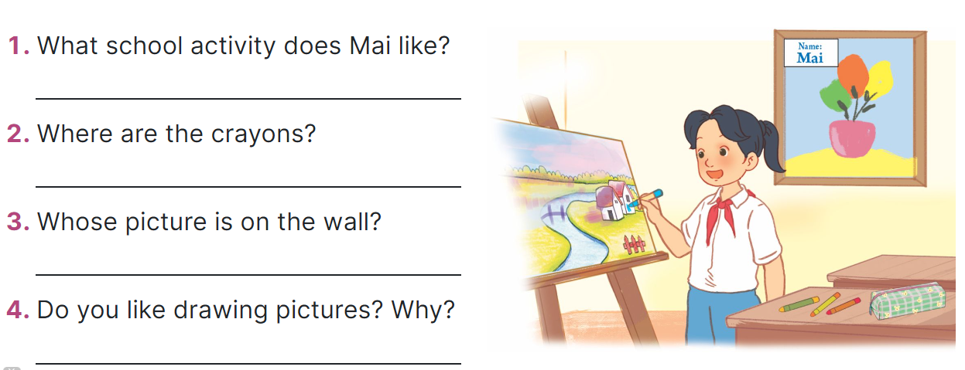  - Have Ss look at the picture to answer the question.  - Have Ss work in pairs to role-play the four exchanges.  - Invite pairs of Ss to stand up and take it in turns to role-play the target exchanges.  Suggested answers:  1. She likes drawing pictures.  2. They’re on the desk.  3. It’s Mai’s.  4. For example: Yes, I do. Because I think it’s interesting.  3. Fun corner and wrap- up (4’)  Game: “Pass the ball”  - Give two different colored balls to two pupils, a blue ball (ask the question) and a white ball (answer the question).  - Ask Ss to listen to music and pass the balls.  - Stop music suddenly. Have the student with a blue ball make a question. Have the student with a white ball answer the question.  - Repeat the game several times. | - Ss listen  -Ss play game  -Ss play game  -Ss praise the winner  - Ss open their books  - Ss listen and say  + Picture 1a: a music room on 1st floor  + Picture 1b: a music room on 2nd floor  + Picture 1c: a music room on 3rd floor  + Picture 2a: Nam doing maths  + Picture 2b: Nam doing crafts  + Picture 2c: Nam reading a book  + Picture 3a: two notebooks on a desk  + Picture 3b: two notebooks in a school bag  + Picture 3c: two notebooks in a desk  + Picture 4a: Minh and Mai watering the flowers  + Picture 4b: Minh and Mai planting trees  + Picture 4c: Minh and Mai walking around Hoan Kiem Lake  + Picture 5a: Lucy and her friends dancing  + Picture 5b: Lucy and Linh playing the guitar and singing  + Picture 5: Lucy and Linh listening to music  - Ss listen to the recording and do the task.  - Ss swap books with a partner, then check answers as a class.  - Ss listen to the recording to double-check their answers.  - Sls listen to the recording and repeat  -Look at the pictures and say  - Ss look at and answer.  - Ss work in pairs to role play  - Ss role play  -Ss listen to the teacher  -Ss play the game  Ex: A: Where did you go last Sunday?  B: I went to Ba Na Hills  -Ss continue playing the game.
D. ADJUSTMENTS (if necessary):
………………………………………………………………………………………….…..……………………………………………………………………………...…….

