Week 21 Preparing date: January 21st 2024
Period 81 Teaching date: January 30th 2024,

Unit 12: JOBS
Lesson 2 (1, 2, 3)
I. OBJECTIVES:
By the end of the lesson, Ss will be able to:
1. Knowledge:
- understand and correctly repeat the sentences in two communicative contexts (pictures) to ask and answer questions about someone’s job.
- correctly say the words and use Is he / she …………? and Yes, he / she is. / No, he / she isn’t. to ask and answer questions about someone’s job.
- enhance the correct use of Is he / she ………? – Yes, / No, ………..to ask and answer questions about someone’s job in a freer context.
- Vocabulary: cook, farmer, singer, nurse
- Model sentences:
A: Is he / she a cook?
B: Yes, he / she is. / No, he / she isn’t. He’s/ She’s….
- Skills: speaking and listening
2. Competences:
- Critical Thinking: talk about jobs
- Co-operation: ready to help friends in pair work/ group work.
- Oral Communication: speak about someone, ask and answer the questions
3. Attitude/ Qualities:
- Kindness: Help partners to complete learning tasks.
- Honesty: tell the truth about feelings and emotions
II. TEACHING AIDS:
- Teacher: Teacher’s guide Pages 154, 155; audio Tracks 16,17, website sachmem.vn, posters, laptop, pictures, textbook, lesson plan, TV or projector.
- Students: Pupil’s book Page 14, notebooks, workbooks, school things.
III. PROCEDURES:
Stages/Time | Teacher’s activities | Students’ activities
1.Warm- up:  (3’)  2. Presentation  (16’)  3.Practice: (7’)  4.Production: (7’)  5. Homework. (2’) | Game: Pass the ball  *Aims: to create a friendly and active atmosphere in the class to beginning the lesson.  *Procedure:  - T gives Ss a ball.  - T asks Ss to listen to music and transfer a ball around the class.  - When the music stops, Ss who keep a ball have to practice with partner using: What’s his/ her job? and He’s/ She’s……..  - T gives feedback.  - Say “Open your book page 8” and look at “Unit 12, Lesson 2 (1,2,3)”.  Activity 1. Vocabulary.  *Aims: Ss will be able to know the vocabulary in front of starting the new lesson.  *Procedure:  -T elicits the new words  + cook : đầu bếp (picture)  + farmer : nông dân (picture)  + singer : ca sĩ (picture)  + nurse : y tá (picture)  - T models (3 times).  - T writes the words on the board.  - Checking: Rub out and remember  Activity 2. Listen, point and repeat:  *Aims: Ss will be able to understand and correctly repeat the sentences in two communicative contexts (pictures) to to ask and answer questions about someone’s job.  *Procedure:  - Have Ss look at Pictures a and b and identify the characters and jobs in the pictures.  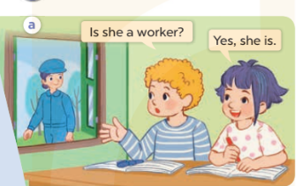  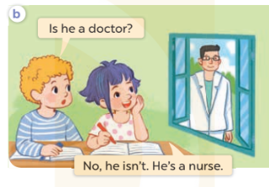  - Play the audio twice (sentence by sentence). Correct their pronunciation where necessary.  - Have Ss to practice the diaguage  - T invites a few pairs to the front of the class to practice.  - T checks pronunciation for ss.  Activity 3. Listen, point and say.  *Aims: Ss will be able to correctly say the words and use Is he / she ………? and Yes, he / she is. / No, he / she isn’t. to ask and answer questions about someone’s job.  *Procedure:  * Model sentences:  - T asks Ss look at picture a, b and helps Ss know the structure from the dialogue.  - T introduces new structure for Ss.  - T explains, models and gives meaning.  - Have Ss repeat the model sentences.  A: Is he / she a cook?  B: Yes, he / she is. / No, he / she isn’t.  *Drill pictures  - Elicit and check comprehension the name of each character.  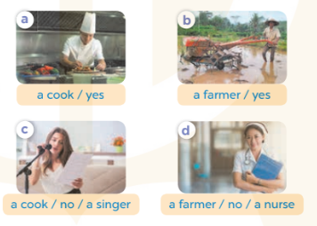  - Run through all the pictures.  - Run through model sentences.  +Run through the question sentences  +Run through the answer sentences  - Have Ss to practise:  + T asks, Ss answer picture a  + Ss ask, T answers picture b  + Group A ask, group B answer picture c  + Group B ask, group A answer picture d  - Ask Ss to work in pairs.  - T controls and corrects.  - Invite a few pairs to come to the front of the classroom, point at the relevant character in each picture, and act out his/her role.  - T gives feedbacks.  Activity 4. Let’s talk.  *Aims: Ss will be able to enhance the correct use of Is he / she ……….? – Yes, / No, ………. to ask and answer questions about someone’s job in a freer context.  *Procedure:  - Have Ss look at the pictures and elicit the jobs  + What can you see in the picture?  +Who are they?  +What’s his/ her job?  - T fills the gaps and writes the sentences on the board.  - T models  - T asks Ss use of Is he / she ……….? – Yes, / No, ………. to ask and answer (groups of four)  - Invite some groups to perform.  - Give feedbacks  *Consolidation  *Aims: Ss will be able consolidate and wrap up the content of the lesson.  *Procedure:  - T asks ss to answer the following questions:  + What have you learnt from the lesson today?  +What are the core values of the lesson? (if the teacher can take from the lesson).  - T review the vocabulary and model sentences.  - T praises some Ss who are hardworking / active/ good…. as well as encourage others to try more.  - Learn the number by heart  - Prepare the new lesson: Unit 12, Lesson 2 (4,5,6). | - Ss listen and keep the ball  - Ss listen to music and play the game  - Ss open their books  -Ss listen and answer  - - Ss listen and repeat  + Choral repetition (3 times).  + Individual repetition (3 ss)  - Ss take note  - Ss look, remember and write  -Look at the pictures and get to know the characters in the pictures.  + In picture a: Bill asks Is she a worker? And Linh answers Yes, she is.  – In picture b: Bill asks Is he a doctor?. And Linh answers No, he isn’t. He’s a nurse.  -Ss listen and repeat in chorus (twice)  -Ss work in pairs to practice  -Ss practice the diaguage  -Ss listen  -Ss look at the picture and answer.  -Ss listen  -Ss listen and repeat  -Ss repeat  - Ss look, listen and answer  + Picture a: a cook / yes + Picture b: a farmer / yes  + Picture c: a cook / no / a singer  + Picture d: a farmer / no / a nurse  -Ss practice in chorus  - Ss practice in chorus  -Ss work in pairs to practice  -Ss listen  -Ss point and say  -Ss go to the board and rold play.  -Ss listen  -Ss look at the picture and answer  + farmer, nurse, singer and cook  -Ss note  - Ss say the completed sentences.  -Ss work in groups  -Ss perform in front of the class.  -Ss answer the questions  - Ss listen  -Ss listen and clap their hands  -Ss listen and take note

IV. ADJUSTMENTS (if necessary):
………………………………………………………………………………………….…..……………………………………………………………………………...………………………………………….…..……………………………………………………………………………….……………………………………………………………………...

---------------------------------------------------------------------

Week 21 Preparing date: January 21st 2024
Period 82 Teaching date: January 30th 2024,

Unit 12: JOBS
Lesson 2 (4, 5, 6)
I. OBJECTIVES:
By the end of the lesson, Ss will be able to:
1. Knowledge:
- listen to and understand four communicative. contexts to ask and answer questions about someone's job and number the correct pictures.
- correctly the four gapped dialogues with the help of the picture cues.
- revise the target vocabulary and sentence patterns by playing the game Clap for ‘yes’.
- Vocabulary: Review
- Skills: speaking, listening, reading and writing.
2. Competences:
- Critical Thinking: talk about someone
- Co-operation: ready to help friends in pair work/ group work.
- Self-control and independent learning: perform listening tasks.
3. Attitude/ Qualities:
- Kindness: Help partners to complete learning tasks.
- Honesty: tell the truth about feelings and emotions.
- Diligence: complete learning tasks.
II. TEACHING AIDS:
- Teacher: Teacher’s guide Pages 156, 157; audio Tracks 18; website sachmem.vn, posters, laptop, pictures, textbook, lesson plan, TV or projector.
- Students: Pupil’s book Page 15, notebooks, workbooks, school things.
III. PROCEDURES:
Stages/Time | Teacher’s activities | Students’ activities
1.Warm- up:  (5’)  2.Practice: (27’)  3. Homework. (3’) | Sing a song: “throw the ball”  *Aims: to create a friendly and active atmosphere in the class to beginning the lesson.  *Procedure:  - Divide the class into 2 teams.  - Stick the pictures of jobs on the board.  + T says a word, a pupil from each team has to point/throw the ball to the right picture and says the word three times.  + The one says faster will get points.  - Encourage Ss to take part in the game.  - Give points for Ss.  - Say “Open your book page 15” and look at “Unit 12, Lesson 2 (4,5,6)”.  Activity 1. Listen and number:  *Aims: Ss will be able to listen to and understand four communicative contexts to ask and answer questions about someone's job and number the correct pictures.  *Procedure:  - Elicit the names and jobs of the characters in the pictures.  - Point at the pictures respectively to explain the context.      - T ask Ss to guess the answers.  + T writes Ss’guessing on the board.  - Listen to the tape:  + Play the recording  + Play the recording again and get Ss to swap books with their partners.  + Play the recording again to check answers together as a class.  + Write the answers on the board for Ss to correct their answers. Then checks Ss’ guessing.  - Play the recording, sentence by sentence, for the class to listen and repeat in chorus.  Key: 1.d 2. b 3. a 4. c  Activity 2. Look, complete and read.  *Aims: Ss will be able to complete four gapped dialogues with the help of picture cues.  *Procedure:  - Have Ss look at the pictures and ask identify the jobs in the pictures.  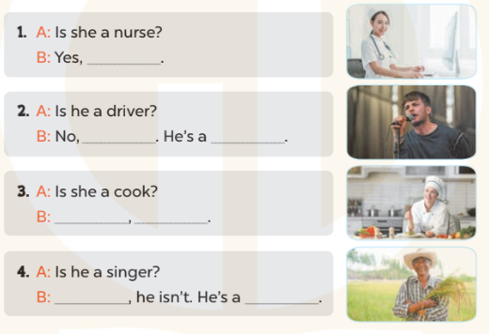  - T models with sentence 1.  + Have Ss look at the sentence.  + Ask them what is missing in the answer (she is).  + Have Ss complete the gap.  + Have Ss read the completed sentence in chorus.  -Have Ss work in pairs and complete the sentences 2, 3 and 4.  - Invite pairs of pupils to stand up and read aloud the sentences.  -T gives feedbacks.  Key: 1. she is 2. he isn't; singer  3. Yes, she is 4. No; farmer  Activity 3. Let’s play.  *Aims: Ss will be able to revise the target vocabulary and sentence patterns by playing the game Clap for ‘yes’.  *Procedure:  - Hold up a flash card for driver and ask Ss Is he a driver? and elicit the answer Yes, he is. Ask Ss to clap their hands and repeat the answer.  -Ask Ss to clap their hands and say Yes, he / she is. if the answer is Yes.  - Keep holding a flash card for driver and ask another question to elicit No, he isn’t. Ask Ss to stamp their feet and repeat the answer. Ask Ss to stamp their feet and say No, he / she isn’t. if the answer is No.  - Repeat the procedure with the other flash cards.  - Invite a few Ss to the front of the class and ask questions.  *Consolidation  *Aims: Ss will be able consolidate and wrap up the content of the lesson.  *Procedure:  - T asks ss to answer the following questions:  + What have you learnt from the lesson today?  +What are the core values of the lesson? (if the teacher can take from the lesson).  - T praises some Ss who are hardworking / active/ good…. as well as encourage others to try more.  - Prepare the new lesson: Unit 12, Lesson 3 (1,2,3). | - Ss listen and play the game  - Ss open their books  -Look at the pictures and say:  + Picture a: a nurse  + Picture b: a cook  + Picture c: a singer  + Picture d: a farmer  -Ss guess the answers  - Ss listen to the tape and write number  - Ss listen again, write number and swap books with their partners.  - Ss check their answers and guessing  -Ss listen and repeat.  -Ss look at the pictures and say  -Ss listen and answer  -Ss read and complete  -Ss work in pairs  -Ss read  - Ss listen  -Ss play the game  - Ss play the game  -Ss listen and answer  -Ss listen and take note

IV. ADJUSTMENTS (if necessary):
………………………………………………………………………………………….…..……………………………………………………………………………...………………………………………….…..……………………………………………………………………………….……………………………………………………………………...

--------------------------------------------------------

Week 21 Preparing date: January 21st 2024
Period 83 Teaching date: February 1st 2024
Unit 12: JOBS
Lesson 3 (1, 2, 3)
I. OBJECTIVES:
By the end of the lesson, Ss will be able to:
1. Knowledge:
- correctly repeat the sounds of the letters er and or in isolation, the words mother and doctor and the sentences My mother is a teacher and My father is a doctor with the correct pronunciation and intonation.
- identify the target words mother and doctor while listening.
- say the chant with the correct rhythm and pronunciation.
- Vocabulary: Review
- Skills: speaking, listening, reading and writing.
2. Competences:
- Co-operation: ready to help friends in pair work/ group work.
- Self-control and independent learning: perform listening tasks.
3. Attitude/ Qualities:
- Kindness: Help partners to complete learning tasks.
- Honesty: tell the truth about feelings and emotions
II. TEACHING AIDS:
- Teacher: Teacher’s guide Pages 157, 158; audio Tracks 19, 20, 21; website sachmem.vn, posters, laptop, pictures, textbook, lesson plan, TV or projector.
- Students: Pupil’s book Page 16, notebooks, workbooks, school things.
III. PROCEDURES:
Stages/Time | Teacher’s activities | Students’ activities
1.Warm- up:  (5’)  2. Presentation  (9’)  3.Practice: (19’)  4. Homework. (2’) | Game: Find and circle the words  *Aims: to create a friendly and active atmosphere in the class to beginning the lesson.  *Procedure:  D B K K E P S C F T  O C T H N E H C A H  C L U A A E A O T I  T E L N F C T S H N  O A W K A I O I E K  R C O O R C I S R B  S R O E M C V T A H  M O T H E R S E A Y  D T S S R S O R S M  A C E B F A Z Y W  - Divide class into 2 groups  - Ask Ss to find and circle the words that they learnt.  - Which groups find the best correct words is winner.  - Give Ss time to play the game.  Rows: mother  Columns: doctor, farmer, sister, father  -T checks who’s winner?  - Say “Open your book page 17” and look at “Unit 12, Lesson 3 (1,2,3)”.  Activity 1. Listen and repeat:  *Aims: Ss will be able to correctly pronounce the sounds of the letters er and or in isolation, in the words mother and doctor, and in the sentences My mother is a teacher and My father is a doctor with correct pronunciation and intonation.  *Procedure:  - T gives instruction to the er and or in isolation, in the words mother and doctor, and in the sentences My mother is a teacher and My father is a doctor.  - Play the recording for the letter er, or.  - Encourage Ss to point at the letter/ word/ sentence while listening.  - Play the recording again and encourage Ss to listen and repeat.  - Do this several times until Ss feel confident.  - T calls some Ss to practice.  - T gives feedbacks.  Activity 2. Listen and circle.  *Aims: Ss will be able to identify the target words mother and doctor while listening.  *Procedure:  - Elicit the sentences and explain that they have to listen.  - T ask Ss to guess the answers.  + T writes Ss’guessing on the board.  - Listen to the tape:  + Play the recording  + Play the recording again and get Ss to swap books with their partners.  + Play the recording again to check answers together as a class.  + Write the answers on the board for Ss to correct their answers. Then checks Ss’ guessing.  - Play the recording, sentence by sentence, for the class to listen and repeat in chorus.  - Invite one or two Ss to stand up and read the completed sentences.  Key: 1.b 2.b  Activity 3. Let’s chant  *Aims: Ss will be able to say the chant with the correct rhythm and pronunciation.  *Procedure:  - Introduce the title and lyrics of the chant.  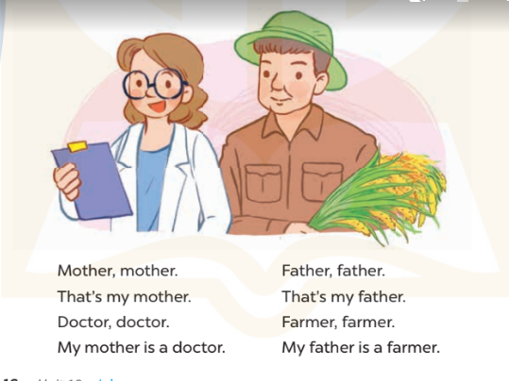  - Play the recording for Ss to listen to the whole chant.  + Have them repeat the title and lyrics line by line.  + Ask Ss to attend to the sounds of the letters er and or and the words mother and doctor.  - Play the recording all the way through for Ss to listen to pronunciation and melody.  - Play the recording line by line for Ss to listen and repeat  - Play the recording for Ss to chant and clap along.  - Ask Ss to practice chant and clap along in pairs or groups.  - Invite groups to the front of the classroom to perform the chant  -T gives feedback.  *Consolidation  *Aims: Ss will be able consolidate and wrap up the content of the lesson.  *Procedure:  - T asks ss to answer the following questions:  + What have you learnt from the lesson today?  +What are the core values of the lesson? (if the teacher can take from the lesson).  - T praises some Ss who are hardworking / active/ good…. as well as encourage others to try more.  - Practice the chant more.  - Prepare the new lesson: Unit 12, Lesson 3 (4,5,6). | - Ss listen  -Ss play game  - Ss open their books  - Ss recognize the differences about color of letter  - - Ss listen  - Ss listen and point  - Ss listen again and repeat  -Ss listen again and repeat  -Ss practice  -Ss listen  -Ss listen and say:  + Number 1:  a. My father is a doctor.  b. My mother is a teacher.  + Number 2:  a. Is your mother a cook?  b. Is your father a doctor?  -Ss guess the answers  - Ss listen to the tape and circle  - Ss listen again, circle and swap books with their partners.  - Ss check their answers and guessing  -Ss listen and repeat.  -Ss read the sentences  - Ss look and listen.  -Ss listen to the chant  - Ss listen and repeat line by line without clap their hands  -Ss note the sounds, words  -Ss listen to melody of the chant  - Ss listen and chant line by line.  - Ss chant and clap along.  - Ss work in groups (two groups) to chant  -Ss perform in front of the class.  -Ss listen  -Ss listen.  -Ss answer the questions  -Ss listen and clap their hands  -Ss listen and take note
IV. ADJUSTMENTS (if necessary):
………………………………………………………………………………………….…..……………………………………………………………………………...………………………………………….…..……………………………………………………………………………….……………………………………………………………………...

-------------------------------------------------------------

Week 21 Preparing date: January 21st 2024
Period 84 Teaching date: February 1st 2024
Unit 12: JOBS
Lesson 3 (4, 5, 6)
I. OBJECTIVES:
By the end of the lesson, Ss will be able to:
1. Knowledge:
- read and complete a table about the jobs of the family members.
- read and complete a paragraph about the pupils’ parents’ jobs.
- make a mind map about family members and present it to the class.
- Vocabulary: Review
- Skills: speaking, listening, reading and writing.
2. Competences:
- Critical Thinking: talk about jobs
- Co-operation: ready to help friends in pair work/ group work.
- Self-control and independent learning: perform reading tasks.
3. Attitude/ Qualities:
- Kindness: Help partners to complete learning tasks.
- Honesty: tell the truth about feelings and emotions.
- Diligence: complete learning tasks.
II. TEACHING AIDS:
- Teacher: Teacher’s guide Pages 159, 160, website sachmem.vn, posters, laptop, pictures, textbook, lesson plan, TV or projector.
- Students: Pupil’s book Page 17, notebooks, workbooks, school things.
III. PROCEDURES:
Stages/Time | Teacher’s activities | Students’ activities
1.Warm- up:  (5’)  2.Practice: (8’)  3.Production: (19’)  4. Homework. (3’) | Game: Guessing  *Aims: to review the vocabulary and structure about greet and respond to greetings.  *Procedure:  - Divide the class into 4 teams.  - Look at the cards (1-8), there are pictures behind them.  + Let Ss guess the pictures then say aloud the job.  + Who can make it will have points for the team. (Spin the lucky wheel to get the points)  - Encourage Ss to take part in the game and practice speaking English.  - Give points for Ss.  - Say “Open your book page 11” and look at “Unit 12, Lesson 3 (4, 5, 6)”.  Activity 1. Read and complete:  *Aims: Ss will be able to read and complete a table about the jobs of the family members.  *Procedure:  - Tell Ss about the context of the paragraphs: Minh and Mary introduce their families.  - Point at the table and elicit the type of information they need to find in the texts.  - Ask Ss attend to the blank in number 1 and find the missing word.  - Write the missing word on the board and get the class to read the completeed sentence together.  - Have Ss work in pairs and complete  - Tell Ss to swap books with a partner, then check answers together as a class.  - Write the correct answers on the board for pupils to correct their answers.  - Invite Ss to read the complete text aloud  -T gives feedbacks.  Key: 1. cook 2. pupil  3. nurse 4. driver  Activity 2. Let’s write  *Aims: Ss will be able to read and complete a paragraph about the pupils’ parents’ jobs.  *Procedure:  - Explain to the class the goal of this activity.  - Ask Ss to read each gapped sentence, guess the missing information and complete the sentence with their own personal information.  - Give Ss time to write their answers  - Ask Ss to swap and correct their answers in pairs.  - Check the answers as a class.  Key: Pupils’ answer.  Activity 3. Project.  *Aims: Ss will be able to make a mind map about family members and present it to the class.  *Procedure:  - Point at the sample mind map and explain that a Ss is going to introduce the jobs of their parents to their friends.  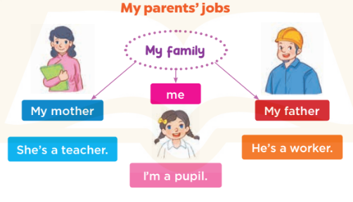  - Have Ss show the mind map that they have prepared for the project.  -Revise some structures and vocabulary that Ss need for their presentations.  +Example: Hello, everyone. My name’s Huong. I’m nine years old. This is my family. There are three people in my family. This is my father. He is a worker. That’s my mother. She’s a teacher. And me, I’m a pupil.  - Give Ss time to practise their presentations by themselves.  - Give Ss time to practise presenting their mind maps within their groups.  - Select a few Ss to present their mind maps to the class if there is enough time.  - Create a class display of the projects and organise a vote to find the most beautiful ones.  *Consolidation  *Aims: Ss will be able consolidate and wrap up the content of the lesson.  *Procedure:  - T asks ss to answer the following questions:  + What have you learnt from the lesson today?  +What are the core values of the lesson?  - T praises some Ss who are hardworking / active/ good…. as well as encourage others to try more.  - Prepare the new lesson: Unit 13: Lesson 1 (1,2,3). | - Ss listen  -Ss play game  - Ss open their books  -Ss listen  - Ss read and answer  -Ss read and complete  -Ss write the first word  -Ss work in pairs  -Ss swap books and check  -Ss check the correct their answers  -Ss read  -Ss listen  -Ss listen  -Ss read and answer  -Ss write  This is a photo of my family. My mother is……………….  My father is………………..  I am………………………..  -Ss swap books and check their answers  -Ss check  -Ss listen  -Ss listen and show the mind map  -Ss work in groups  -Ss show the picture and say.  -Ss perform in front of the class.  -Ss vote the most beautiful ones  -Ss answer the questions  -Ss listen and clap their hands  -Ss listen and take note
IV. ADJUSTMENTS (if necessary):
………………………………………………………………………………………….…..……………………………………………………………………………...…………
………………………………………………………………………………………….…..……………………………………………………………………………...…………

