Week 22 Preparing date: February 5th 2024
Period 85 Teaching date: February 15th 2024,

Unit 13: My house
Lesson 1 (1, 2, 3)
I. OBJECTIVES:
By the end of the lesson, Ss will be able to:
1. Knowledge:
–use the words living room, bedroom, kitchen, bathroom, here, there
–use Where’s the……….? – It’s here/ there. to ask and answer questions about the location of a room in a house
- Vocabulary: living room, bedroom, kitchen, bathroom, here, there
- Model sentences:
A: Where’s the……….?
B: It’s here/ there.
- Skills: speaking and listening
2. Competences:
- Critical Thinking: talk about house
- Co-operation: ready to help friends in pair work/ group work.
- Sociability: Talk to each other, say good words to others.
3. Attitude/ Qualities:
- Kindness: Help partners to complete learning tasks.
- Honesty: tell the truth about feelings and emotions
II. TEACHING AIDS:
- Teacher: Teacher’s guide Pages 161, 162, audio Tracks 22, 23, website sachmem.vn, posters, laptop, pictures, textbook, lesson plan, TV or projector.
- Students: Pupil’s book Page 18, notebooks, workbooks, school things.
III. PROCEDURES:
Stages/Time | Teacher’s activities | Students’ activities
1.Warm- up:  (3’)  2. Presentation  (16’)  3.Practice: (7’)  4.Production: (7’)  5. Homework. (2’) | Game: jigsaw puzzle  *Aims: to create a friendly and active atmosphere in the class to beginning the lesson.  *Procedure:  - Divide class into 4 groups: Doreamon, Nobita, Xuka and Xeko.  - Ask Ss look at the pieces of picture.  - Ask Ss go to the board and jigsaw puzzle into the correct picture  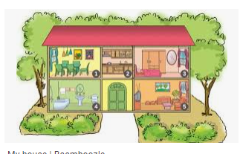  -T checks who’s the winner?  - Ask Ss look at the pieces of picture  - Say “Open your book page 18” and look at “Unit 13, Lesson 1 (1,2,3)”.  Activity 1. Vocabulary.  *Aims: Ss will be able to know the vocabulary in front of starting the new lesson.  *Procedure:  -T elicits the new words  + living room : phòng khách  (picture)  + bedroom : phòng ngủ (situation)  + kitchen : phòng bếp (picture)  + bathroom : phòng tắm (picture)  + house : ngôi nhà (translation)  + here : ở đây (situation)  + there : ở kia (translation)  - T models (3 times).  - T writes the words on the board.  - Checking: Rub out and remember  Activity 2. Listen, point and repeat:  *Aims: Ss will be able to understand and correctly repeat the sentences in two communicative contexts (pictures) focusing on asking and answering about the location of a room in a house.  *Procedure:  - Have Ss look at Pictures a and b and identify the characters in the pictures.  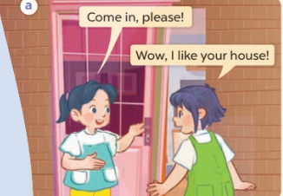  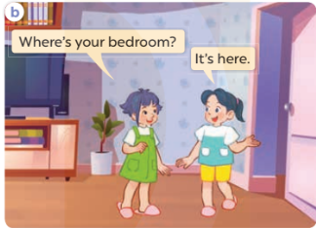  - Play the audio twice (sentence by sentence). Correct their pronunciation where necessary.  - Have Ss to practice the dialogue  - T invites a few pairs to the front of the class to practice.  - T checks pronunciation for ss.  Activity 3 Listen, point and say.  *Aims: Ss will be able to correctly say the words and use Where’s the……..? − It’s here / there. to ask and answer questions about the location of a room in a house.  *Procedure:  * Model sentences:  - T asks Ss look at picture a , b and helps Ss know the structure from the dialogue.  - T introduces new structure for Ss.  - T explains, models and gives meaning.  -Have Ss repeat the model sentences.  A: Where’s the bedroom?  B: It’s here/ there.  *Drill pictures  - Elicit and check comprehension the name of the rooms.  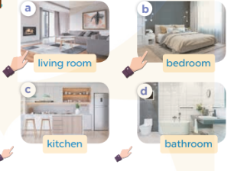  - Run through all the pictures.  - Run through model sentences.  + Run through the questions.  + Run through the answers  - Have Ss to practise:  + T says asks and Ss answer (change role).  + Ss – Ss (change role).  - Ask Ss to work in pairs.  - T controls and corrects.  - Invite a few pairs to come to the front of the classroom, point at the relevant character in each picture, and act out his/her role.  - Encourage Ss to practise speaking English.  - T gives feedbacks.  Activity 4. Let’s talk.  *Aims: Ss will be able to enhance the correct use of Where’s the……? − It’s here / there. to ask and answer questions about the location of a room in a house in a freer context.  *Procedure:  - T asks ss to guess each character and what the children say.  + What can you see in the picture?  +How many rooms are there in the picture?  +What rooms are they?  +Where’s the ……….?  - T fills the gaps and writes the sentences on the board.  - T models  - T asks Ss to work in pairs to ask and answer  - Invite some pupils to the front of the class to present their exchanges.  - Give feedbacks  *Consolidation  *Aims: Ss will be able consolidate and wrap up the content of the lesson.  *Procedure:  - T asks ss to answer the following questions:  + What have you learnt from the lesson today?  - T review the vocabulary and model sentences.  - T praises some Ss who are hardworking / active/ good…. as well as encourage others to try more.  - Learn the number by heart  - Prepare the new lesson: Unit 13, Lesson 1 (4,5,6). | - Ss listen  - Ss play the game  - Ss open their books  -Ss listen and answer  - - Ss listen and repeat  + Choral repetition (3 times).  + Individual repetition (3 ss)  - Ss take note  - Ss look, remember and write  -Look at the pictures and get to know the characters in the pictures.  + Mai says Come in, please!Linh says Wow, I like your house! in picture a.  + Linh asks Where’s your bedroom? Mai answers It’s here. in picture b.  -Ss listen and repeat in chorus (twice)  -Ss work in pairs to practice  -Ss practice the dialogue  -Ss listen  -Ss look at the picture and answer.  -Ss listen  -Ss listen and repeat  -Ss repeat  - Ss look, listen and repeat  -Ss practice in chorus  -Ss work in pairs to practice  -Ss point and say  -Ss listen.  -Ss listen  -Ss look at the picture and answer  +I can see a house  + There are four rooms  + They are living room, kietchen, bedroom, bathroom.  + It’s here/ there  -Ss note  - Ss say the completed sentences.  -Ss work in pairs  -Ss perform in front of the class.  -Ss answer the questions  - Ss listen  -Ss listen and clap their hands  -Ss listen and take note

D. ADJUSTMENTS (if necessary):
………………………………………………………………………………………….…..……………………………………………………………………………...………………………………………….…..……………………………………………………………………………….……………………………………………………………………...

Week 22 Preparing date: February 5th 2024
Period 86 Teaching date: February 15th 2024
Unit 13: My house
Lesson 1 (4, 5, 6)
I. OBJECTIVES:
By the end of the lesson, Ss will be able to:
1. Knowledge:
- listen to and understand simple exchanges in relation to the topic “My house”
- read and write about the location of rooms in a house and things in a room.
- Vocabulary: Review
- Skills: speaking, listening, reading and writing.
2. Competences:
- Co-operation: ready to help friends in pair work/ group work.
- Self-control and independent learning: perform listening tasks.
3. Attitude/ Qualities:
- Kindness: Help partners to complete learning tasks.
- Honesty: tell the truth about feelings and emotions.
- Diligence: complete learning tasks.
II. TEACHING AIDS:
- Teacher: Teacher’s guide Pages 163, 164; audio Tracks 24, 25; website sachmem.vn, posters, laptop, pictures, textbook, lesson plan, TV or projector.
- Students: Pupil’s book Page 19, notebooks, workbooks, school things.
III. PROCEDURES:
Stages/Time | Teacher’s activities | Students’ activities
1.Warm- up:  (5’)  2.Practice: (27’)  3. Homework. (3’) | Game: “Passing the ball”  *Aims: to create a friendly and active atmosphere in the class to beginning the lesson.  *Procedure:  - Divide class into 3 teams.  - Each team has 1 sticky ball.  - Play the music, ss in each team take turn to pass the ball.  - After the music ends, 3 ss have the ball – stand up and say the name, using the sentence model.  - Say “Open your book page 19” and look at “Unit 13, Lesson 1 (4,5,6)”.  Activity 1. Listen and circle:  *Aims: Ss will be able to listen to and understand two communicative contexts in which pupils ask and answer questions about the location of a room in a house and circle the correct pictures  *Procedure:  - Elicit the name of the room in each picture 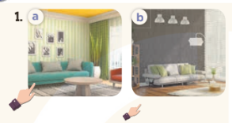  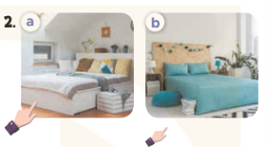  - T ask Ss to guess the answers.  + T writes Ss’guessing on the board.  - Listen to the tape:  + Play the recording  + Play the recording again and get Ss to swap books with their partners.  + Play the recording again to check answers together as a class.  + Write the answers on the board for Ss to correct their answers. Then checks Ss’ guessing.  - Play the recording, sentence by sentence, for the class to listen and repeat in chorus.  Key: 1.a 2.b  Activity 2. Look, complete and read.  *Aims: Ss will be able to complete four gapped exchanges with the help of picture cues.  *Procedure:  - Have Ss look at the pictures and identify the rooms (a living room, a kitchen, a bathroom and a bedroom).  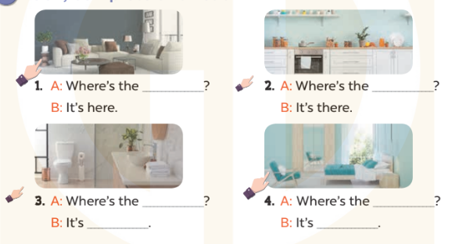  - Have Ss look at the four incomplete exchanges and elicits the missing words in the sentences.  - T models with sentence 1  + Ask Ss what is missing in the sentence.  + Have Ss look at the picture and complete the gap, then read the completed sentence in chorus.  -Have Ss work in groups and complete the sentences 2,3 and 4.  - Ask a few Ss to stand up and read the completed sentences aloud.  -T gives feedbacks.  Key:  1. living room 2. kitchen  3. bathroom; there 4. bedroom; here  Activity 3. Let’s sing.  *Aims: Ss will be able to sing the song Where is it? with the correct melody and pronunciation.  *Procedure:  - Introduce the title and lyrics of the song: “Where is it? ” song.  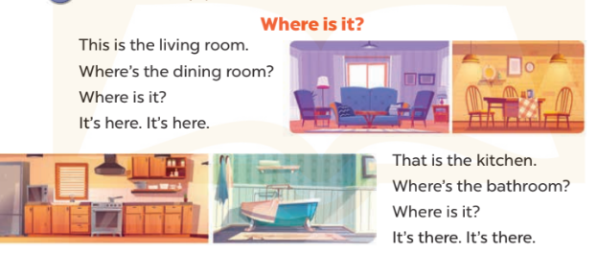  - Play the recording for Ss to listen to the whole song.  + Have them repeat the title and lyrics line by line.  + Tell Ss to point at the relevant character while singing his or her name.  - Play the recording all the way through for Ss to listen to pronunciation and melody of the song.  - Play the recording line by line for Ss to listen, repeat and point at the relevant character.  - Play the recording for Ss to sing and do actions.  - Ask Ss to practice singing and doing actions in pairs or groups.  - Invite groups to the front of the classroom to perform the song  -T gives feedback.  *Consolidation  *Aims: Ss will be able consolidate and wrap up the content of the lesson.  *Procedure:  - T asks ss to answer the following questions:  + What have you learnt from the lesson today?  +What are the core values of the lesson? (if the teacher can take from the lesson).  - T praises some Ss who are hardworking / active/ good…. as well as encourage others to try more.  - Learn the number by heart  - Prepare the new lesson: Unit 13, Lesson 2 (1,2,3). | - Ss listen and keep the puppet  - Ss listen to music and play the game  -Ss listen  - Ss open their books  -Look at the pictures and say:  + Picture 1a: a hand pointing at a nearby living room  + Picture 1b: a hand pointing at distant living room  + Picture 2a: a hand pointing at a nearby bedroom  + Picture 2b: a hand pointing at a distant bedroom  -Ss guess the answers  - Ss listen to the tape and circle  - Ss listen again, circle and swap books with their partners.  - Ss check their answers and guessing  -Ss listen and repeat.  -Ss look at the picture and say:  -Ss look and answer  -Ss answer: living room  -Ss look, complete and read the completed sentence in chorus.  -Ss complete the sentence  -Ss read aloud  - Ss look and listen.  -Ss listen to the song  - Ss listen and repeat line by line without the action.  -Ss point to the character while singing  -Ss listen to melody of the song  - Ss listen and sing line by line.  - Ss sing and do actions.  + Ss work in groups (two groups) to sing.  -Ss perform in front of the class.  -Ss listen  -Ss answer the questions  -Ss listen and clap their hands  -Ss listen and take note

IV. ADJUSTMENTS (if necessary):
………………………………………………………………………………………….…..……………………………………………………………………………...………………………………………….…..……………………………………………………………………………….……………………………………………………………………...
Week 22 Preparing date: February 5th 2024
Period 87 Teaching date: February 16th 2024
Unit 13: My house
Lesson 2 (1, 2, 3)
I. OBJECTIVES:
By the end of the lesson, Ss will be able to:
1. Knowledge:
- use the words table, chair, book, lamp, in and on in the target sentence patterns
- use Where are the…..? – They’re……. to ask and answer questions about the locations of things in a room
- Vocabulary: table, chair, book, lamp, in, on
- Model sentences:
A: Where are the tables?
B: They’re in the living room.
- Skills: speaking and listening
2. Competences:
- Critical Thinking: talk about house
- Co-operation: ready to help friends in pair work/ group work.
- Oral Communication: speak about someone, ask and answer the questions
3. Attitude/ Qualities:
- Kindness: Help partners to complete learning tasks.
- Honesty: tell the truth about feelings and emotions
II. TEACHING AIDS:
- Teacher: Teacher’s guide Pages 165, 166; audio Tracks 26,27, website sachmem.vn, posters, laptop, pictures, textbook, lesson plan, TV or projector.
- Students: Pupil’s book Page 20, notebooks, workbooks, school things.
III. PROCEDURES:
Stages/Time | Teacher’s activities | Students’ activities
1.Warm- up:  (3’)  2. Presentation  (16’)  3.Practice: (7’)  4.Production: (7’)  5. Homework. (2’) | Game: Guess the pictures  *Aims: to create a friendly and active atmosphere in the class to beginning the lesson.  *Procedure:  - Write any word on the board.  - The first pupil has to take the last four or three letters of that word and form a new word.  - The second pupil does the same, and the chain continues until a pupil is unable to form a word.  - The pupil who fails to form a word or misspells it is out of the game.  - Say “Open your book page 20” and look at “Unit 13, Lesson 2 (1,2,3)”.  Activity 1. Vocabulary.  *Aims: Ss will be able to know the vocabulary in front of starting the new lesson.  *Procedure:  -T elicits the new words  + table : cái bàn (realia)  + chair : cái ghế (realia)  + lamp : cái đèn (picture)  + on : trên (visual)  + in : trong (visual)  - T models (3 times).  - T writes the words on the board.  - Checking: Rub out and remember  Activity 2. Listen, point and repeat:  *Aims: Ss will be able to understand and correctly repeat the sentences in two communicative contexts (pictures) to to ask and answer questions about the locations of things in a room.  *Procedure:  - Have Ss look at Pictures a and b and identify the characters in the pictures.  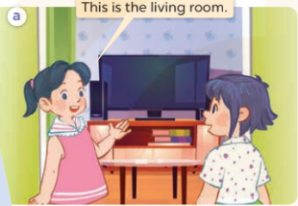  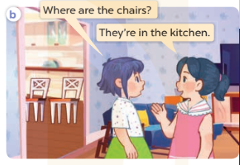  - Play the audio twice (sentence by sentence). Correct their pronunciation where necessary.  - Have Ss to practice the diaguage  - T invites a few pairs to the front of the class to practice.  - T checks pronunciation for ss.  Activity 3. Listen, point and say.  *Aims: Ss will be able to correctly say the words and use Where are the….? – They’re ……. to ask and answer questions about the locations of things in a room.  *Procedure:  * Model sentences:  - T asks Ss look at picture b and helps Ss know the structure from the dialogue.  - T introduces new structure for Ss.  - T explains, models and gives meaning.  - Have Ss repeat the model sentences.  A: Where are the tables?  B: They’re in the living room.  *Drill pictures  - Elicit and check comprehension the name of each character.  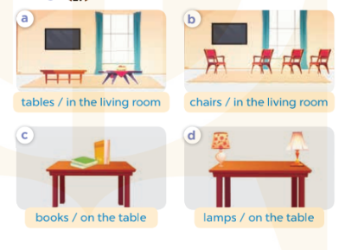  - Run through all the pictures.  - Run through model sentences.  +Run through the question sentences  +Run through the answer sentences  - Have Ss to practise:  + T asks, Ss answer picture a  + Ss ask, T answers picture b  + Group A ask, group B answer picture c  + Group B ask, group A answer picture d  - Ask Ss to work in pairs.  - T controls and corrects.  - Invite a few pairs to come to the front of the classroom, point at the relevant character in each picture, and act out his/her role.  - T gives feedbacks.  Activity 4. Let’s talk.  *Aims: Ss will be able to enhance the correct use of Where are the ….? – They’re…….. to ask and answer questions about the locations of things in a room in a freer context.  *Procedure:  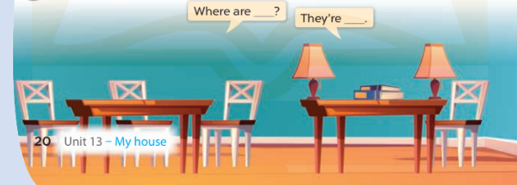  - T asks ss to attend to the picture.  + What can you see in the picture?  +What are they?  +Where are they?  - T fills the gaps and writes the sentences on the board.  - T models  - T asks Ss use of Where are…..? and They’re ……. to ask and answer (groups of four)  - Invite some groups to perform.  - Give feedbacks  *Consolidation  *Aims: Ss will be able consolidate and wrap up the content of the lesson.  *Procedure:  - T asks ss to answer the following questions:  + What have you learnt from the lesson today?  +What are the core values of the lesson? (if the teacher can take from the lesson).  - T review the vocabulary and model sentences.  - T praises some Ss who are hardworking / active/ good…. as well as encourage others to try more.  - Learn the number by heart  - Prepare the new lesson: Unit 13, Lesson 2 (4,5,6). | - Ss listen  - Ss play the game  - Ss open their books  -Ss listen and answer  - - Ss listen and repeat  + Choral repetition (3 times).  + Individual repetition (3 ss)  - Ss take note  - Ss look, remember and write  -Look at the pictures and get to know the characters in the pictures.  + In picture a: Mai says This is the living room.  – In picture b: Linh asks Where are the chairs? And Mai answers They’re in the kitchen.  -Ss listen and repeat in chorus (twice)  -Ss work in pairs to practice  -Ss practice the diaguage  -Ss listen  -Ss look at the picture and answer.  -Ss listen  -Ss listen and repeat  -Ss repeat  - Ss look, listen and answer  + Picture a: a. tables in the living room  + Picture b: chairs in the living room  + Picture c: books on the table  + Picture d: lamps on the table  -Ss practice in chorus  - Ss practice in chorus  -Ss work in pairs to practice  -Ss listen  -Ss go to the board and role play.  -Ss listen  -Ss look at the picture and answer  + two tables, four chairs, two books and two lamps on a table  -Ss note  - Ss say the completed sentences.  -Ss work in groups  -Ss perform in front of the class.  -Ss answer the questions  - Ss listen  -Ss listen and clap their hands  -Ss listen and take note

IV. ADJUSTMENTS (if necessary):
………………………………………………………………………………………….…..……………………………………………………………………………...………………………………………….…..……………………………………………………………………………….……………………………………………………………………...

Week 22 Preparing date: February 5th 2024
Period 88 Teaching date: February 16th 2024
Unit 13: My house
Lesson 2 (4, 5, 6)
I. OBJECTIVES:
By the end of the lesson, Ss will be able to:
1. Knowledge:
- listen to and understand simple exchanges in relation to the topic “My house”
- read and write about the location of rooms in a house and things in a room.
- Vocabulary: Review
- Skills: speaking, listening, reading and writing.
2. Competences:
- Critical Thinking: talk about rooms in a house and things in a room.
- Co-operation: ready to help friends in pair work/ group work.
- Self-control and independent learning: perform listening tasks.
3. Attitude/ Qualities:
- Kindness: Help partners to complete learning tasks.
- Honesty: tell the truth about feelings and emotions.
- Diligence: complete learning tasks.
II. TEACHING AIDS:
- Teacher: Teacher’s guide Pages 167, 168; audio Tracks 28; website sachmem.vn, posters, laptop, pictures, textbook, lesson plan, TV or projector.
- Students: Pupil’s book Page 21, notebooks, workbooks, school things.
III. PROCEDURES:
Stages/Time | Teacher’s activities | Students’ activities
1.Warm- up:  (5’)  2.Practice: (27’)  3. Homework. (3’) | Sing a song: “My house”  *Aims: to create a friendly and active atmosphere in the class to beginning the lesson.  *Procedure:  - Show the song on the screen.  https://www.youtube.com/watch?v=qZyJPZxsmZk  - Ask pupils to listen, sing and dance the song.  - Say “Open your book page 21” and look at “Unit 13, Lesson 2 (4,5,6)”.  Activity 1. Listen and number:  *Aims: Ss will be able to listen to and understand four communicative contexts in which two characters ask and answer questions about the locations of things in a room and number the correct pictures.  *Procedure:  - Elicit the names and ages of the characters in the pictures.  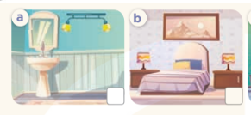  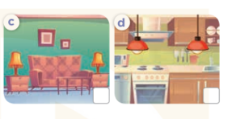  - T ask Ss to guess the answers.  + T writes Ss’guessing on the board.  - Listen to the tape:  + Play the recording  + Play the recording again and get Ss to swap books with their partners.  + Play the recording again to check answers together as a class.  + Write the answers on the board for Ss to correct their answers. Then checks Ss’ guessing.  - Play the recording, sentence by sentence, for the class to listen and repeat in chorus.  Key: 1.c 2. d 3. a 4. b  Activity 2. Look, circle and read.  *Aims: Ss will be able to circle the correct answers to the gapped exchanges with the help of picture cues.  *Procedure:  - Have Ss look at the pictures and identify the rooms and things in the pictures.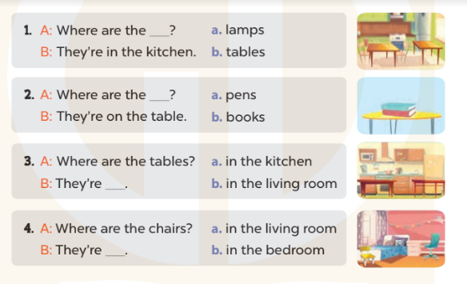  - T models with sentence 1.  + Have Ss look at the sentence.  + Ask them what is missing in the answer (tables).  + Have Ss circle the correct options  + Have Ss read the completed sentence in chorus.  -Have Ss work in pairs and circle the sentences 2, 3 and 4.  - Invite pairs of pupils to stand up and read aloud the sentences.  -T gives feedbacks.  Key: 1. b 2. b 3. a 4. b  Activity 3. Let’s play.  *Aims: Ss will be able to review vocabulary and structure words in relation to the topic “My house” and use them in the sentence patterns Where’s…….? − It’s here / there. and Where are …….?– They’re ……. by playing the game Bingo.  *Procedure:  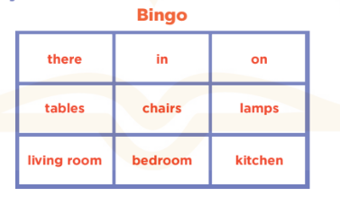  - Explain how to play the game:  + Draw a 3 x 3 Bingo grid on the board and a list of the vocabulary words for reviewing.  + Get Ss to copy the grid onto a paper sheet and fill their grids with the vocabulary words.  + Ss need to listen carefully for the words that you’ll be calling out from the list on the board. If they have a word that is called out, then they need to cross it out on their grids.  + Eventually, one pupil will have crossed out all of his or her words and should out “Bingo!” to show that he / she has finished.  - Give Ss time to play the game in pairs or groups.  - When time runs out, invite a few pairs to stand up and take turns asking and answering questions using the sentence patterns Where’s …….? − It’s here / there. and Where are …….? – They’re…….  *Consolidation  *Aims: Ss will be able consolidate and wrap up the content of the lesson.  *Procedure:  - T asks ss to answer the following questions:  + What have you learnt from the lesson today?  +What are the core values of the lesson? (if the teacher can take from the lesson).  - T praises some Ss who are hardworking / active/ good…. as well as encourage others to try more.  - Prepare the new lesson: Unit 13, Lesson 3 (1,2,3). | - Sing and dance the song in chorus.  - Ss open their books  -Look at the pictures and say:  + Picture a: two lamps in the bathroom  + Picture b: two lamps in the bedroom  + Picture c: two lamps in the living room  + Picture d: two lamps in the kitchen  -Ss guess the answers  - Ss listen to the tape and write number  - Ss listen again, write number and swap books with their partners.  - Ss check their answers and guessing  -Ss listen and repeat.  -Ss look at the pictures and say  -Ss listen and answer  -Ss read and complete  -Ss work in pairs  -Ss read  - Ss listen  -Ss play the game  - Ss play the game  -Ss listen and answer  -Ss listen and take note

IV. ADJUSTMENTS (if necessary):
………………………………………………………………………………………….…..……………………………………………………………………………...………………………………………….…..……………………………………………………………………………….………………………………………………………………………

