Week 23 Preparing date: February 14th 2024
Period 89 Teaching date: February 20th 2024

Unit 13: MY HOUSE
Lesson 3 (1, 2, 3)
I. OBJECTIVES:
By the end of the lesson, Ss will be able to:
1. Knowledge:
- correctly repeat the sounds of the letters ou and ow in isolation, the words house and brown and the sentences Wow, it’s a big house! and Wow, it’s a brown house! with the correct pronunciation and intonation.
- identify the target words house and brown while listening.
- say the chant with the correct rhythm and pronunciation.
- Vocabulary: Review
- Skills: speaking, listening, reading and writing.
2. Competences:
- Co-operation: ready to help friends in pair work/ group work.
- Self-control and independent learning: perform listening tasks.
3. Attitude/ Qualities:
- Kindness: Help partners to complete learning tasks.
- Honesty: tell the truth about feelings and emotions
II. TEACHING AIDS:
- Teacher: Teacher’s guide Pages 169, 170; audio Tracks 29, 30, 31; website sachmem.vn, posters, laptop, pictures, textbook, lesson plan, TV or projector.
- Students: Pupil’s book Page 22, notebooks, workbooks, school things.
III. PROCEDURES:
Stages/Time | Teacher’s activities | Students’ activities
1.Warm- up:  (5’)  2. Presentation  (9’)  3.Practice: (19’)  4. Homework. (2’) | Game: Find and circle the words  *Aims: to create a friendly and active atmosphere in the class to beginning the lesson.  *Procedure:  H B K K E P M C F T  O C T H S N O W F H  U L U A A E U O T I  S E L N F C S S T N  E A W K R I E S E K  R C O O R C I S R B  S R O E M C V T A H  B R O W N R S T A Y  D T S S R S O R S M  A C E B K N W O W  - Divide class into 2 groups  - Ask Ss to find and circle the words that they learnt.  - Which groups find the best correct words is winner.  - Give Ss time to play the game.  Rows: brown, snow, wow  Columns: house, mouse  -T checks who’s winner?  - Say “Open your book page 22” and look at “Unit 13, Lesson 3 (1,2,3)”.  Activity 1. Listen and repeat:  *Aims: Ss will be able to correctly pronounce the sounds of the letters ou and ow in isolation, in the words house and brown, and in the sentences Wow, it’s a big house! and Wow, it’s a brown house! with correct pronunciation and intonation.  *Procedure:  - T gives instruction to the ou and ow in isolation, in the words house and brown, and in the sentences Wow, it’s a big house! and Wow, it’s a brown house!  - Play the recording for the letter ou, ow.  - Encourage Ss to point at the letter/ word/ sentence while listening.  - Play the recording again and encourage Ss to listen and repeat.  - Do this several times until Ss feel confident.  - T calls some Ss to practice.  - T gives feedbacks.  Activity 2. Listen and circle.  *Aims: Ss will be able to identify the target words house and brown while listening.  *Procedure:  - Elicit the sentences and explain that they have to listen.  - T ask Ss to guess the answers.  + T writes Ss’guessing on the board.  - Listen to the tape:  + Play the recording  + Play the recording again and get Ss to swap books with their partners.  + Play the recording again to check answers together as a class.  + Write the answers on the board for Ss to correct their answers. Then checks Ss’ guessing.  - Play the recording, sentence by sentence, for the class to listen and repeat in chorus.  - Invite one or two Ss to stand up and read the completed sentences.  Key: 1.b 2.b  Activity 3. Let’s chant  *Aims: Ss will be able to say the chant with the correct rhythm and pronunciation.  *Procedure:  - Introduce the title and lyrics of the chant.  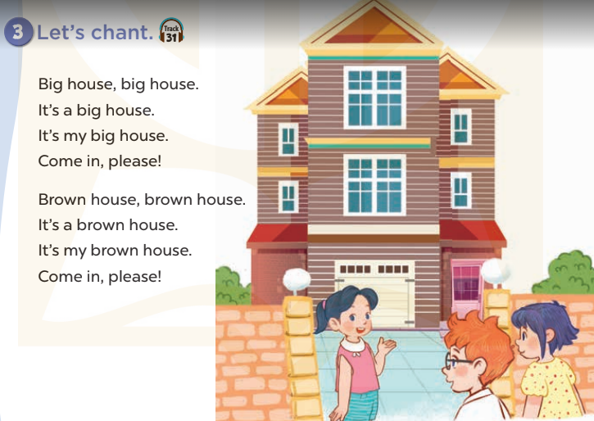  - Play the recording for Ss to listen to the whole chant.  + Have them repeat the title and lyrics line by line.  + Ask Ss to attend to the sounds of the letters ou and ow and the words house and brown.  - Play the recording all the way through for Ss to listen to pronunciation and melody.  - Play the recording line by line for Ss to listen and repeat  - Play the recording for Ss to chant and clap along.  - Ask Ss to practice chant and clap along in pairs or groups.  - Invite groups to the front of the classroom to perform the chant  -T gives feedback.  *Consolidation  *Aims: Ss will be able consolidate and wrap up the content of the lesson.  *Procedure:  - T asks ss to answer the following questions:  + What have you learnt from the lesson today?  +What are the core values of the lesson? (if the teacher can take from the lesson).  - T praises some Ss who are hardworking / active/ good…. as well as encourage others to try more.  - Practice the chant more.  - Prepare the new lesson: Unit 13, Lesson 3 (4,5,6). | - Ss listen  -Ss play game  - Ss open their books  - Ss recognize the differences about color of letter  - - Ss listen  - Ss listen and point  - Ss listen again and repeat  -Ss listen again and repeat  -Ss practice  -Ss listen  -Ss listen and say:  + Number 1:  a. I like a big house.  b. I like a brown house.  + Number 2:  a. I don’t like a big house  b. I don’t like a brown house  -Ss guess the answers  - Ss listen to the tape and circle  - Ss listen again, circle and swap books with their partners.  - Ss check their answers and guessing  -Ss listen and repeat.  -Ss read the sentences  - Ss look and listen.  -Ss listen to the chant  - Ss listen and repeat line by line without clap their hands  -Ss note the sounds, words  -Ss listen to melody of the chant  - Ss listen and chant line by line.  - Ss chant and clap along.  - Ss work in groups (two groups) to chant  -Ss perform in front of the class.  -Ss listen  -Ss listen.  -Ss answer the questions  -Ss listen and clap their hands  -Ss listen and take note
IV. ADJUSTMENTS (if necessary):
………………………………………………………………………………………….…..……………………………………………………………………………...………………………………………….…..……………………………………………………………………………….……………………………………………………………………...
Week 23 Preparing date: February 14th 2024
Period 90 Teaching date: February 20th 2024

Unit 13: MY HOUSE
Lesson 3 (4, 5, 6)
I. OBJECTIVES:
By the end of the lesson, Ss will be able to:
1. Knowledge:
- read a paragraph and complete sentences with the words from the paragraph
- read, understand and complete a gapped text using the information from a picture cue
- make a model house and tell the class about it.
- Vocabulary: Review
- Skills: speaking, listening, reading and writing.
2. Competences:
- Critical Thinking: talk about things in the house.
- Co-operation: ready to help friends in pair work/ group work.
- Self-control and independent learning: perform reading tasks.
3. Attitude/ Qualities:
- Kindness: Help partners to complete learning tasks.
- Honesty: tell the truth about feelings and emotions.
- Diligence: complete learning tasks.
II. TEACHING AIDS:
- Teacher: Teacher’s guide Pages 170, 171, website sachmem.vn, posters, laptop, pictures, textbook, lesson plan, TV or projector.
- Students: Pupil’s book Page 23, notebooks, workbooks, school things.
III. PROCEDURES:
Stages/Time | Teacher’s activities | Students’ activities
1.Warm- up:  (5’)  2.Practice: (8’)  3.Production: (19’)  4. Homework. (3’) | Game: Guessing  *Aims: to review the vocabulary and structure about greet and respond to greetings.  *Procedure:  - Divide the class into 4 teams.  - Look at the cards (1-8), there are pictures behind them.  + Let Ss guess the pictures then say aloud the rooms and things in the house.  + Who can make it will have points for the team. (Spin the lucky wheel to get the points)  - Encourage Ss to take part in the game and practice speaking English.  - Give points for Ss.  - Say “Open your book page 11” and look at “Unit 13, Lesson 3 (4, 5, 6)”.  Activity 1. Read and complete:  *Aims: Ss will be able to read a paragraph and complete sentences with the words from the paragraph *Procedure:  - Tell Ss about this activity.  - Get Ss to scan the paragraph and find the missing words.  - Ask Ss attend to the blank in sentence 1 and find the missing word.  - Write the missing word on the board and get the class to read the completed sentence together.  - Have Ss work in pairs and complete  - Tell Ss to swap books with a partner, then check answers together as a class.  - Write the correct answers on the board for pupils to correct their answers.  - Invite Ss to read the complete sentences aloud  -T gives feedbacks.  Key: 1.the bedroom  2. the kitchen  3. the kitchen 4. the table  Activity 2. Let’s write  *Aims: Ss will be able to read, understand and complete a gapped text using the information from a picture cue  *Procedure:  - Explain to the class the goal of this activity.  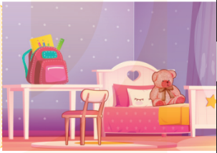  - Ask Ss to read each gapped sentence, guess the missing information and complete the sentence with their own personal information.  - Give Ss time to write their answers  - Ask Ss to swap and correct their answers in pairs.  - Check the answers as a class.  Key: Pupils’ answer.  Activity 3. Project.  *Aims: Ss will be able to make a model house and tell the class about it.  *Procedure:  - Tell Ss about this activity. Check their dool’s houses.  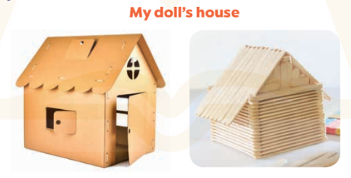  - Stick a sample of a doll’s house on the board and write the presentation language under it.  -Give Ss repeat the sentences until they can say them by themselves.  - Give Ss time to practise their presentations by themselves.  - Invite a student to the front of the classroom to model the presentation.  - Give Ss work in groups to present their doll’s houses.  - Invite a few SS from different groups to present their doll’s houses in front of the classroom.  -Give Ss display of doll’s houses and vote for the best decorated one.  *Consolidation  *Aims: Ss will be able consolidate and wrap up the content of the lesson.  *Procedure:  - T asks ss to answer the following questions:  + What have you learnt from the lesson today?  +What are the core values of the lesson?  - T praises some Ss who are hardworking / active/ good…. as well as encourage others to try more.  - Prepare the new lesson: Unit 14: Lesson 1 (1,2,3). | - Ss listen  -Ss play game  - Ss open their books  -Ss listen  - Ss read and answer  -Ss read and complete  -Ss write the first word  -Ss work in pairs  -Ss swap books and check  -Ss check the correct their answers  -Ss read  -Ss listen  -Ss listen  -Ss read and answer  -Ss write  Look at my bedroom. The table is………the bedroom. My school bag is……….the table. The teddy bear is……………..  -Ss swap books and check their answers  -Ss check  -Ss listen  -Ss note  -Ss repeat the sentences  -Ss practice  -Ss present  -Ss work in groups  -Ss present in front of class.  -Ss vote the most beautiful ones  -Ss answer the questions  -Ss listen and clap their hands  -Ss listen and take note
IV. ADJUSTMENTS (if necessary):
………………………………………………………………………………………….…..……………………………………………………………………………...…………
………………………………………………………………………………………….…..……………………………………………………………………………...…………

Week 23 Preparing date: February 14th 2024
Period 91 Teaching date: February 22nd 2024

Unit 14: MY BEDROOM
Lesson 1 (1, 2, 3)
I. OBJECTIVES:
By the end of the lesson, Ss will be able to:
1. Knowledge:
– understand and correctly repeat the sentences in two communicative contexts (pictures) focusing on quantities of things in a room
- correctly say the words and use There’s / There are……… in the room. to talk about quantities of things in a room;
-enhance the correct use of There’s / There are…….. in the room. to talk about quantities of things in a room in a freer context.
- Vocabulary: desk, bed, door, window
- Model sentences:
There’s a desk in the room.
There are two doors in the room.
- Skills: speaking and listening
2. Competences:
- Critical Thinking: talk about things in bedroom.
- Co-operation: ready to help friends in pair work/ group work.
- Sociability: Talk to each other, say good words to others.
3. Attitude/ Qualities:
- Kindness: Help partners to complete learning tasks.
- Honesty: tell the truth about feelings and emotions
II. TEACHING AIDS:
- Teacher: Teacher’s guide Pages 172, 173, audio Tracks 32, 33, website sachmem.vn, posters, laptop, pictures, textbook, lesson plan, TV or projector.
- Students: Pupil’s book Page 24, notebooks, workbooks, school things.
III. PROCEDURES:
Stages/Time | Teacher’s activities | Students’ activities
1.Warm- up:  (3’)  2. Presentation  (16’)  3.Practice: (7’)  4.Production: (7’)  5. Homework. (2’) | Game: jigsaw puzzle  *Aims: to create a friendly and active atmosphere in the class to beginning the lesson.  *Procedure:  - Divide class into 4 groups: Doreamon, Nobita, Xuka and Xeko.  - Ask Ss look at the pieces of picture.  - Ask Ss go to the board and jigsaw puzzle into the correct picture    -T checks who’s the winner?  - Ask Ss look at the pieces of picture  - Say “Open your book page 24” and look at “Unit 14, Lesson 1 (1,2,3)”.  Activity 1. Vocabulary.  *Aims: Ss will be able to know the vocabulary in front of starting the new lesson.  *Procedure:  -T elicits the new words  + desk : cái bàn học sinh  (realia)  + bed : cái giường (picture)  + door : cửa ra vào (realia)  + window : cửa sổ (realia)  - T models (3 times).  - T writes the words on the board.  - Checking: Rub out and remember  Activity 2. Listen, point and repeat:  *Aims: Ss will be able to understand and correctly repeat the sentences in two communicative contexts (pictures) focusing on quantities of things in a room.  *Procedure:  - Have Ss look at Pictures a and b and identify the characters in the pictures.  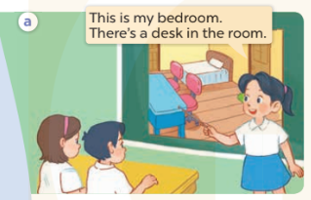  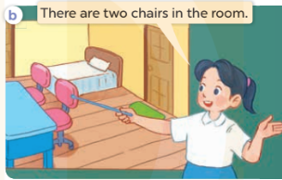  - Play the audio twice (sentence by sentence). Correct their pronunciation where necessary.  - Have Ss to practice the dialogue  - T invites a few pairs to the front of the class to practice.  - T checks pronunciation for ss.  Activity 3 Listen, point and say.  *Aims: Ss will be able to correctly say the words and use There’s / There are ……. in the room. to talk about quantities of things in a room.  *Procedure:  * Model sentences:  - T asks Ss look at picture a , b and helps Ss know the structure from the dialogue.  - T introduces new structure for Ss.  - T explains, models and gives meaning.  -Have Ss repeat the model sentences.  There’s a desk in the room.  There are two doors in the room  *Drill pictures  - Elicit and check comprehension the name of the thing in the room.  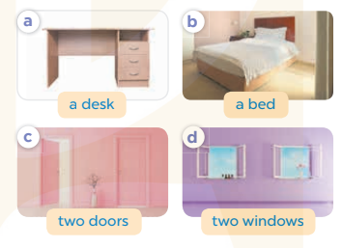  - Run through all the pictures.  - Run through model sentences.  - Have Ss to practise  - Ask Ss to work in pairs.  - T controls and corrects.  - Invite a few pairs to come to the front of the classroom, point at the relevant character in each picture, and act out his/her role.  - Encourage Ss to practise speaking English.  - T gives feedbacks.  Activity 4. Let’s talk.  *Aims: Ss will be able to enhance the correct use of There’s / There are ……… in the room. to talk about quantities of things in a room in a freer context.  *Procedure:  - T asks ss to look at the things in the bedroom and elicit their names  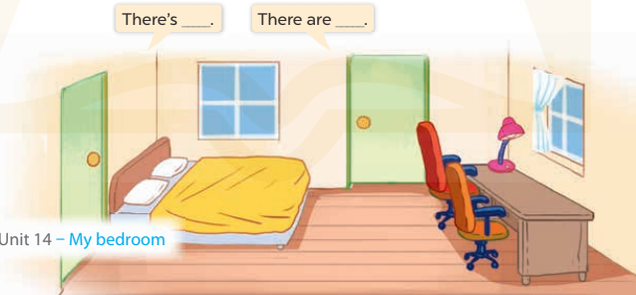  + What can you see in the picture?  - T fills the gaps and writes the sentences on the board.  - T models  - T asks Ss to work in pairs to ask and answer  - Invite some pupils to the front of the class to present their exchanges.  - Give feedbacks  *Consolidation  *Aims: Ss will be able consolidate and wrap up the content of the lesson.  *Procedure:  - T asks ss to answer the following questions:  + What have you learnt from the lesson today?  - T review the vocabulary and model sentences.  - T praises some Ss who are hardworking / active/ good…. as well as encourage others to try more.  - Learn the number by heart  - Prepare the new lesson: Unit 14, Lesson 1 (4,5,6). | - Ss listen  - Ss play the game  - Ss open their books  -Ss listen and answer  - - Ss listen and repeat  + Choral repetition (3 times).  + Individual repetition (3 ss)  - Ss take note  - Ss look, remember and write  -Look at the pictures and get to know the characters in the pictures.  + Mai says This is my bedroom. There’s a desk in the room. in picture a.  + Mai says There are two chairs in the room. in picture b.  -Ss listen and repeat in chorus (twice)  -Ss work in pairs to practice  -Ss practice the dialogue  -Ss listen  -Ss look at the picture and answer.  -Ss listen  -Ss listen and repeat  -Ss repeat  - Ss look, listen and repeat  -Ss practice in chorus  -Ss work in pairs to practice  -Ss point and say  -Ss listen.  -Ss listen  -Ss look at the picture and answer  + singular things (ex: a bed, a desk)  + multiple things (ex: two chairs, two windows).  -Ss note  - Ss say the completed sentences.  -Ss work in pairs  -Ss perform in front of the class.  -Ss answer the questions  - Ss listen  -Ss listen and clap their hands  -Ss listen and take note

IV. ADJUSTMENTS (if necessary):
………………………………………………………………………………………….…..……………………………………………………………………………...………………………………………….…..……………………………………………………………………………….……………………………………………………………………...

Week 23 Preparing date: February 14th 2024
Period 92 Teaching date: February 22nd 2024

Unit 14: MY BEDROOM
Lesson 1 (4, 5, 6)
I. OBJECTIVES:
By the end of the lesson, Ss will be able to:
1. Knowledge:
- listen to and understand two communicative contexts in which pupils describe things in the bedroom and tick the correct pictures.
- complete the four gapped sentence patterns with the help of picture cues.
- revise the target vocabulary items through the game Memory game.
- Vocabulary: Review
- Skills: speaking, listening, reading and writing.
2. Competences:
- Co-operation: ready to help friends in pair work/ group work.
- Self-control and independent learning: perform listening tasks.
3. Attitude/ Qualities:
- Kindness: Help partners to complete learning tasks.
- Honesty: tell the truth about feelings and emotions.
- Diligence: complete learning tasks.
II. TEACHING AIDS:
- Teacher: Teacher’s guide Pages 174; audio Tracks 34; website sachmem.vn, posters, laptop, pictures, textbook, lesson plan, TV or projector.
- Students: Pupil’s book Page 25, notebooks, workbooks, school things.
III. PROCEDURES:
Stages/Time | Teacher’s activities | Students’ activities
1.Warm- up:  (5’)  2.Practice: (27’)  3. Homework. (3’) | Sing a song: “If you happy and you know it”  *Aims: to create a friendly and active atmosphere in the class to beginning the lesson.  *Procedure:  - Show the song on the screen.  https://www.youtube.com/watch?v=zyMWcWqmhRc  - Ask pupils to listen, sing and dance the song.  - Say “Open your book page 25” and look at “Unit 14, Lesson 1 (4,5,6)”.  Activity 1. Listen and tick:  *Aims: Ss will be able to listen to and understand two communicative contexts in which pupils describe things in the bedroom and tick the correct pictures.  *Procedure:  - Elicit the name of the things in the room in each picture 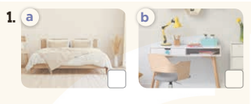  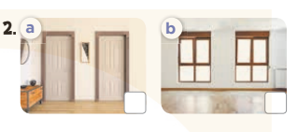  - T ask Ss to guess the answers.  + T writes Ss’guessing on the board.  - Listen to the tape:  + Play the recording  + Play the recording again and get Ss to swap books with their partners.  + Play the recording again to check answers together as a class.  + Write the answers on the board for Ss to correct their answers. Then checks Ss’ guessing.  - Play the recording, sentence by sentence, for the class to listen and repeat in chorus.  Key: 1.a 2.b  Activity 2. Look, complete and read.  *Aims: Ss will be able to complete the four gapped sentence patterns with the help of picture cues.  *Procedure:  - Have Ss look at the first picture and ask them some questions such as What’s this? and Where is it?  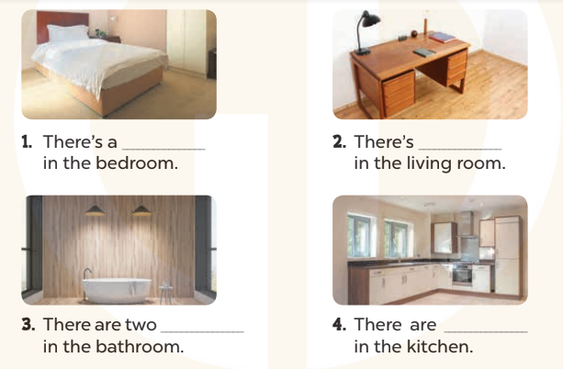  - Have Ss look at the four incomplete sentnces and elicits the missing words in the sentences.  - T models with sentence 1  + Ask Ss what is missing in the sentence.  + Have Ss look at the picture and complete the gap, then read the completed sentence in chorus.  -Have Ss work in groups and complete the sentences 2,3 and 4.  - Ask a few Ss to stand up and read the completed sentences aloud.  -T gives feedbacks.  Key:  1. bed 2. a desk  3. lamps 4. two windows  Activity 3. Let’s play  *Aims: Ss will be able to revise the target vocabulary items through the game Memory game.  *Procedure:  - Tell Ss that they are going to look at the cards for 60 seconds, memorise the words, then remember as many of the words as possible.  -Explain how the game is played.  - Put the cards on a desk or stick them on the board. Then cover them with a piece of cloth  - Divide the class into groups. Remove the cloth and show the cards for 60 seconds. Then cover them again.  - Have the groups say the names of the things aloud. For each correct word, give them a star or a point.  -The group with the most stars / points wins.  *Consolidation  *Aims: Ss will be able consolidate and wrap up the content of the lesson.  *Procedure:  - T asks ss to answer the following questions:  + What have you learnt from the lesson today?  +What are the core values of the lesson? (if the teacher can take from the lesson).  - T praises some Ss who are hardworking / active/ good…. as well as encourage others to try more.  - Prepare the new lesson: Unit 14, Lesson 2 (1,2,3). | - Sing and dance the song in chorus.  - Ss open their books  -Look at the pictures and say:  + Picture 1a: a bed in the bedroom  + Picture 1b: a desk in the bedroom  + Picture 2a: two doors in the bedroom  + Picture 2b: two windows in the bedroom  -Ss guess the answers  - Ss listen to the tape and circle  - Ss listen again, circle and swap books with their partners.  - Ss check their answers and guessing  -Ss listen and repeat.  -Ss look at the picture and answer  -Ss look and answer  -Ss answer: bed  -Ss look, complete and read the completed sentence in chorus.  -Ss complete the sentence  -Ss read aloud  - Ss look and listen.  - Ss listen  -Ss look and listen  -Ss play the game  -Ss answer the questions  -Ss listen and clap their hands  -Ss listen and take note

IV. ADJUSTMENTS (if necessary):
………………………………………………………………………………………….…..……………………………………………………………………………...………………………………………….…..……………………………………………………………………………….………………………………………………………………………

