Week 24 Preparing date: February 18th 2024
Period 93 Teaching date: February 27th 2024

Unit 14: MY BEDROOM
Lesson 2 (1, 2, 3)
I. OBJECTIVES:
By the end of the lesson, Ss will be able to:
1. Knowledge:
- understand and correctly repeat the sentences in two communicative contexts (pictures) to describe things in the room.
- correctly say the words and use The …….. is ……. / The …… are …….. to describe things in the room.
- enhance the correct use of The ……..is ……….. / The ……..are ……….to describe things in the room in a freer context.
- Vocabulary: big, small, old, new
- Model sentences:
The door is big.
The chairs are new.
- Skills: speaking and listening
2. Competences:
- Co-operation: ready to help friends in pair work/ group work.
- Oral Communication: speak about someone, ask and answer the questions
3. Attitude/ Qualities:
- Kindness: Help partners to complete learning tasks.
- Honesty: tell the truth about feelings and emotions
II. TEACHING AIDS:
- Teacher: Teacher’s guide Pages 176, 177; audio Tracks 35,36, website sachmem.vn, posters, laptop, pictures, textbook, lesson plan, TV or projector.
- Students: Pupil’s book Page 26, notebooks, workbooks, school things.
III. PROCEDURES:
Stages/Time | Teacher’s activities | Students’ activities
1.Warm- up:  (3’)  2. Presentation  (16’)  3.Practice: (7’)  4.Production: (7’)  5. Homework. (2’) | Game: Who says fast?  *Aims: to create a friendly and active atmosphere in the class to beginning the lesson.  *Procedure:  - T holds a school thing card and a sentence with a missing word.  - Ask Ss to guess the answer as fast as possible.  - Then have Ss do the same with the rest.  - This can be played in groups to make it more interesting.  - Say “Open your book page 26” and look at “Unit 14, Lesson 2 (1,2,3)”.  Activity 1. Vocabulary.  *Aims: Ss will be able to know the vocabulary in front of starting the new lesson.  *Procedure:  -T elicits the new words  + big : to, lớn (picture)  + small : nhỏ, bé (picture)  + new : mới (picture)  + old : cũ (picture)  - T models (3 times).  - T writes the words on the board.  - Checking: Rub out and remember  Activity 2. Listen, point and repeat:  *Aims: Ss will be able to understand and correctly repeat the sentences in two communicative contexts (pictures) to describe things in the room.  *Procedure:  - Have Ss look at Pictures a and b and identify the characters in the pictures.  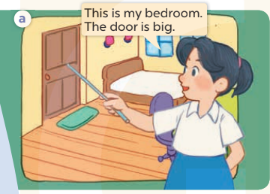  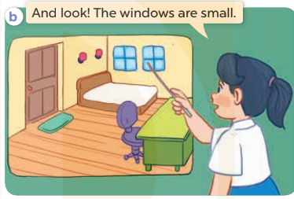  - Play the audio twice (sentence by sentence). Correct their pronunciation where necessary.  - Have Ss to practice the diaguage  - T invites a few pairs to the front of the class to practice.  - T checks pronunciation for ss.  Activity 3. Listen, point and say.  *Aims: Ss will be able to correctly say the words and use The …. is …... / The …….are ……. to describe things in the room.  *Procedure:  * Model sentences:  - T asks Ss look at picture a, b and helps Ss know the structure from the dialogue.  - T introduces new structure for Ss.  - T explains, models and gives meaning.  - Have Ss repeat the model sentences.  The door is big.  The chairs are new.  *Drill pictures  - Have Ss look at the pictures and elicit the things in the room.  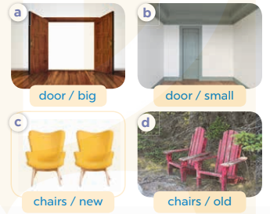  - Run through all the pictures.  - Run through model sentences.  - Have Ss to practise:  - Ask Ss to work in pairs.  - T controls and corrects.  - Invite a few pairs to come to the front of the classroom, point at the relevant character in each picture, and act out his/her role.  - T gives feedbacks.  Activity 4. Let’s talk.  *Aims: Ss will be able to enhance the correct use of The …… is ……. / The……. are ……..to describe things in the room in a freer context.  *Procedure:  - Have Ss look at the things in a bedroom and say their names. 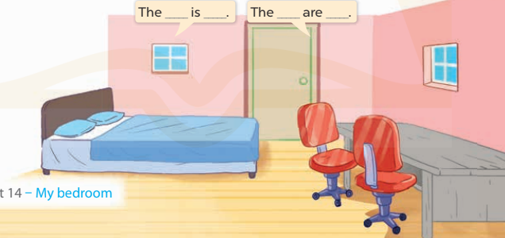  + What can you see in the picture?  +What are they?  - T fills the gaps and writes the sentences on the board.  - T models  - T asks Ss use of The bed is new. The chair are new. to introduce the things in the room.  - Invite some groups to perform.  - Give feedbacks  *Consolidation  *Aims: Ss will be able consolidate and wrap up the content of the lesson.  *Procedure:  - T asks ss to answer the following questions:  + What have you learnt from the lesson today?  +What are the core values of the lesson? (if the teacher can take from the lesson).  - T review the vocabulary and model sentences.  - T praises some Ss who are hardworking / active/ good…. as well as encourage others to try more.  - Learn the number by heart  - Prepare the new lesson: Unit 14, Lesson 2 (4,5,6). | - Ss listen  - Ss play the game  - Ss open their books  -Ss listen and answer  - - Ss listen and repeat  + Choral repetition (3 times).  + Individual repetition (3 ss)  - Ss take note  - Ss look, remember and write  -Look at the pictures and get to know the characters in the pictures.  + In picture a: Mai says This is my bedroom. The door is big.  – In picture b: Mai says And look! The windows are small.  -Ss listen and repeat in chorus (twice)  -Ss work in pairs to practice  -Ss practice the diaguage  -Ss listen  -Ss look at the picture and answer.  -Ss listen  -Ss listen and repeat  -Ss repeat  - Ss look, listen and answer  + Picture a: a big door  + Picture b: a small door  + Picture c: two new chairs + Picture d: two old chairs  -Ss practice in chorus  - Ss practice in chorus  -Ss work in pairs to practice  -Ss listen  -Ss point and sa  -Ss go to the board and role play.  -Ss listen  -Ss look at the picture and answer  + A bedroom with a bed, a desk, a door, two chairs and two windows  -Ss note  - Ss say the completed sentences.  -Ss work in groups  -Ss perform in front of the class.  -Ss answer the questions  - Ss listen  -Ss listen and clap their hands  -Ss listen and take note

D. ADJUSTMENTS (if necessary):
………………………………………………………………………………………….…..……………………………………………………………………………...………………………………………….…..……………………………………………………………………………….……………………………………………………………………...

Week 24 Preparing date: February 18th 2024
Period 94 Teaching date: February 27th 2024

Unit 14: MY BEDROOM
Lesson 2 (4, 5, 6)
I. OBJECTIVES:
By the end of the lesson, Ss will be able to:
1. Knowledge:
- listen to and understand four communicative contexts in which characters introduce and describe things in a bedroom and number the correct pictures.
- complete four gapped sentences with the help of picture cues.
- sing the song My bedroom with the correct pronunciation, rhythm and melody.- Vocabulary: Review
- Skills: speaking, listening, reading and writing.
2. Competences:
- Co-operation: ready to help friends in pair work/ group work.
- Self-control and independent learning: perform listening tasks.
3. Attitude/ Qualities:
- Kindness: Help partners to complete learning tasks.
- Honesty: tell the truth about feelings and emotions.
- Diligence: complete learning tasks.
II. TEACHING AIDS:
- Teacher: Teacher’s guide Pages 178, 179; audio Tracks 37, 38; website sachmem.vn, posters, laptop, pictures, textbook, lesson plan, TV or projector.
- Students: Pupil’s book Page 27, notebooks, workbooks, school things.
III. PROCEDURES:
Stages/Time | Teacher’s activities | Students’ activities
1.Warm- up:  (5’)  2.Practice: (27’)  3. Homework. (3’) | Sing a song: “throw the ball”  *Aims: to create a friendly and active atmosphere in the class to beginning the lesson.  *Procedure:  - Divide the class into 2 teams.  - Stick the pictures of things in the room on the board.  + T says a word, a pupil from each team has to point/throw the ball to the right picture and says the word three times.  + The one says faster will get points.  - Encourage Ss to take part in the game.  - Give points for Ss.  - Say “Open your book page 27” and look at “Unit 14, Lesson 2 (4,5,6)”.  Activity 1. Listen and number:  *Aims: Ss will be able to listen to and understand four communicative contexts in which characters introduce and describe things in a bedroom and number the correct pictures  *Procedure:  - Have Ss look at the pictures and ask them some questions such as What is this? and What are these? 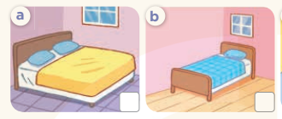  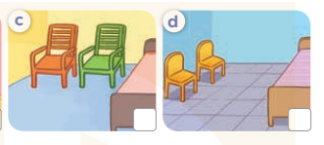  - T ask Ss to guess the answers.  + T writes Ss’guessing on the board.  - Listen to the tape:  + Play the recording  + Play the recording again and get Ss to swap books with their partners.  + Play the recording again to check answers together as a class.  + Write the answers on the board for Ss to correct their answers. Then checks Ss’ guessing.  - Play the recording, sentence by sentence, for the class to listen and repeat in chorus.  Key: 1.b 2. a 3. c 4. d  Activity 2. Look, complete and read.  *Aims: Ss will be able to complete four gapped dialogues with the help of picture cues.  *Procedure:  - Have Ss look at the pictures and ask identify things in the room in the pictures.  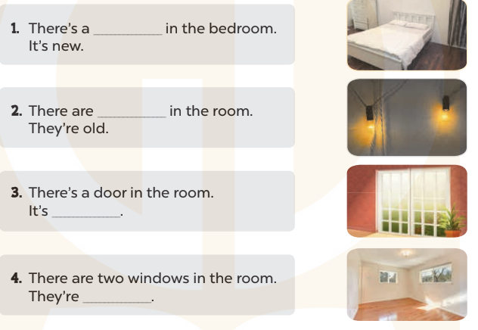  - T models with sentence 1.  + Have Ss look at the sentence.  + Ask them what is missing in the answer ( bed ).  + Have Ss complete the gap.  + Have Ss read the completed sentence in chorus.  -Have Ss work in pairs and complete the sentences 2, 3 and 4.  - Invite pairs of pupils to stand up and read aloud the sentences.  -T gives feedbacks.  Key: 1. bed 2. two lamps 3. big 4. small  Activity 3. Let’s sing.  *Aims: Ss will be able to sing the song My bedroom with the correct pronunciation, rhythm and melody *Procedure:  - Introduce the title and lyrics of the song: “My bedroom? ” song.  - Play the recording for Ss to listen to the whole song.  + Have them repeat the title and lyrics line by line.  + Tell Ss to point at the relevant character while singing his or her name.  - Play the recording all the way through for Ss to listen to pronunciation and melody of the song.  - Play the recording line by line for Ss to listen, repeat and point at the relevant character.  - Play the recording for Ss to sing and do actions.  - Ask Ss to practice singing and doing actions in pairs or groups.  - Invite groups to the front of the classroom to perform the song  -T gives feedback.  *Consolidation  *Aims: Ss will be able consolidate and wrap up the content of the lesson.  *Procedure:  - T asks ss to answer the following questions:  + What have you learnt from the lesson today?  +What are the core values of the lesson? (if the teacher can take from the lesson).  - T praises some Ss who are hardworking / active/ good…. as well as encourage others to try more.  - Prepare the new lesson: Unit 14, Lesson 3 (1,2,3). | - Ss listen and play the game  - Ss open their books  -Look at the pictures and say:  + Picture a: a big bed in a bedroom  + Picture b: a small bed in a bedroom  + Picture c: two big chairs in a bedroom  + Picture d: two small chairs in a bedroom  -Ss guess the answers  - Ss listen to the tape and write number  - Ss listen again, write number and swap books with their partners.  - Ss check their answers and guessing  -Ss listen and repeat.  -Ss look at the pictures and say  -Ss listen and answer  -Ss read and complete  -Ss work in pairs  -Ss read  - Ss look and listen.  -Ss listen to the song  - Ss listen and repeat line by line without the action.  -Ss point to the character while singing  -Ss listen to melody of the song  - Ss listen and sing line by line.  - Ss sing and do actions.  + Ss work in groups (two groups) to sing.  -Ss perform in front of the class.  -Ss listen  -Ss listen and answer  -Ss listen and take note

IV. ADJUSTMENTS (if necessary):
………………………………………………………………………………………….…..……………………………………………………………………………...………………………………………….…..……………………………………………………………………………….……………………………………………………………………...

Week 24 Preparing date: February 18th 2024
Period 95 Teaching date: February 29th 2024

Unit 14: MY BEDROOM
Lesson 3 (1, 2, 3)
I. OBJECTIVES:
By the end of the lesson, Ss will be able to:
1. Knowledge:
- correctly repeat the sounds of the letters oo in isolation, the words room and door and the sentences There’s the bed in the room and The doors are big. with the correct pronunciation and intonation.
- identify the target words room and door while listening.
- say the chant with the correct rhythm and pronunciation.
- Vocabulary: Review
- Skills: speaking, listening, reading and writing.
2. Competences:
- Co-operation: ready to help friends in pair work/ group work.
- Self-control and independent learning: perform listening tasks.
3. Attitude/ Qualities:
- Kindness: Help partners to complete learning tasks.
- Honesty: tell the truth about feelings and emotions
II. TEACHING AIDS:
- Teacher: Teacher’s guide Pages 179, 180; audio Tracks 39, 40, 41; website sachmem.vn, posters, laptop, pictures, textbook, lesson plan, TV or projector.
- Students: Pupil’s book Page 28, notebooks, workbooks, school things.
III. PROCEDURES:
Stages/Time | Teacher’s activities | Students’ activities
1.Warm- up:  (5’)  2. Presentation  (9’)  3.Practice: (19’)  4. Homework. (2’) | Game: Find and circle the words  *Aims: to create a friendly and active atmosphere in the class to beginning the lesson.  *Procedure:  D B K K E P S C F T  O C T H N E C C A H  O L U A A E H O A I  R O O M F C O S H N  T A W K F I O S E K  R T O O R C L S E B  S R O E R C V T A H  M M T H H R S T A Y  D T S S R S O R S M  A C E B F A Z Y W  - Divide class into 2 groups  - Ask Ss to find and circle the words that they learnt.  - Which groups find the best correct words is winner.  - Give Ss time to play the game.  Rows: room, too  Columns: door, school.  -T checks who’s winner?  - Say “Open your book page 17” and look at “Unit 12, Lesson 3 (1,2,3)”.  Activity 1. Listen and repeat:  *Aims: Ss will be able to correctly pronounce the sounds of the letters oo in isolation, in the words room and door, and in the sentences There’s the bed in the room. and The doors are big with correct pronunciation and intonation.  *Procedure:  - T gives instruction to the letters oo in isolation, in the words room and door, and in the sentences There’s the bed in the room. and The doors are big.  - Play the recording for the letter oo.  - Encourage Ss to point at the letter/ word/ sentence while listening.  - Play the recording again and encourage Ss to listen and repeat.  - Do this several times until Ss feel confident.  - T calls some Ss to practice.  - T gives feedbacks.  Activity 2. Listen and circle.  *Aims: Ss will be able to identify the target words room and door while listening.  *Procedure:  - Elicit the sentences and explain that they have to listen.  - T ask Ss to guess the answers.  + T writes Ss’guessing on the board.  - Listen to the tape:  + Play the recording  + Play the recording again and get Ss to swap books with their partners.  + Play the recording again to check answers together as a class.  + Write the answers on the board for Ss to correct their answers. Then checks Ss’ guessing.  - Play the recording, sentence by sentence, for the class to listen and repeat in chorus.  - Invite one or two Ss to stand up and read the completed sentences.  Key: 1.b 2.c  Activity 3. Let’s chant  *Aims: Ss will be able to say the chant with the correct rhythm and pronunciation.  *Procedure:  - Introduce the title and lyrics of the chant.  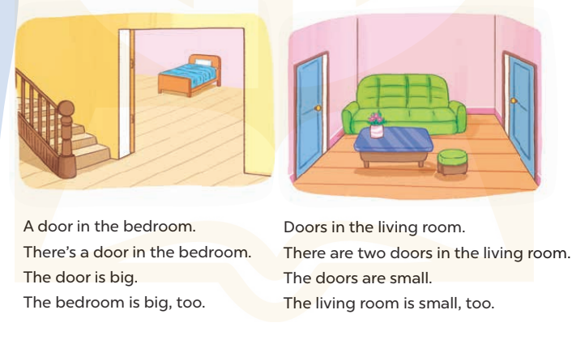  - Play the recording for Ss to listen to the whole chant.  + Have them repeat the title and lyrics line by line.  + Ask Ss to attend to the sounds of the letters oo and the words room and door.  - Play the recording all the way through for Ss to listen to pronunciation and melody.  - Play the recording line by line for Ss to listen and repeat  - Play the recording for Ss to chant and clap along.  - Ask Ss to practice chant and clap along in pairs or groups.  - Invite groups to the front of the classroom to perform the chant  -T gives feedback.  *Consolidation  *Aims: Ss will be able consolidate and wrap up the content of the lesson.  *Procedure:  - T asks ss to answer the following questions:  + What have you learnt from the lesson today?  +What are the core values of the lesson? (if the teacher can take from the lesson).  - T praises some Ss who are hardworking / active/ good…. as well as encourage others to try more.  - Practice the chant more.  - Find a photo of a bedroom in a newspaper or a magazine.  - Prepare the new lesson: Unit 14, Lesson 3 (4,5,6). | - Ss listen  -Ss play game  - Ss open their books  - Ss recognize the differences about color of letter  - - Ss listen  - Ss listen and point  - Ss listen again and repeat  -Ss listen again and repeat  -Ss practice  -Ss listen  -Ss listen and say:  + Number 1: The….is there  + Number 2: The…..is big.  -Ss guess the answers  - Ss listen to the tape and circle  - Ss listen again, circle and swap books with their partners.  - Ss check their answers and guessing  -Ss listen and repeat.  -Ss read the sentences  - Ss look and listen.  -Ss listen to the chant  - Ss listen and repeat line by line without clap their hands  -Ss note the sounds, words  -Ss listen to melody of the chant  - Ss listen and chant line by line.  - Ss chant and clap along.  - Ss work in groups (two groups) to chant  -Ss perform in front of the class.  -Ss listen  -Ss listen.  -Ss answer the questions  -Ss listen and clap their hands  -Ss listen and take note

IV. ADJUSTMENTS (if necessary):
………………………………………………………………………………………….…..……………………………………………………………………………...………………………………………….…..……………………………………………………………………………….……………………………………………………………………...

Week 24 Preparing date: February 18th 2024
Period 96 Teaching date: February 29th 2024

Unit 14: MY BEDROOM
Lesson 3 (4, 5, 6)
I. OBJECTIVES:
By the end of the lesson, Ss will be able to:
1. Knowledge:
- read the text and complete the gapped sentences.
- read the text and complete the gapped sentences.
- complete a gapped paragraph with the help of the picture cue.
- Vocabulary: Review
- Skills: speaking, listening, reading and writing.
2. Competences:
- Co-operation: ready to help friends in pair work/ group work.
- Self-control and independent learning: perform reading tasks.
3. Attitude/ Qualities:
- Kindness: Help partners to complete learning tasks.
- Honesty: tell the truth about feelings and emotions.
- Diligence: complete learning tasks.
II. TEACHING AIDS:
- Teacher: Teacher’s guide Pages 181, 182, website sachmem.vn, posters, laptop, pictures, textbook, lesson plan, TV or projector.
- Students: Pupil’s book Page 29, notebooks, workbooks, school things.
III. PROCEDURES:
Stages/Time | Teacher’s activities | Students’ activities
1.Warm- up:  (5’)  2.Practice: (8’)  3.Production: (19’)  4. Homework. (3’) | Game: Brainstorming  *Aims: to review the vocabulary and structure about greet and respond to greetings.  *Procedure:  - Divide the class into four groups.  - Each group chooses one pupil to be the 'runner'. The runners go to the teacher's desk and read the category.  Ex: Find objects/things in your bedroom/living room.  - The runners then go back to their group and tell their group members the category. Their group brainstorm words from that category and write them down.  - The first group to finish shouts 'stop' and then calls out their answers. If their answers are correct, they score one point for each word in the category.  - The group with the highest score at the end of the game wins.  - Say “Open your book page 29” and look at “Unit 14, Lesson 3 (4, 5, 6)”.  Activity 1. Read and complete:  *Aims: Ss will be able to read the text and complete the gapped sentences  *Procedure:  - Tell Ss how to complete the task.  - Point at the table and elicit the type of information they need to find in the texts.  - Ask Ss attend to the blank in number 1 and find the missing word.  - Write the missing word on the board and get the class to read the completeed sentence together.  - Have Ss work in pairs and complete  - Tell Ss to swap books with a partner, then check answers together as a class.  - Write the correct answers on the board for pupils to correct their answers.  - Invite Ss to read the complete text aloud  -T gives feedbacks.  Key: 1. desk 2. Chairs  3. big 4. small  Activity 2. Let’s write  *Aims: Ss will be able to complete a gapped paragraph with the help of the picture cue.  *Procedure:  - Explain to the class the goal of this activity.  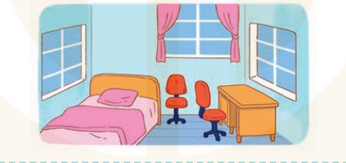  - Ask Ss to read each gapped sentence, look at the picture and fill in the gap.  - Give Ss time to write their answers  - Ask Ss to swap and correct their answers in pairs.  - Check the answers as a class.  Key: first gap: small  second gap: bed / desk  third gap: small / old  fourth gap: chairs  fifth gap: old / new  Activity 3. Project.  *Aims: Ss will be able to find a picture of a bedroom and tell the class about things in the room.  *Procedure:  - Tell Ss to find a photo of a bedroom in a newspaper or a magazine as homework. They should bring their photos to class.  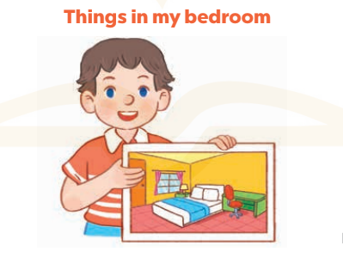  - Have Ss work in groups. Each member introduces the picture of the bedroom using the structures they have learnt in the unit.  - Invite one or two Ss to show their photos and describe them in front of the class.  +Example: Hello, everyone. My name’s Huong. I’m nine years old. This is my bedroom. There is a bed. It is bag. There are two windows. They are new.  - Create a class display of the projects and organise a vote to find the most beautiful ones.  *Consolidation  *Aims: Ss will be able consolidate and wrap up the content of the lesson.  *Procedure:  - T asks ss to answer the following questions:  + What have you learnt from the lesson today?  +What are the core values of the lesson?  - T praises some Ss who are hardworking / active/ good…. as well as encourage others to try more.  - Prepare the new lesson: Unit 15: Lesson 1 (1,2,3). | - Ss listen  -Ss play game  - Ss open their books  -Ss listen  - Ss read and answer  -Ss read and complete  -Ss write the first word  -Ss work in pairs  -Ss swap books and check  -Ss check the correct their answers  -Ss read  -Ss listen  -Ss listen  -Ss read and answer  -Ss write  This is my bedroom. It is……..  There is a…………………….  It is……..There are two……….  They are……………………..  -Ss swap books and check their answers  -Ss check  -Ss listen  -Ss work in groups  -Ss show the picture and say.  -Ss perform in front of the class.  -Ss vote the most beautiful ones  -Ss answer the questions  -Ss listen and clap their hands  -Ss listen and take note
IV. ADJUSTMENTS (if necessary):
………………………………………………………………………………………….…..…………………………………………………………………………………………

