Week 25 Preparing date: February 25th 2024
Period 97 Teaching date: March 5th 2024

Unit 15: AT THE DINING TABLE
Lesson 1 (1, 2, 3)
I. OBJECTIVES:
By the end of the lesson, Ss will be able to:
1. Knowledge:
- use the words bean, fish, meat, juice in relation to the topic “Food and drinks”
- use Would you like some ………? – Yes, please. / No, thanks. To offer someone food or drinks and accept or decline someone’s offer.
-understand and correctly repeat the sentences in two communicative contexts (pictures) focusing on offering someone food or drinks and accepting or declining someone’s offer.
-correctly use Would you like some ……..? – Yes, please. / No, thanks. to offer someone food or drinks and accept or decline someone’s offer.
-enhance the correct use of Would you like some ……..? – Yes, please. / No, thanks. to offer someone food or drinks and accept or decline someone’s offer.
- Vocabulary: bean, fish, meat, juice, rice, would like
- Model sentences:
A: Would you like some rice?
B: Yes, please. / No, thanks.
- Skills: speaking and listening
2. Competences:
- Critical Thinking: talk about friends
- Co-operation: ready to help friends in pair work/ group work.
- Sociability: Talk to each other, say good words to others.
3. Attitude/ Qualities:
- Kindness: Help partners to complete learning tasks.
- Honesty: tell the truth about feelings and emotions
II. TEACHING AIDS:
- Teacher: Teacher’s guide Pages 183, audio Tracks 42, 43, website sachmem.vn, posters, laptop, pictures, textbook, lesson plan, TV or projector.
- Students: Pupil’s book Page 30, notebooks, workbooks, school things.
III. PROCEDURES:
Stages/Time | Teacher’s activities | Students’ activities
1.Warm- up:  (3’)  2. Presentation  (16’)  3.Practice: (7’)  4.Production: (7’)  5. Homework. (2’) | Game: jigsaw puzzle  *Aims: to create a friendly and active atmosphere in the class to beginning the lesson.  *Procedure:  - Divide class into 4 groups: Doreamon, Nobita, Xuka and Xeko.  - Ask Ss look at the pieces of picture.  - Ask Ss go to the board and jigsaw puzzle into the correct picture  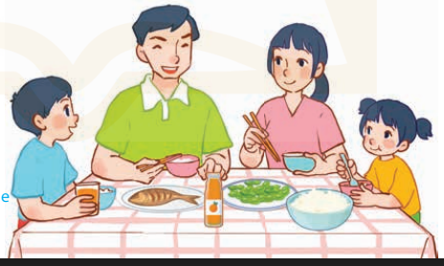  -T checks who’s the winner?  - Ask Ss look at the pieces of picture  - Say “Open your book page 30” and look at “Unit 15, Lesson 1 (1,2,3)”.  Activity 1. Vocabulary.  *Aims: Ss will be able to know the vocabulary in front of starting the new lesson.  *Procedure:  -T elicits the new words  + rice : cơm (realia)  + bean : đậu quả, hạt đậu (realia)  + fish : cá (visual)  + meat : thịt (picture)  + juice : nước hoa quả (picture)  + would like : muốn (situation)  - T models (3 times).  - T writes the words on the board.  - Checking: Rub out and remember  Activity 2. Listen, point and repeat:  *Aims: Ss will be able to understand and correctly repeat the sentences in two communicative contexts (pictures) focusing on offering someone food or drinks and accepting or declining someone’s offer.  *Procedure:  - Have Ss look at Pictures a and b and identify the characters in the pictures.  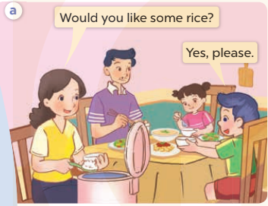  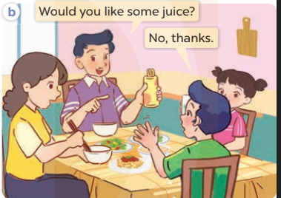  - Play the audio twice (sentence by sentence). Correct their pronunciation where necessary.  - Have Ss to practice the dialogue  - T invites a few pairs to the front of the class to practice.  - T checks pronunciation for ss.  Activity 3 Listen, point and say.  *Aims: Ss will be able to correctly use Would you like some ……? – Yes, please. / No, thanks. to offer someone food or drinks and accept or decline someone’s offer.  *Procedure:  * Model sentences:  - T asks Ss look at picture a , b and helps Ss know the structure from the dialogue.  - T introduces new structure for Ss.  - T explains, models and gives meaning.  -Have Ss repeat the model sentences.  A: Would you like some rice?  B: Yes, please. / No, thanks.  *Drill pictures  - Elicit and check comprehension the name of the rooms.  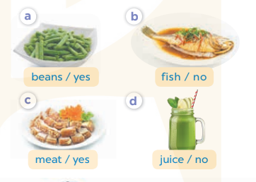  - Run through all the pictures.  - Run through model sentences.  + Run through the questions.  + Run through the answers  - Have Ss to practise:  + T says asks and Ss answer (change role).  + Ss – Ss (change role).  - Ask Ss to work in pairs.  - T controls and corrects.  - Invite a few pairs to come to the front of the classroom, point at the relevant character in each picture, and act out his/her role.  - Encourage Ss to practise speaking English.  - T gives feedbacks.  Activity 4. Let’s talk.  *Aims: Ss will be able to enhance the correct use of Would you like some ……..? – Yes, please. / No, thanks. to offer someone food or drinks and accept or decline someone’s offer.  *Procedure:  - T asks ss to guess each character and what the children say.  + What can you see in the picture?  +What food and drinks can you see on the table?  - T fills the gaps and writes the sentences on the board.  - T models  - T asks Ss to work in pairs to ask and answer  - Invite some pupils to the front of the class to present their exchanges.  - Give feedbacks  *Consolidation  *Aims: Ss will be able consolidate and wrap up the content of the lesson.  *Procedure:  - T asks ss to answer the following questions:  + What have you learnt from the lesson today?  - T review the vocabulary and model sentences.  - T praises some Ss who are hardworking / active/ good…. as well as encourage others to try more.  - Learn the number by heart  - Prepare the new lesson: Unit 15, Lesson 1 (4,5,6). | - Ss listen  - Ss play the game  - Ss open their books  -Ss listen and answer  - - Ss listen and repeat  + Choral repetition (3 times).  + Individual repetition (3 ss)  - Ss take note  - Ss look, remember and write  -Look at the pictures and get to know the characters in the pictures.  + Mother asks Would you like some rice? Nam answers Yes, please. in picture a.  + F ather asks Would you like some juice? Nam answers No, thanks. in picture b.  -Ss listen and repeat in chorus (twice)  -Ss work in pairs to practice  -Ss practice the dialogue  -Ss listen  -Ss look at the picture and answer.  -Ss listen  -Ss listen and repeat  -Ss repeat  - Ss look, listen and answer  + Picture a: beans/ yes  + Picture b: fish/ no  + Picture c: meat/ yes  + Picture d: juice/ no  -Ss practice in chorus  -Ss work in pairs to practice  -Ss point and say  -Ss listen.  -Ss listen  -Ss look at the picture and answer  +I can see a family at the dining table: father, mother, their son and daughter are having lunch.  + There some food and drinks on the table such as rice, fish, beans and juice.  -Ss note  - Ss say the completed sentences.  -Ss work in pairs  -Ss perform in front of the class.  -Ss answer the questions  - Ss listen  -Ss listen and clap their hands  -Ss listen and take note

IV. ADJUSTMENTS (if necessary):
………………………………………………………………………………………….…..……………………………………………………………………………...………………………………………….…..……………………………………………………………………………….……………………………………………………………………...

-------------------------------------------------------------------

Week 25 Preparing date: February 25th 2024
Period 98 Teaching date: March 5th 2024

Unit 15: AT THE DINING TABLE
Lesson 1 (4, 5, 6)
I. OBJECTIVES:
By the end of the lesson, Ss will be able to:
1. Knowledge:
- listen to and understand two communicative contexts about food and drinks.
- look, complete and read six target sentences with the help of picture cues.
- sing the song Would you like some …? with the correct pronunciation, rhythm and melody.
- Vocabulary: Review
- Skills: speaking, listening, reading and writing.
2. Competences:
- Co-operation: ready to help friends in pair work/ group work.
- Self-control and independent learning: perform listening tasks.
3. Attitude/ Qualities:
- Kindness: Help partners to complete learning tasks.
- Honesty: tell the truth about feelings and emotions.
- Diligence: complete learning tasks.
B. TEACHING AIDS:
- Teacher: Teacher’s guide Pages 185; audio Tracks 44, 45; website sachmem.vn, posters, laptop, pictures, textbook, lesson plan, TV or projector.
- Students: Pupil’s book Page 31, notebooks, workbooks, school things.
III. PROCEDURES:
Stages/Time | Teacher’s activities | Students’ activities
1.Warm- up:  (5’)  2.Practice: (27’)  3. Homework. (3’) | Game: “Passing the ball”  *Aims: to create a friendly and active atmosphere in the class to beginning the lesson.  *Procedure:  - Divide class into 3 teams.  - Each team has 1 sticky ball.  - Play the music, ss in each team take turn to pass the ball.  - After the music ends, 3 ss have the ball – stand up and say the name, using the sentence model.  - Say “Open your book page 31” and look at “Unit 15, Lesson 1 (4,5,6)”.  Activity 1. Listen and tick:  *Aims: Ss will be able to listen to and understand two communicative contexts about food and drinks *Procedure:  - Elicit the name of the food in each picture 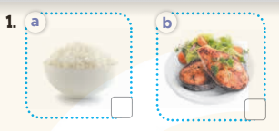  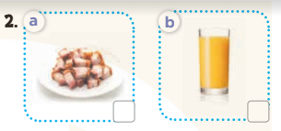  - T ask Ss to guess the answers.  + T writes Ss’guessing on the board.  - Listen to the tape:  + Play the recording  + Play the recording again and get Ss to swap books with their partners.  + Play the recording again to check answers together as a class.  + Write the answers on the board for Ss to correct their answers. Then checks Ss’ guessing.  - Play the recording, sentence by sentence, for the class to listen and repeat in chorus.  Key: 1.b 2.b  Activity 2. Look, complete and read.  *Aims: Ss will be able to look, complete and read six target sentences with the help of picture cues.*Procedure:  - Have Ss look at the pictures and identify the food (rice, beans, fish, juice).  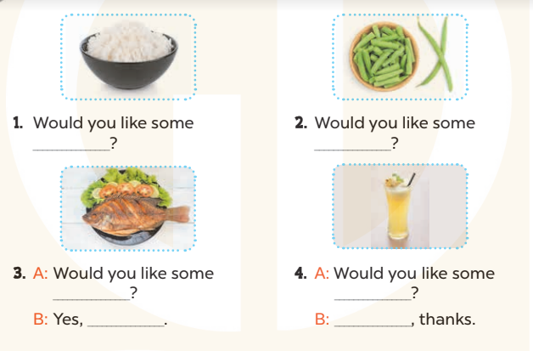  - Have Ss look at the four incomplete exchanges and elicits the missing words in the sentences.  - T models with sentence 1  + Ask Ss what is missing in the sentence.  + Have Ss look at the picture and complete the gap, then read the completed sentence in chorus.  -Have Ss work in groups and complete the sentences 2,3 and 4.  - Ask a few Ss to stand up and read the completed sentences aloud.  -T gives feedbacks.  Key:  - rice 2. beans 3. fish; please  4. juice; No  - Activity 3. Let’s sing.  *Aims: Ss will be able to sing the song Would you like some…? with the correct melody and pronunciation.  *Procedure:  - Introduce the title and lyrics of the song: “ Would you like some…? ” song.  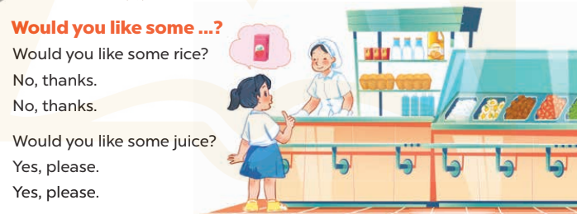  - Play the recording for Ss to listen to the whole song.  + Have them repeat the title and lyrics line by line.  + Tell Ss to point at the relevant character while singing his or her name.  - Play the recording all the way through for Ss to listen to pronunciation and melody of the song.  - Play the recording line by line for Ss to listen, repeat and point at the relevant character.  - Play the recording for Ss to sing and do actions.  - Ask Ss to practice singing and doing actions in pairs or groups.  - Invite groups to the front of the classroom to perform the song  -T gives feedback.  *Consolidation  *Aims: Ss will be able consolidate and wrap up the content of the lesson.  *Procedure:  - T asks ss to answer the following questions:  + What have you learnt from the lesson today?  +What are the core values of the lesson? (if the teacher can take from the lesson).  - T praises some Ss who are hardworking / active/ good…. as well as encourage others to try more.  - Learn the sing by heart  - Prepare the new lesson: Unit 15, Lesson 2 (1,2,3). | - Ss listen and keep the puppet  - Ss listen to music and play the game  -Ss listen  - Ss open their books  -Look at the pictures and say:  + Picture 1a: a bowl of rice  + Picture 1b: a plate of fish  + Picture 2a: a plate of meat  + Picture 2b: a glass of juice  -Ss guess the answers  - Ss listen to the tape and tick  - Ss listen again, tick and swap books with their partners.  - Ss check their answers and guessing  -Ss listen and repeat.  -Ss look at the picture and say  -Ss look and answer  -Ss answer: rice  -Ss look, complete and read the completed sentence in chorus.  -Ss complete the sentence  -Ss read aloud  - Ss look and listen.  -Ss listen to the song  - Ss listen and repeat line by line without the action.  -Ss point to the character while singing  -Ss listen to melody of the song  - Ss listen and sing line by line.  - Ss sing and do actions.  + Ss work in groups (two groups) to sing.  -Ss perform in front of the class.  -Ss listen  -Ss answer the questions  -Ss listen and clap their hands  -Ss listen and take note

IV. ADJUSTMENTS (if necessary):
………………………………………………………………………………………….…..……………………………………………………………………………...………………………………………….…..……………………………………………………………………………….……………………………………………………………………...

-----------------------------------------------------

Week 25 Preparing date: February 25th 2024
Period 99 Teaching date: March 7th 2024

Unit 15: AT THE DINING TABLE
Lesson 2 (1, 2, 3)
I. OBJECTIVES:
By the end of the lesson, Ss will be able to:
1. Knowledge:
- use What would you like to eat/drink? – I’d like some…….., please. To ask and answer questions about food and drinks
- understand and correctly repeat the sentences in two communicative contexts (pictures). focusing on what someone would like to eat or drink.
- correctly use What would you like to eat / drink? - I’d like some ……, please. to ask and answer questions about what someone would like to eat or drink.
- enhance the correct use of What would you like to eat / drink? – I’d like some ….., please. to ask and answer questions about what someone would like to eat or drink.
- Vocabulary: egg, chicken, water, milk, bread, eat, drink.
- Model sentences:
A: What would you like to eat / drink?
B: I’d like some bread/ milk, please
- Skills: speaking and listening
2. Competences:
- Critical Thinking: talk about someone
- Co-operation: ready to help friends in pair work/ group work.
- Oral Communication: speak about someone, ask and answer the questions
3. Attitude/ Qualities:
- Kindness: Help partners to complete learning tasks.
- Honesty: tell the truth about feelings and emotions
II. TEACHING AIDS:
- Teacher: Teacher’s guide Pages 187 audio Tracks 46, 47, website sachmem.vn, posters, laptop, pictures, textbook, lesson plan, TV or projector.
- Students: Pupil’s book Page 32, notebooks, workbooks, school things.
III. PROCEDURES:
Stages/Time | Teacher’s activities | Students’ activities
1.Warm- up:  (3’)  2. Presentation  (16’)  3.Practice: (7’)  4.Production: (7’)  5. Homework. (2’) | Game: Board Race!  *Aims: to create a friendly and active atmosphere in the class to beginning the lesson.  *Procedure:  - Divide the class into two teams  - Give each team a colored marker.  - Draw a line down the middle of the board and write a topic at the top.  - Have Ss write as many words related to the topic in a relay.  - The first pupil will write the first word and pass the colored marker to the one next in line.  - Score each team with one point for each correct word.  - Unreadable or misspelled words are not counted.  - Say “Open your book page 32” and look at “Unit 13, Lesson 2 (1,2,3)”.  Activity 1. Vocabulary.  *Aims: Ss will be able to know the vocabulary in front of starting the new lesson.  *Procedure:  -T elicits the new words  + bread : bánh mì (realia)  + milk : sữa (realia)  + egg : trứng (realia)  + chicken : thịt gà (visual)  + water : nước (realia)  + eat : ăn (mime)  + drink : uống (mime)  - T models (3 times).  - T writes the words on the board.  - Checking: Rub out and remember  Activity 2. Listen, point and repeat:  *Aims: Ss will be able to understand and correctly repeat the sentences in two communicative contexts (pictures). focusing on what someone would like to eat or drink.  *Procedure:  - Have Ss look at Pictures a and b and identify the characters in the pictures.  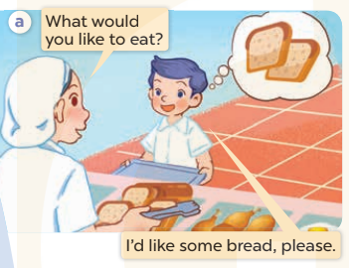  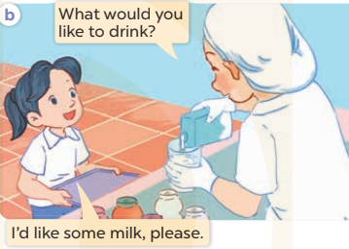  - Play the audio twice (sentence by sentence). Correct their pronunciation where necessary.  - Have Ss to practice the diaguage  - T invites a few pairs to the front of the class to practice.  - T checks pronunciation for ss.  Activity 3. Listen, point and say.  *Aims: Ss will be able to correctly use What would you like to eat / drink? - I’d like some ………,, please. to ask and answer questions about what someone would like to eat or drink.  *Procedure:  * Model sentences:  - T asks Ss look at picture b and helps Ss know the structure from the dialogue.  - T introduces new structure for Ss.  - T explains, models and gives meaning.  - Have Ss repeat the model sentences.  A: What would you like to eat / drink?  B: I’d like some bread/ milk, please  *Drill pictures  - Elicit and check comprehension the name of each character.  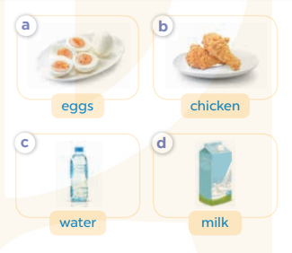  - Run through all the pictures.  - Run through model sentences.  +Run through the question sentences  +Run through the answer sentences  - Have Ss to practise:  + T asks, Ss answer picture a  + Ss ask, T answers picture b  + Group A ask, group B answer picture c  + Group B ask, group A answer picture d  - Ask Ss to work in pairs.  - T controls and corrects.  - Invite a few pairs to come to the front of the classroom, point at the relevant character in each picture, and act out his/her role.  - T gives feedbacks.  Activity 4. Let’s talk.  *Aims: Ss will be able to enhance the correct use of What would you like to eat / drink? – I’d like some …., please. to ask and answer questions about what someone would like to eat or drink.  *Procedure:  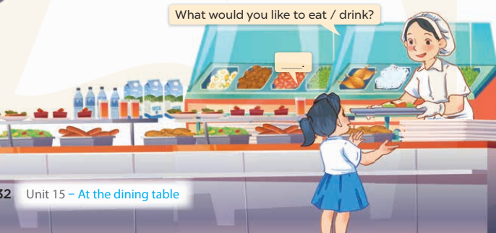  - T asks ss to attend to the picture.  + What can you see in the picture?  +Where are they?  + What would she like to eat/ drink?  - T fills the gaps and writes the sentences on the board.  - T models  - T asks Ss use of What would you like to eat / drink? – I’d like some …., please. to ask and answer (groups of four)  - Invite some groups to perform.  - Give feedbacks  *Consolidation  *Aims: Ss will be able consolidate and wrap up the content of the lesson.  *Procedure:  - T asks ss to answer the following questions:  + What have you learnt from the lesson today?  +What are the core values of the lesson? (if the teacher can take from the lesson).  - T review the vocabulary and model sentences.  - T praises some Ss who are hardworking / active/ good…. as well as encourage others to try more.  - Learn the vocabulary by heart  - Prepare the new lesson: Unit 15, Lesson 2 (4,5,6). | - Ss listen  - Ss play the game  - Ss open their books  -Ss listen and answer  - - Ss listen and repeat  + Choral repetition (3 times).  + Individual repetition (3 ss)  - Ss take note  - Ss look, remember and write  -Look at the pictures and get to know the characters in the pictures.  + In picture a: Staff asks What would you like to eat?  Nam answers I’d like some bread, please.  + In picture b: Staff asks What would you like to drink? And Mai answers I’d like some milk, please.  -Ss listen and repeat in chorus (twice)  -Ss work in pairs to practice  -Ss practice the diaguage  -Ss listen  -Ss look at the picture and answer.  -Ss listen  -Ss listen and repeat  -Ss repeat  - Ss look, listen and answer  + Picture a: some eggs  + Picture b: some chicken  + Picture c: a bottle of water  + Picture d: a box of milk  -Ss practice in chorus  - Ss practice in chorus  -Ss work in pairs to practice  -Ss listen  -Ss go to the board and role play.  -Ss listen  -Ss look at the picture and answer  + Mai is at the school canteen. A member of staff serves food like rice, bread, fish, chicken, meat, eggs, beans, and some drinks like water, milk and juice. Mai wants something to eat or drink.  -Ss note  - Ss say the completed sentences.  -Ss work in groups  -Ss perform in front of the class.  -Ss answer the questions  - Ss listen  -Ss listen and clap their hands  -Ss listen and take note

IV. ADJUSTMENTS (if necessary):
………………………………………………………………………………………….…..……………………………………………………………………………...………………………………………….…..……………………………………………………………………………….……………………………………………………………………...

---------------------------------------------------------

Week 25 Preparing date: February 25th 2024
Period 100 Teaching date: March 7th 2024

Unit 15: AT THE DINING TABLE
Lesson 2 (4, 5, 6)
I. OBJECTIVES:
By the end of the lesson, Ss will be able to:
1. Knowledge:
- listen to and understand four communicative contexts in relation to food and drinks.
- look, complete and read four target sentences with the help of picture cues.
- revise target words about food and drinks by playing the game Board race.
- Vocabulary: Review
- Skills: speaking, listening, reading and writing.
2. Competences:
- Critical Thinking: talk about rooms in a house and things in a room.
- Co-operation: ready to help friends in pair work/ group work.
- Self-control and independent learning: perform listening tasks.
3. Attitude/ Qualities:
- Kindness: Help partners to complete learning tasks.
- Honesty: tell the truth about feelings and emotions.
- Diligence: complete learning tasks.
II. TEACHING AIDS:
- Teacher: Teacher’s guide Pages 188; audio Tracks 48; website sachmem.vn, posters, laptop, pictures, textbook, lesson plan, TV or projector.
- Students: Pupil’s book Page 33, notebooks, workbooks, school things.
III. PROCEDURES:
Stages/Time | Teacher’s activities | Students’ activities
1.Warm- up:  (5’)  2.Practice: (27’)  3. Homework. (3’) | Sing a song: “My house”  *Aims: to create a friendly and active atmosphere in the class to beginning the lesson.  *Procedure:  - Show the song on the screen.  https://www.youtube.com/watch?v=qZyJPZxsmZk  - Ask pupils to listen, sing and dance the song.  - Say “Open your book page 33” and look at “Unit 15, Lesson 2 (4,5,6)”.  Activity 1. Listen and number:  *Aims: Ss will be able to listen to and understand four communicative contexts in relation to food and drinks.  *Procedure:  - Elicit the names and ages of the characters in the pictures.  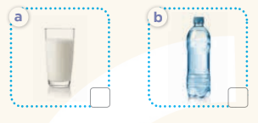  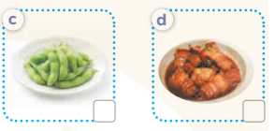  - T ask Ss to guess the answers.  + T writes Ss’guessing on the board.  - Listen to the tape:  + Play the recording  + Play the recording again and get Ss to swap books with their partners.  + Play the recording again to check answers together as a class.  + Write the answers on the board for Ss to correct their answers. Then checks Ss’ guessing.  - Play the recording, sentence by sentence, for the class to listen and repeat in chorus.  Key: 1.c 2. d 3. a 4. b  Activity 2. Look, complete and read.  *Aims: Ss will be able to look, complete and read four target sentences with the help of picture cues.  *Procedure:  - Have Ss look at the pictures and identify food and drink in the pictures. 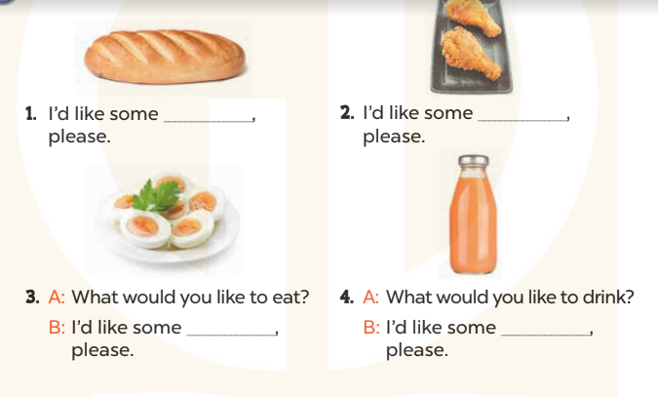  - T models with sentence 1.  + Have Ss look at the sentence.  + Ask them what is missing in the answer (bread)  + Have Ss circle the correct options  + Have Ss read the completed sentence in chorus.  -Have Ss work in pairs and circle the sentences 2, 3 and 4.  - Invite pairs of pupils to stand up and read aloud the sentences.  -T gives feedbacks.  Key: 1. b 2. b 3. a 4. b  Activity 3. Let’s play.  *Aims: Ss will be able to revise target words about food and drinks by playing the game Board race.  *Procedure:  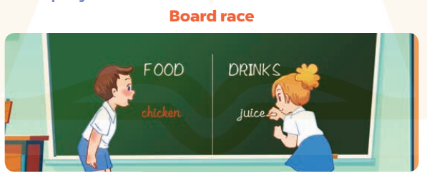  - Tell Ss that they are going to play the game Board race. Write Food and Drinks on opposite sides of the board.  - Have two teams play the game. When you say “Go”, the teams have to race to write the name of a food or drinks. Each pupil writes one word at a time, before passing the marker /chalk to the next pupil and going to the back of the line.  - Explain that a pupil who makes spelling mistakes or writes a word of food or drink under the wrong category will be out of the game.  - At the end of the game, announce the winner for the team that has written more correct words.  *Consolidation  *Aims: Ss will be able consolidate and wrap up the content of the lesson.  *Procedure:  - T asks ss to answer the following questions:  + What have you learnt from the lesson today?  +What are the core values of the lesson? (if the teacher can take from the lesson).  - T praises some Ss who are hardworking / active/ good…. as well as encourage others to try more.  - Prepare the new lesson: Unit 15, Lesson 3 (1,2,3). | - Sing and dance the song in chorus.  - Ss open their books  -Look at the pictures and say:  + Picture a: a glass of milk + Picture b: a bottle of water  + Picture c: some beans + Picture d: some meat  -Ss guess the answers  - Ss listen to the tape and write number  - Ss listen again, write number and swap books with their partners.  - Ss check their answers and guessing  -Ss listen and repeat.  -Ss look at the pictures and say  -Ss listen and answer  -Ss read and complete  -Ss work in pairs  -Ss read  - Ss listen  -Ss play the game  - Ss play the game  -Ss listen and answer  -Ss listen and take note

D. ADJUSTMENTS (if necessary):
………………………………………………………………………………………….…..……………………………………………………………………………...………………………………………….…..……………………………………………………………………………….………………………………………………………………………

