Week 26 Preparing date: March 4th 2024
Period 101 Teaching date: March 12th 2024

Unit 15: AT THE DINING TABLE
Lesson 3 (1, 2, 3)
I. OBJECTIVES:
By the end of the lesson, Ss will be able to:
1. Knowledge:
- correctly repeat the sounds of the letters ea in isolation, the words bread and meat and the sentences I’d like some bread, please. and Would you like some meat?. with the correct pronunciation and intonation.
- identify the target words bread and meat while listening.
- say the chant with the correct rhythm and pronunciation.
- Vocabulary: Review
- Skills: speaking, listening, reading and writing.
2. Competences:
- Co-operation: ready to help friends in pair work/ group work.
- Self-control and independent learning: perform listening tasks.
3. Attitude/ Qualities:
- Kindness: Help partners to complete learning tasks.
- Honesty: tell the truth about feelings and emotions
II. TEACHING AIDS:
- Teacher: Teacher’s guide Pages 190; audio Tracks 49, 50, 51; website sachmem.vn, posters, laptop, pictures, textbook, lesson plan, TV or projector.
- Students: Pupil’s book Page 34, notebooks, workbooks, school things.
III. PROCEDURES:
Stages/Time | Teacher’s activities | Students’ activities
1.Warm- up:  (5’)  2. Presentation  (9’)  3.Practice: (19’)  4. Homework. (2’) | Game: Find and circle the words  *Aims: to create a friendly and active atmosphere in the class to beginning the lesson.  *Procedure:  O B K K E P S C E T  O R T H E A D C A H  O E U A A E C O T I  R A M M F C C S H N  T D B E A N L S E K  R T R A R C L S E B  S R O T R C V T A H  M M T H H R S T A Y  D P L E A S E R S M  A C E B F A Z Y W  - Divide class into 2 groups  - Ask Ss to find and circle the words that they learnt.  - Which groups find the best correct words is winner.  - Give Ss time to play the game.  Rows: bean, please, head.  Columns: bread, meat, eat.  -T checks who’s winner?  - Say “Open your book page 34” and look at “Unit 15, Lesson 3 (1,2,3)”.  Activity 1. Listen and repeat:  *Aims: Ss will be able to correctly pronounce the sounds of the letters ea in isolation, in the words bread and meat, and in the sentences I’d like some bread, please. and Would you like some meat? with correct pronunciation and intonation.  *Procedure:  - T gives instruction to the letters ea in isolation, in the words bread and meat, and in the sentences I’d like some bread, please. and Would you like some meat?  - Play the recording for the letter ea.  - Encourage Ss to point at the letter/ word/ sentence while listening.  - Play the recording again and encourage Ss to listen and repeat.  - Do this several times until Ss feel confident.  - T calls some Ss to practice.  - T gives feedbacks.  Activity 2. Listen and tick.  *Aims: Ss will be able to identify the target words bread and meat while listening.  *Procedure:  - Elicit the sentences and explain that they have to listen.  - T ask Ss to guess the answers.  + T writes Ss’guessing on the board.  - Listen to the tape:  + Play the recording  + Play the recording again and get Ss to swap books with their partners.  + Play the recording again to check answers together as a class.  + Write the answers on the board for Ss to correct their answers. Then checks Ss’ guessing.  - Play the recording, sentence by sentence, for the class to listen and repeat in chorus.  - Invite one or two Ss to stand up and read the completed sentences.  Key: 1.b 2.c  Activity 3. Let’s chant  *Aims: Ss will be able to say the chant with the correct rhythm and pronunciation.  *Procedure:  - Introduce the title and lyrics of the chant.  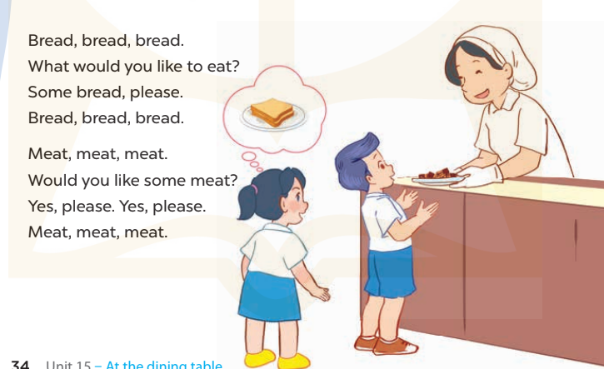  - Play the recording for Ss to listen to the whole chant.  + Have them repeat the title and lyrics line by line.  + Ask Ss to attend to the sounds of the letters ea and the words bead and meat.  - Play the recording all the way through for Ss to listen to pronunciation and melody.  - Play the recording line by line for Ss to listen and repeat  - Play the recording for Ss to chant and clap along.  - Ask Ss to practice chant and clap along in pairs or groups.  - Invite groups to the front of the classroom to perform the chant  -T gives feedback.  *Consolidation  *Aims: Ss will be able consolidate and wrap up the content of the lesson.  *Procedure:  - T asks ss to answer the following questions:  + What have you learnt from the lesson today?  +What are the core values of the lesson? (if the teacher can take from the lesson).  - T praises some Ss who are hardworking / active/ good…. as well as encourage others to try more.  - Practice the chant more.  - Prepare the new lesson: Unit 15, Lesson 3 (4,5,6). | - Ss listen  -Ss play game  - Ss open their books  - Ss recognize the differences about color of letter  - - Ss listen  - Ss listen and point  - Ss listen again and repeat  -Ss listen again and repeat  -Ss practice  -Ss listen  -Ss listen and say:  + Number 1: I’d like some…,please.  + Number 2: Would you like some…..?.  -Ss guess the answers  - Ss listen to the tape and tick  - Ss listen again, tick and swap books with their partners.  - Ss check their answers and guessing  -Ss listen and repeat.  -Ss read the sentences  - Ss look and listen.  -Ss listen to the chant  - Ss listen and repeat line by line without clap their hands  -Ss note the sounds, words  -Ss listen to melody of the chant  - Ss listen and chant line by line.  - Ss chant and clap along.  - Ss work in groups (two groups) to chant  -Ss perform in front of the class.  -Ss listen  -Ss listen.  -Ss answer the questions  -Ss listen and clap their hands  -Ss listen and take note
IV. ADJUSTMENTS (if necessary):
………………………………………………………………………………………….…..……………………………………………………………………………...………………………………………….…..……………………………………………………………………………….……………………………………………………………………...

Week 26 Preparing date: March 4th 2024
Period 102 Teaching date: March 12th 2024
Unit 15: AT THE DINING TABLE
Lesson 3 (4, 5, 6)
I. OBJECTIVES:
By the end of the lesson, Ss will be able to:
1. Knowledge:
- read and complete a passage with five words “dining, drinks, like, rice, some” provided in a box.
- complete a paragraph about what a pupil and his / her family members would like to eat and drink by writing the target words in the gaps.
- do a survey with classmates and tell the class about food and drinks they would like to eat or drink.
- Vocabulary: Review
- Skills: speaking, listening, reading and writing.
2. Competences:
- Co-operation: ready to help friends in pair work/ group work.
- Self-control and independent learning: perform reading tasks.
3. Attitude/ Qualities:
- Kindness: Help partners to complete learning tasks.
- Honesty: tell the truth about feelings and emotions.
- Diligence: complete learning tasks.
II. TEACHING AIDS:
- Teacher: Teacher’s guide Pages 192, website sachmem.vn, posters, laptop, pictures, textbook, lesson plan, TV or projector.
- Students: Pupil’s book Page 35, notebooks, workbooks, school things.
III. PROCEDURES:
Stages/Time | Teacher’s activities | Students’ activities
1.Warm- up:  (5’)  2. Practice: (8’)  3.Production: (19’)  4. Homework. (3’) | Game: Brainstorming  *Aims: to review the vocabulary and structure about greet and respond to greetings.  *Procedure:  - Divide the class into four groups.  - Each group chooses one pupil to be the 'runner'. The runners go to the teacher's desk and read the category.  Ex: Find food and drink  - The runners then go back to their group and tell their group members the category. Their group brainstorm words from that category and write them down.  - The first group to finish shouts 'stop' and then calls out their answers. If their answers are correct, they score one point for each word in the category.  - The group with the highest score at the end of the game wins.  - Say “Open your book page 35” and look at “Unit 15, Lesson 3 (4, 5, 6)”.  Activity 1. Read and complete:  *Aims: Ss will be able to read and complete a passage with five words provided in a box.  *Procedure:  - Tell Ss how to complete the task.  - Point at the words provided in the box and the five gaps in the passage - Ask Ss attend to the blank in number 1 and find the missing word.  - Write the missing word on the board and get the class to read the completeed sentence together.  - Have Ss work in pairs and complete  - Tell Ss to swap books with a partner, then check answers together as a class.  - Write the correct answers on the board for pupils to correct their answers.  - Invite Ss to read the complete text aloud.  -T gives feedbacks.  Key: 1. dining 2. drinks 3. like  4. some 5. rice  Activity 2. Let’s write  *Aims: Ss will be able to complete a paragraph about what a pupil and his / her family members would like to eat anddrink by writing the target words in the gaps.  *Procedure:  - Explain to the class the goal of this activity.    - Ask Ss to read each gapped sentence, look at the picture and fill in the gap.  - Give Ss time to write their answers  - Ask Ss to swap and correct their answers in pairs.  - Check the answers as a class.  Key: Pupils’ own answers  Activity 3. Project.  *Aims: Ss will be able to do a survey with classmates to find out what they would like to eat and drink, then tell the class about the results.  *Procedure:  - Draw the table on the board. Ask a pupil: What would you like to eat and drink?, then write their name and answers in the table.  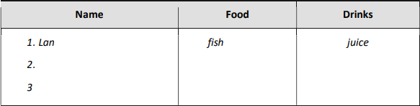  - Ask Ss move around the classroom and find three classmates to ask.  - Remind Ss to write their answers in the table before moving on to the next person.  - Allow enough time for all Ss to complete their tables.  - Invite a few Ss to share their results with the class.  *Consolidation  *Aims: Ss will be able consolidate and wrap up the content of the lesson.  *Procedure:  - T asks ss to answer the following questions:  + What have you learnt from the lesson today?  - T praises some Ss who are hardworking / active/ good…. as well as encourage others to try more.  - Prepare the new lesson: Review 3. | - Ss listen  -Ss play game  - Ss open their books  -Ss listen  - Ss read and answer  -Ss read and complete  -Ss write the first word  -Ss work in pairs  -Ss swap books and check  -Ss check the correct their answers  -Ss read  -Ss listen  -Ss listen  -Ss read and answer  -Ss write  My father and my mother would like some……………….  My sister/ brother would like …………………………………  I would like……..and………..  -Ss swap books and check their answers  -Ss check  -Ss listen and answer  -Ss work in groups  -Ss write the answers  -Ss complete the table  -Ss perform in front of the class.  -Ss answer the questions  -Ss listen and clap their hands  -Ss listen and take note
IV. ADJUSTMENTS (if necessary):
………………………………………………………………………………………….…..………………………………………………………………………………………………….…..……………………………………………………………………………...
……………………………………………………………………...…………

Week 26 Preparing date: March 4th 2024
Period 103 Teaching date: March 14th 2024

REVIEW 3
Parts 1, 2, 3
I. OBJECTIVES:
By the end of the lesson, Ss will be able to:
1. Knowledge:
- correctly use the following sentence patterns:
+ Who’s this / that? It’s my ……..
+ How old is he / she? He’s /She’s ……….
+ What’s her job? – He’s / She’s ……..
+ Is he / she ………? – Yes, he / she is. / No, he / she isn’t.
+ Where’s ………..? – It’s here / there.
+ Where are the ……..? – They’re ………..
+ There’s / There are …………. in the room.
+ The …….. is ………. The ……… are ……….
+ Would you like some ……….? – Yes, please. / No, thanks.
+ What would you like to eat / drink? – I’d like some ………, please.
- through different contexts, take part in three fun activities relating to their language knowledge and competences.
- Vocabulary: Review
- Skills: speaking, listening, reading and writing.
2. Competences:
- Co-operation: ready to help friends in pair work/ group work.
- Self-control and independent learning: perform listening tasks.
3. Attitude/ Qualities:
- Kindness: Help partners to complete learning tasks.
- Honesty: tell the truth about feelings and emotions.
- Diligence: complete learning tasks.
II. TEACHING AIDS:
- Teacher: Teacher’s guide Pages 194; Track 52, 53; website sachmem.vn, posters, laptop, pictures, textbook, lesson plan, TV or projector.
- Students: Pupil’s book Page 36, 37, notebooks, workbooks, school things.
III. PROCEDURES:
Stages/Time | Teacher’s activities | Students’ activities
1.Warm- up:  (5’)  2.Practice: (52’)  3. Homework. (3’) | Game: Whispering  *Aims: to review the vocabulary and structure about greet and respond to greetings.  *Procedure:  - Divide class into 2 groups.  -Ask 5 Ss in each group stand in a straight line.  - T says a word or phrase to the first pupil in this line.  - Then, the first pupil whispers what she/ he hear to the second person in line; the second one whispers what he/ she hears to the third one and so on until the last pupil in group hears the word or phrase.  - The last pupil says the word or phrase out loud.  - The faster group has correct word or phrase is the winner.  - Say “Open your book page 36, 37” and look at Review 3.  Activity 1. Listen and tick:  *Aims: Ss will be able to listen to and understand five communicative contexts  *Procedure:  - Elicit the names of the characters in each picture and check comprehension.  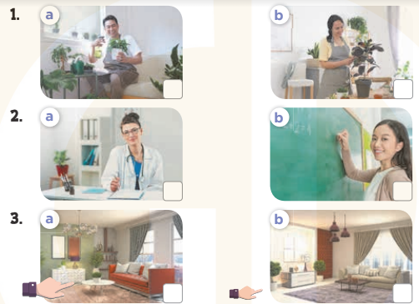  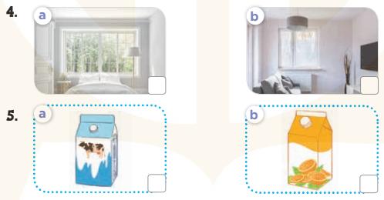  - T ask Ss to guess the answers.  + T writes Ss’guessing on the board.  - Listen to the tape:  + Play the recording  + Play the recording again and get Ss to swap books with their partners.  + Play the recording again to check answers together as a class.  + Write the answers on the board for Ss to correct their answers. Then checks Ss’ guessing.  - Play the recording, sentence by sentence, for the class to listen and repeat in chorus.  Key: 1. a 2. a 3. b 4. b 5. a  Activity 2. Listen and number  *Aims: Ss will be able to listen to and understand four communicative contexts  *Procedure:  - Elicit the names of the characters in each picture and what they say  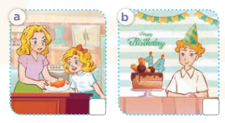  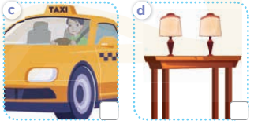  - T ask Ss to guess the answers.  + T writes Ss’guessing on the board.  - Listen to the tape:  + Play the recording  + Play the recording again and get Ss to swap books with their partners.  + Play the recording again to check answers together as a class.  + Write the answers on the board for Ss to correct their answers. Then checks Ss’ guessing.  - Play the recording, sentence by sentence, for the class to listen and repeat in chorus.  Key: 1. b 2. c 3. d 4. a  Activity 3. Read and match  *Aims: Ss will be able to read and match pairs of target sentence patterns  *Procedure:  - Tell Ss about this activity. Point at sentence 1, elicit the answer and models.  - Give Ss work in pairs to do the sentence 2,3,4,5.  - Tell Ss to swap their books with their partners, then check answers together as a class.  - Write the correct answers on the board for Ss to correct their answers.  - Invite some pairs to stand up and read the matched exchanges aloud.  Key:  1. c 2. e 3. d 4. b 5. a  - Prepare the new lesson: REVIEW 5.5 | - Ss listen  -Ss play game  - Ss open their books  -Look at the pictures and say:  + Picture 1a. a father  + Picture 1b. a mother.  + Picture 2a. a mother working as a doctor  + Picture 2b. a mother working as a teacher  + Picture 3a. a living room (near)  + Picture 3b. a living room (far)  + Picture 4a. a big window + Picture 4b. a small window.  + Picture 5a. a carton of milk  + Picture 5b. a carton of juice  -Ss guess the answers  - Ss listen to the tape and tick  - Ss listen again, tick and swap books with their partners.  - Ss check their answers and guessing  -Ss listen and repeat.  -Look at the pictures and say:  + Picture a: a mother giving chicken to her daughter  + Picture b: a boy sitting near a birthday cake with the number 14 on it  + Picture c: a father driving a taxi  + Picture d: two lamps on a table  -Ss guess the answers  - Ss listen to the tape and write the number  - Ss listen again, write number and swap books with their partners.  - Ss check their answers and guessing  -Ss listen and repeat.  -Ss look at the sentence 1 and say  -Ss work in pairs and match  -Ss swap their books and match  -Ss check  -Ss read aloud  -Ss listen and take note
IV. ADJUSTMENTS (if necessary):
………………………………………………………………………………………….…..……………………………………………………………………………...…………………………………………………………………………………………………….…..……………………………………………………………………………...…………

Week 26 Preparing date: March 4th 2024
Period 104 Teaching date: March 14th 2024

REVIEW 3
Parts 4, 5
I. OBJECTIVES:
By the end of the lesson, Ss will be able to:
1. Knowledge:
- correctly use the following sentence patterns:
+ Who’s this / that? It’s my ……..
+ How old is he / she? He’s /She’s ……….
+ What’s her job? – He’s / She’s ……..
+ Is he / she ………? – Yes, he / she is. / No, he / she isn’t.
+ Where’s ………..? – It’s here / there.
+ Where are the ……..? – They’re ………..
+ There’s / There are …………. in the room.
+ The …….. is ………. The ……… are ……….
+ Would you like some ……….? – Yes, please. / No, thanks.
+ What would you like to eat / drink? – I’d like some ………, please.
- through different contexts, take part in three fun activities relating to their language knowledge and competences.
- Vocabulary: Review
- Skills: speaking, listening, reading and writing.
2. Competences:
- Co-operation: ready to help friends in pair work/ group work.
- Self-control and independent learning: perform listening tasks.
3. Attitude/ Qualities:
- Kindness: Help partners to complete learning tasks.
- Honesty: tell the truth about feelings and emotions.
- Diligence: complete learning tasks.
II. TEACHING AIDS:
- Teacher: Teacher’s guide Pages 194; Track 52, 53; website sachmem.vn, posters, laptop, pictures, textbook, lesson plan, TV or projector.
- Students: Pupil’s book Page 36, 37, notebooks, workbooks, school things.
III. PROCEDURES:
Stages/Time | Teacher’s activities | Students’ activities
1.Warm- up:  (5’)  2.Practice: (52’)  3.Production: (10’)  4  . Homework. (3’) | Game: Whispering  *Aims: to review the vocabulary and structure about greet and respond to greetings.  *Procedure:  - Divide class into 2 groups.  -Ask 5 Ss in each group stand in a straight line.  - T says a word or phrase to the first pupil in this line.  - Then, the first pupil whispers what she/ he hear to the second person in line; the second one whispers what he/ she hears to the third one and so on until the last pupil in group hears the word or phrase.  - The last pupil says the word or phrase out loud.  - The faster group has correct word or phrase is the winner.  - Say “Open your book page 36, 37” and look at Review 3.  Activity 4. Read and complete  *Aims: Ss will be able to read and complete a gapped text.  *Procedure:  - Elicit the words in the box and the passage.  - Tell Ss about this activity. Point at number 1, elicit the answer and models.  - Give Ss work in pairs to do the task  - Tell Ss to swap their books with their partners, then check answers together as a class.  - Write the correct answers on the board for Ss to correct their answers.  - Invite some pairs to stand up and read the passage aloud.  Key:  1. are 2. is 3. big 4. in 5. on  * Mini game: Comprehension questions  - Ask Ss to read the conversation again  - Give Ss work in pairs and answer the questions:  + How many bedrooms in the passage?  There are 2 bedrooms.  + What thing does each bedroom have?  There is a lamp.  + Where is the clock?  It’s on the desk.  Activity 5. Ask and answer  *Aims: Ss will be able to read and answer questions using picture cues *Procedure:  - Ask Ss to read the question and elicit the answer  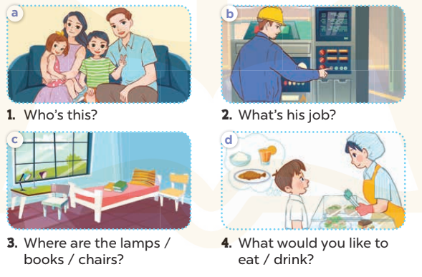  - Get Ss to role-play the exchange with sentence 1  - Give Ss time to take it in turns to role-play the four exchanges.  - Invite some paris to stand up and role-play.  Key: Pupil’s answer  *Consolidation  *Aims: Ss will be able consolidate and wrap up the content of the lesson.  *Procedure:  - T asks ss to answer the following questions:  + What have you learnt from the lesson today?  - T praises some Ss who are hardworking / active/ good…. as well as encourage others to try more.  - Prepare the new lesson: Fun time 3 | - Ss listen  -Ss play game  -Ss listen and answer  -Ss look at the dialogue and say number 1  -Ss work in pairs and complete  -Ss swap their books and complete  -Ss check  -Ss read aloud  - Ss open their book  -Ss read the passage again  -Ss work in pairs and answer  -Ss listen and answer  -Ss role play sentence 1  -Ss work in paris  -Ss role play  -Ss listen and answer  -Ss listen and clap their hands  -Ss listen and take note
IV. ADJUSTMENTS (if necessary):
………………………………………………………………………………………….…..………………………………………………………………………………………………………………………………….…..………………………………………………

